**USER MANUAL**

**Operating Lease Support System Version 2.1**

**Master Data Information Module, Marketing Module, Maintenance Module & Collection Module**

**Copyright Notice**

© 2014 PT. Berlian Sistem Informasi. All Rights Reserved

All material contained in this manual including text, graphics, icons and images contain proprietary and confidential information of PT. Berlian Sistem Informasi and are protected by international intellectual property and other laws. The compilation of all text, graphics, icons and images in this Manual is the exclusive property of PT. Berlian Sistem Informasi. No modification, rental, lease, sale, transmission, distribution, reposting or creation or derivate works based on the material in this Manual is allowed, unless with the express permission of PT. Berlian Sistem Informasi.

# Table of Contents

[Table of Contents ii](#_Toc407957075)

[Version 2.1 1](#_Toc407957076)

[1. Starting to Use the system 1](#_Toc407957077)

[1.1 Opening your browser and connecting the system 1](#_Toc407957078)

[1.2 Signing In 2](#_Toc407957079)

[2. Master Data Module 3](#_Toc407957080)

[2.1 Customer Information 3](#_Toc407957081)

[2.1.1 Customer Detail 4](#_Toc407957082)

[2.1.2 Filter and Sort Customer 6](#_Toc407957083)

[2.1.3 Add New Customer 7](#_Toc407957084)

[2.1.4 Edit Customer 8](#_Toc407957085)

[2.2 Supplier Information 10](#_Toc407957086)

[2.2.1 Supplier Detail 11](#_Toc407957087)

[2.2.2 Filter and Sort Supplier 13](#_Toc407957088)

[2.2.3 Add New Supplier 14](#_Toc407957089)

[2.2.4 Edit Supplier 16](#_Toc407957090)

[2.3 Product Information 17](#_Toc407957091)

[2.3.1 Product Detail 18](#_Toc407957092)

[2.3.2 Filter and Sort Product’s 20](#_Toc407957093)

[2.3.3 Add New Product 22](#_Toc407957094)

[2.3.4 Edit Product 23](#_Toc407957095)

[3. Marketing Module 26](#_Toc407957096)

[3.1 Calculation of Refinance 26](#_Toc407957097)

[3.1.1 Details of Calculation of Refinance 28](#_Toc407957098)

[3.1.2 Filter and Sort Calculations of Refinance 29](#_Toc407957099)

[3.1.3 Create New Calculation of Refinance 30](#_Toc407957100)

[3.1.4 Edit Calculation of Refinance Record 33](#_Toc407957101)

[3.2 Quotation of Refinance 36](#_Toc407957102)

[3.2.1 Details of Quotation of Refinance 38](#_Toc407957103)

[3.2.2 Filter and Sort Quotation of Refinance 40](#_Toc407957104)

[3.2.3 Create New Quotation of Refinance 40](#_Toc407957105)

[3.2.4 Edit Quotation of Refinance record 42](#_Toc407957106)

[3.3 Calculation of Operating Lease 44](#_Toc407957107)

[3.3.1 Details of Calculation of Operating Lease 46](#_Toc407957108)

[3.3.2 Filter and Sort Calculations of Operating Lease 52](#_Toc407957109)

[3.3.3 Create New Calculation of Operating Lease 52](#_Toc407957110)

[3.3.3.1 Step 1: 53](#_Toc407957111)

[3.3.3.2 Step 2: 55](#_Toc407957112)

[3.3.3.3 Step 3: 57](#_Toc407957113)

[3.3.3.4 Step 4: 58](#_Toc407957114)

[3.3.3.5 Step 5: 59](#_Toc407957115)

[3.3.3.6 Step 6: 61](#_Toc407957116)

[3.3.4 Edit Calculation of Operating Lease Record 62](#_Toc407957117)

[3.4 Quotation of Operating Lease 62](#_Toc407957118)

[3.4.1 Details of Quotation of Operating Lease 64](#_Toc407957119)

[3.4.2 Filter and Sort Quotation of Operating Lease 65](#_Toc407957120)

[3.4.3 Create New Quotation of Refinance 66](#_Toc407957121)

[3.2.4 Edit Quotation of Operating Lease record 68](#_Toc407957122)

[3.5 Agreement Information Inquiry 70](#_Toc407957123)

[3.5.1 Details of Agreement Information Inquiry 72](#_Toc407957124)

[3.5.2 Filter and Sort Agreement Information Inquiry 74](#_Toc407957125)

[3.5.3 Create New Agreement Information Inquiry 75](#_Toc407957126)

[3.5.4 Edit Agreement Information Inquiry Record 77](#_Toc407957127)

[4. Maintenance Module 79](#_Toc407957128)

[4.1 Service History Inquiry 79](#_Toc407957129)

[4.1.1 Open Service History Inquiry 81](#_Toc407957130)

[4.1.2 Add Service History Inquiry 83](#_Toc407957131)

[4.1.3 Details of Service History 85](#_Toc407957132)

[5. Collection Module 88](#_Toc407957133)

[5.1 Billing Payment History 88](#_Toc407957134)

[5.1.1 Open Billing Payment History 90](#_Toc407957135)

[5.1.2 Details of Billing Payment History 92](#_Toc407957136)

# Version 2.1

This manual covers the explanation of features, functions that are delivered to operate the Operating Lease Support System (OLSS). The version 2.1 includes basic features of operating lease system, e.g.: customer information, supplier information, product information, quotation of refinance, calculation of operating lease, quotation of operating lease, agreement information inquiry, service history, and billing payment history.

The following paragraphs will list all features available inside each module with this version and describe what they are for and how to use them.

# 1. Starting to Use the system

## 1.1 Opening your browser and connecting the system

Before you can use the system and all the functions you need for you work, you need to open the system. The first step to do is opening your browser. Depending on your computer you may find your browser on the “quick start menu” (shown below), in your “start menu” under Programs, or on your desktop. If you are not sure how to open a web browser, contact your technical support or assistance.

openbrowser

1. Launch Internet Explorer

Next, type in the field for ‘Address’ the URL under which the application is installed and click ‘Go’ or hit the ‘Enter’ button on your keyboard. The address of system will be temporary for 1st Go Live, if you are not sure of the address contact technical support. The recommended server name is <http://10.1.1.37/olss>.



1. Connecting the system over browser

The browser then takes a few seconds to display the page that belongs to the URL address you have typed in. When it’s fully loaded you will see following Login Window before you can enter the system. If you see a notice similar to “the page cannot be displayed” then you have likely entered the incorrect address. Verify that the address is correct then contact your corporate technical support for assistance.

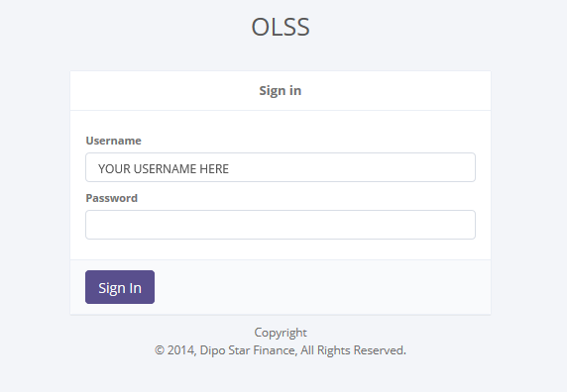

1. Connecting the system over browser

## 1.2 Signing In

The application is secured by login to prevent unauthorized access foremost but also each person’s login is combined with a different set of functions that can be accessed. For example any employee can see his/her profile, but not that of another employee, or only a few management staff are entrusted with processing data. So your login serves the system as a checkpoint to analyze what can be displayed and based on that check it will show only features and data you are allowed to see.

After you type the application URL you will get to the Login Window as shown above that secures the access from unauthorized access and is a checkpoint for your access privileges. In that window you type in your Username and Password, which was given to you by the administrator:

1. Start with User Name

User Name is a text field; in order to make an entry simply click your mouse in the respective field, and start typing the information.

1. Continue with Password

Password is also a text field, follow same steps as above described for User Name to enter your password, e.g. ‘demo’. For security reasons the password will not be shown in the letter you type in but with dots or stars:

After entering your user name and password the whole screen on your PC would look like this (note that your company may have implemented a different design, but you should still be able to locate the User Name and Password boxes as well as the Sign in button:



1. Signing the system on the Sign in Screen

Click the “Sign in” button underneath the password field (marked red in the above illustration), or hit again the ‘Enter’ button on your keyboard to access the application and its features. When entering the application you will see the following (depend on what you allowed to see):

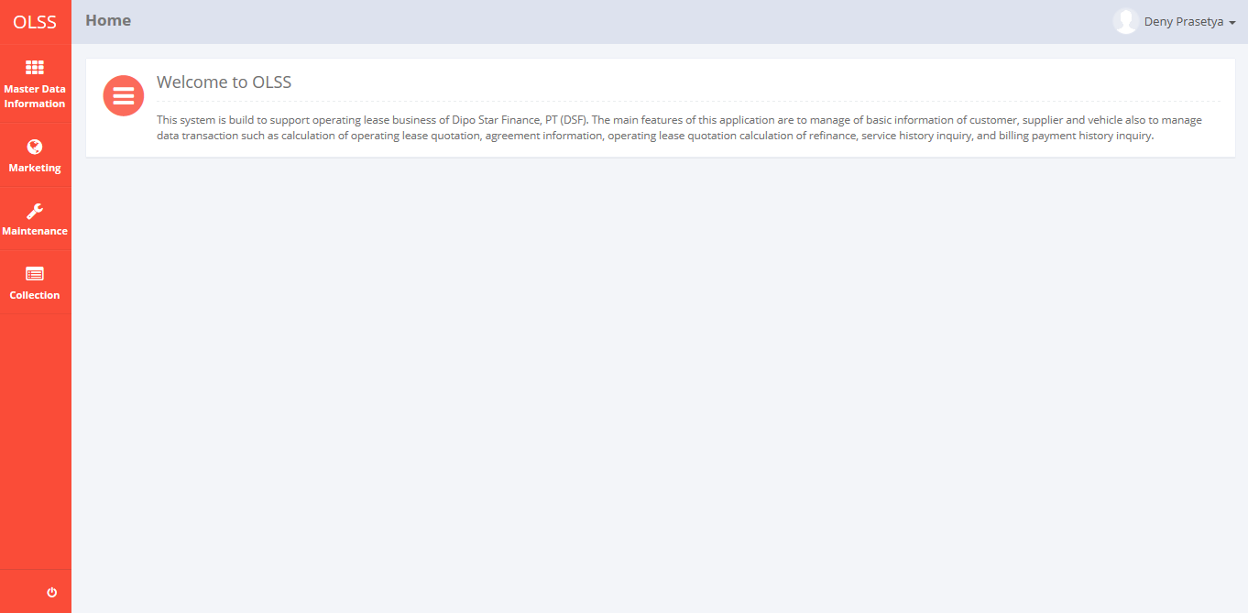

1. Home screen

**Forgot your password?**

Before we continue with the application and its functions, if you have forgetting your password, you can contact technical support or your assistance.

# 2. Master Data Module

Operating Lease Support System includes Master Data Module features; Customer Information, Supplier Information, and Product Information. All features will be described in the subsequent sections. The Master Data Information menu of Operating Lease Support System serves as the basic access to master data information and records of all data. With the master data menu, you will be able to access all of master data information, including information that will be adjusted through other features of Operating Lease Support System.

Additionally you can add new records, edit existing records, view detail and also filter specific records based on columns by writing a keyword on the search field. The features and data contained in your Operating Lease Support System menu are limited by your security and data authorization settings so you may not be able to access all features.

## 2.1 Customer Information

The customer information feature supports the management of all data related to a customer including basic information, corporate information, financial information, credit information, owned product information, detail of product and so on.

Although each user can draft, save changes, submit, and view their respective data; activation and deactivation of them will conducted by authorized super users only. Since the manager or supervisor will do the activation, user will have to contact them in order to activate/deactivate the records. Only authorized user, such as company manager or supervisor can changes all status (draft, submitted, active, inactive) of their information or records by using the system.

To enter in customer information data, click sub menu ‘Customer Information’ in Master Data Information.

When first entering the Customer Information module, user will see a list of customers that already recorded in the system. The main page of employee list is shown in picture below.

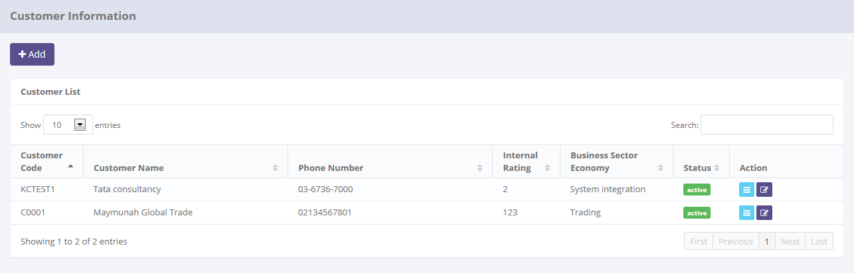

Click here to add new records.

Pick the number of records, to filter number of records in the list.

Click here to do some action to this record such as edit and see a data detail.

Enter here to filter the specific records.

1. Main Page of Customer List

Only authorized users have access to all customer information in order to keep them up to date. The screen above appears after you select a record from the customer list page by clicking the action buttons as follows:

1.  , on the rightmost column. Or,
2. , on the top-left of the customer list screen.

In the customer information module provides several functions:

1. View detail of customer information and/or change status of customer records.
2. Filter and sort function.
3. Add new customer, within save as draft and/or submit.
4. Modify this customer’s information; keep them up-to-date.

In the Customer Information module, the records will have several step of status when proceed by user. At the first time, when new customer added by user, the status will be saved as . After saved, the records can be submitted by user and the status will be set as . If records have been submitted, it can be activated by authorized user, then the status will be set as .

In special cases, if the authorized user want to inactive customer records, he/she can do some procedure to  the records, and the status will be . And also if the authorized user want the records changes by the members, they can the record, then automatically the status of the records will be changes to .

### 2.1.1 Customer Detail

To enter in customer information data, click sub menu ‘Customer Information’ in Master Data Information.

When first entering the Customer Information module, user will see a list of customers that already recorded in the system. The main page of employee list is shown in picture below.



Click here to view this customer’s information data.

1. Main Page of Customer Information

This screen appears after you select a record from the customer list page by clicking the action button , on the rightmost column.

Once the view detail screen opened, there are 4 buttons that can be performed on the screen as follows:

1. , on the top-left corner of the screen.
2. , on the bottom-left corner of the screen. Only for authorized user. It will be displayed if status is **active**.
3. , on the bottom-left corner of the screen. Only for authorized user. It will be be displayed if status is **inactive**.
4. , on the bottom-left corner of the screen. Only for authorized user. It will be displayed if status is **active**.

Once the view detail screen opens, all of information related to customer in the system will be able to be seen. See the picture below:

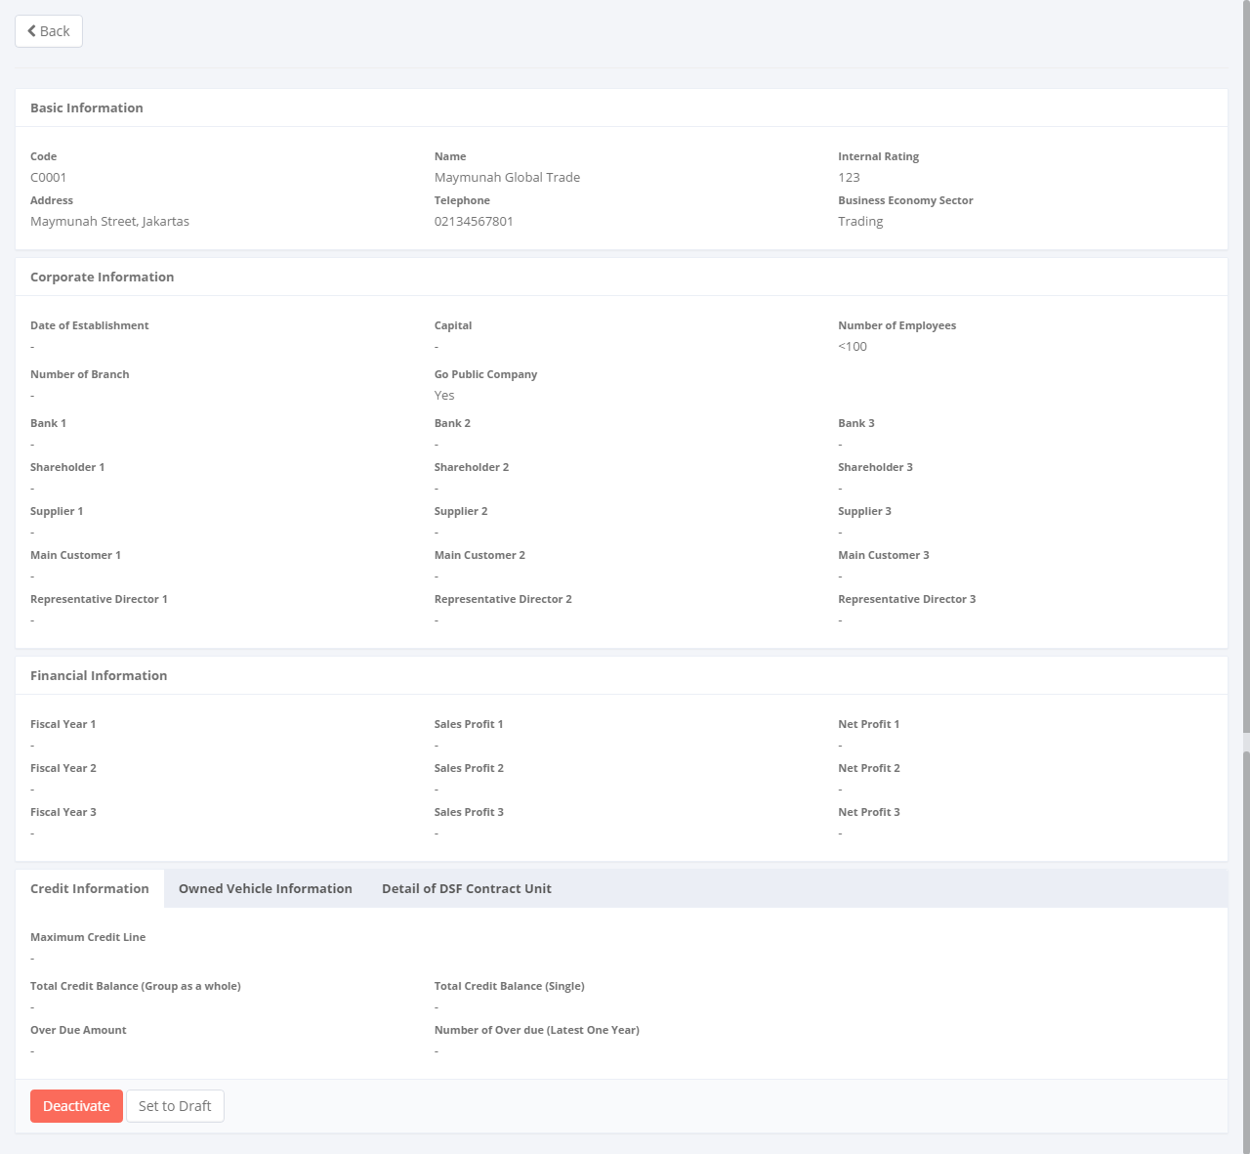

Return to the previous page

Changes a status of product record

1. Customer Detail

As mentioned above on the Customer Information module, user will see a list of customers. Here you can see the detail information related with customers, such as; basic information, corporate information, financial information, credit information, owned product information, detail of product and so on.

If you are authorized users, you can change record status by clicking **Activate** button, and in other case you can also changes the record status to **inactive** by clicking **Deactive** button, but make sure you actually want to deactive because the records can’t used for the transaction process in another modules.

In special case, if you a authorized user you can ask your member to update a data within clicking **Set to Draft** button. After clicking **Set to Draft** button, that‘ll give the permission for the user to update the record. You also have a **Back** button, which redirect you to the previous page, customer information page.

### 2.1.2 Filter and Sort Customer

To enter in customer information data, click sub menu ‘Customer Information’ in Master Data Information.

When first entering the Customer Information module, user will see a list of customers that already recorded in the system. The main page of employee list is shown in picture below.



Pick the number of records, to filter number of records in the list.

Click on table header, to sort a record per columns in the list.

Enter here to filter the specific records.

1. Main Page of Customer Information

To filter the records there are two categories as follows:

* + 1. To sort the record by column, user can click  column title on the table header.
    2. Filter the number of records. User can select the number of records that want to be showed by picking this feature on the screen. If the records have been filtered based on number, the amount of records that will be shown is same as the selected number. For example if you want to display 10 customer records, you can select 10.
    3. Filter the records with the specific information. You can do it by entering the keywords on the  field. For example, you can enter name of customer on the **search field**, and then press **Enter** button on the keyboard. See the picture below:

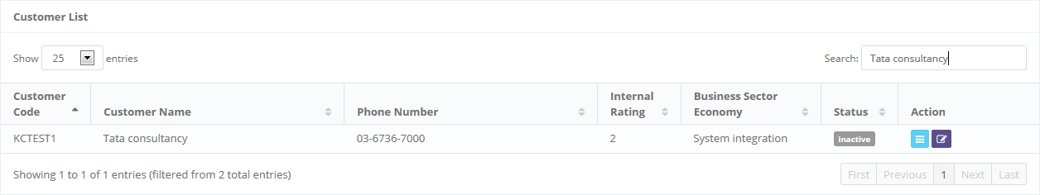

1. Customer List

### 2.1.3 Add New Customer

To enter in customer information data, click sub menu ‘Customer Information’ in Master Data Information.

When first entering the Customer Information module, user will see a list of customers that already recorded in the system. The main page of employee list is shown in picture below.



Click here to add new records.

1. Main Page of Customer Information

This screen appears after you select a record from the customer list page by clicking the action button , on top-left screen. To enter a data you can utilize a screen show below.

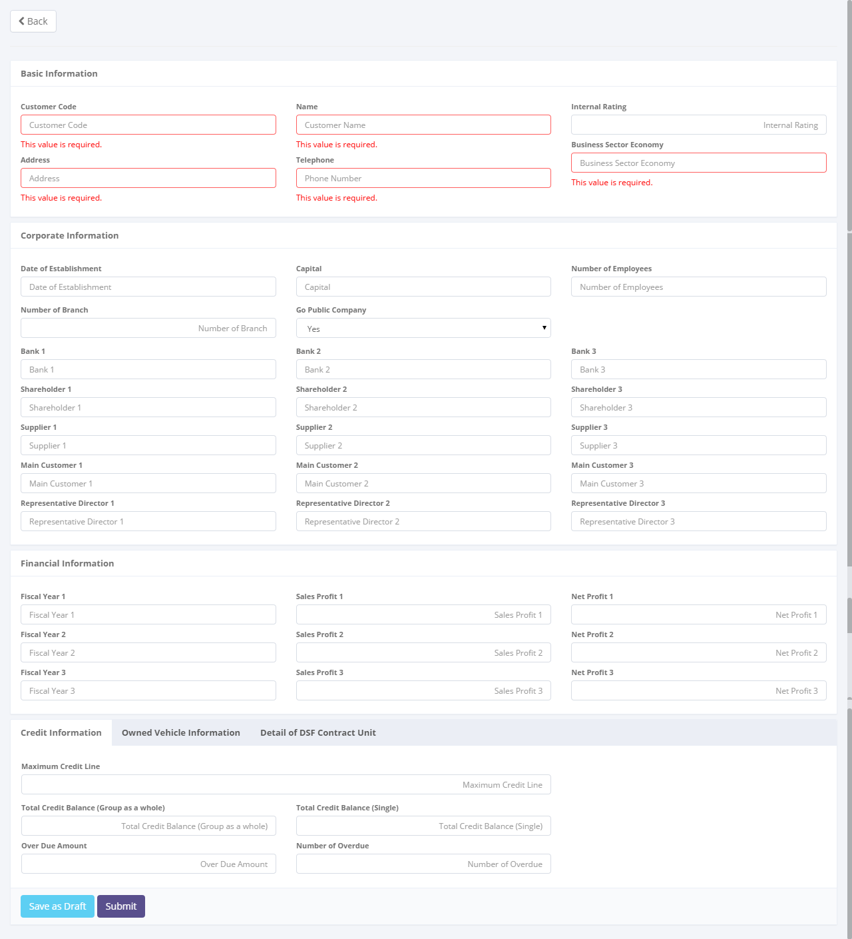

Return back to the previous page

To **Save as Draft** and **Submit** a customer record

1. Add New Customer

Once the Add New Customer screen opens, there are 3 buttons that will be displayed on the screen as follows:

1. , on the top-left corner of the screen.
2.  , on the bottom-left corner of the screen.
3. , on the bottom-left corner of the screen.

If data already entered on the screen, user can save a data on the system by clicking **Save as Draft** button, or **Submit** button. Ensure that you actually want to **Submit** a record, because the records can’t be reserved and update after submitted by user. For authorized user they still can update the data after submitted. But don’t be afraid, if you don’t have an authorization, data still can be updated as long as draft.

There are 5 mandatory fields that should be inputted including; customer code, customer name, customer address, customer telephone, and so on. It can’t leave as blanks. If blanks, system will notified it after you clicking **Save as Draft** or **Submit** button. After clicking **Save as Draft** or **Submit** button, system will notified if it success or failed to save or submit a data. You also have a **Back** button, which redirect you to the previous page, customer information page.

### 2.1.4 Edit Customer

To enter in customer information data, click sub menu ‘Customer Information’ in Master Data Information.

When first entering the Customer Information module, user will see a list of customers that already recorded in the system. The main page of employee list is shown in picture below.



Click here to update a record.

1. Main Page of Customer Information

This screen appears after you select a record from the customer list page by clicking the action button , on top-left screen. To enter a data you can utilize a screen show below:

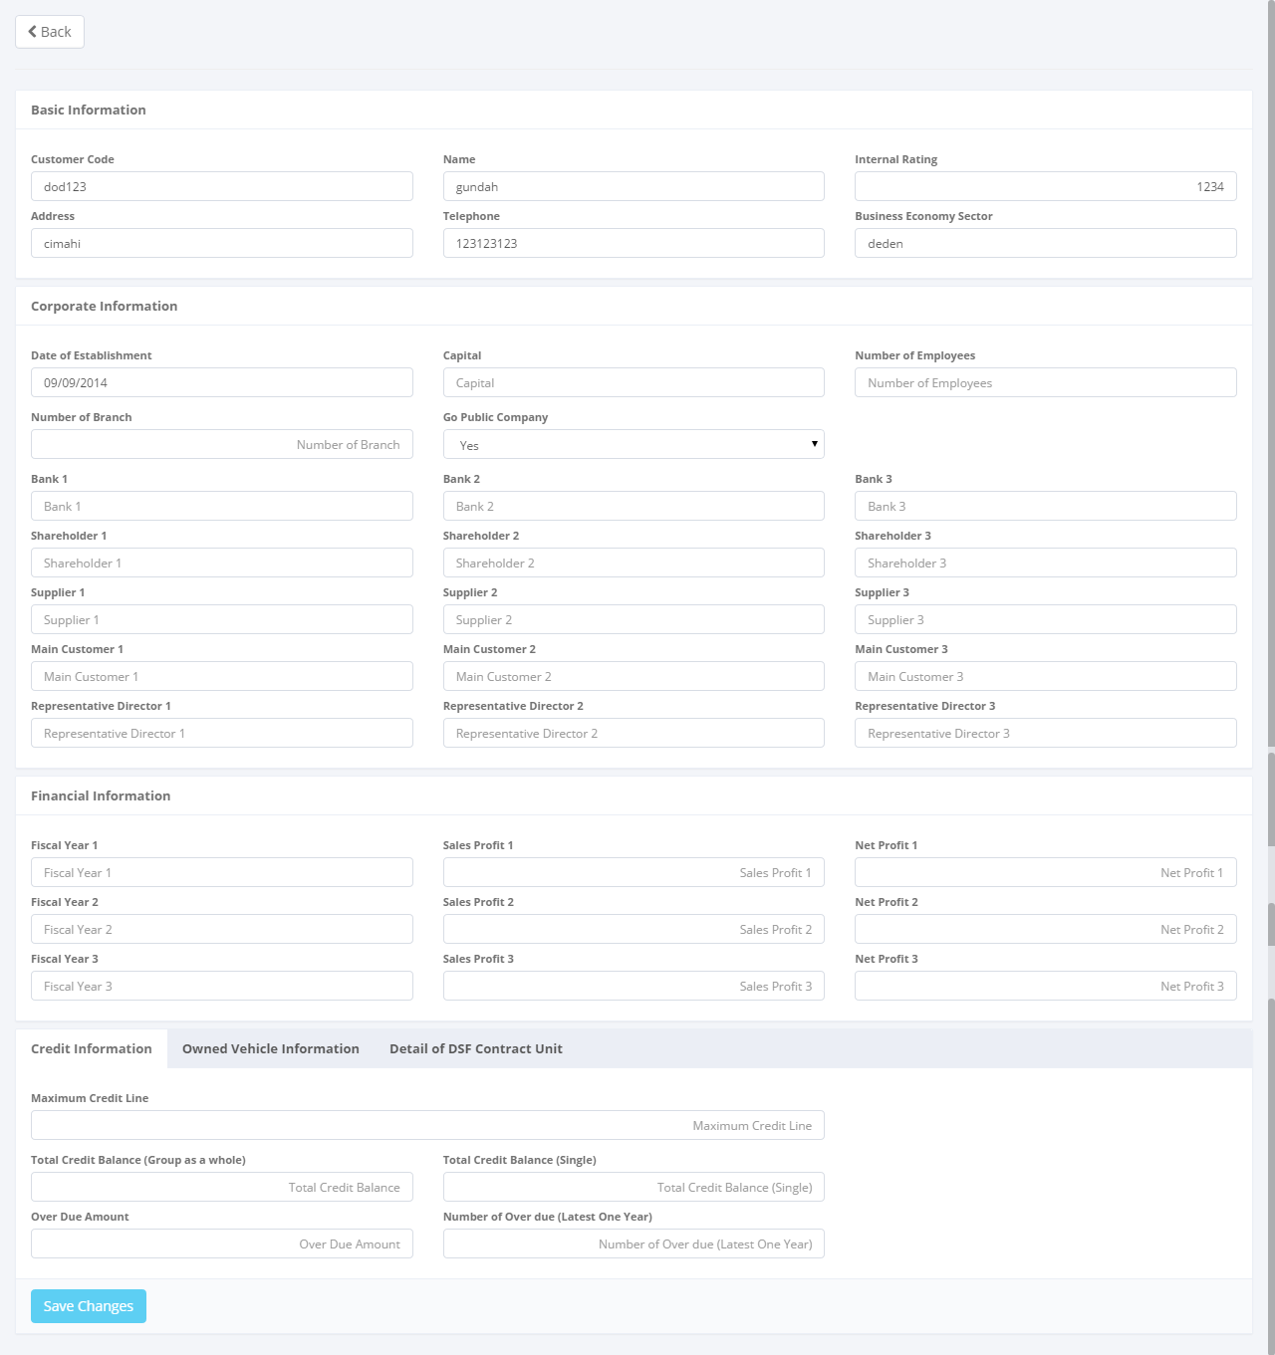

Return back to the previous page

To **Save Changes** a customer record

1. Edit Customer

.

Once the Add New Customer screen opened, there are 3 buttons that will be displayed on the screen as follows:

1. , on the top-left corner of the screen.
2.  , on the bottom-left corner of the screen.
3. , on the bottom-left corner of the screen.

If data already changes on the screen, user can save a data on the system by clicking **Save Changes** button, or **Submit** button. Ensure that you actually want to **Submit** a record, because the records can’t be reserved and update after submitted by user. For authorized user, they still can update the data after submitted. But don’t be afraid if you don’t have an authorization, data still can be updated as long as draft.

There are 5 mandatory fields that should be inputted including; customer code, customer name, customer address, customer telephone, and so on. It can’t leave as blanks. If blanks, system will notified it after you clicking **Save Changes** or **Submit** button. After clicking **Save Changes** or **Submit** button, system will notified if it success or failed to save or submit a data. You also have a **Back** button, which redirect you to the previous page, customer information page.

## 2.2 Supplier Information

The Supplier Information feature supports the management of all data related to a supplier including basic information, corporate information, payment information and so on.

Although each user can draft, save changes, submit, and view their respective data; activation and deactivation of them will conducted by authorized super users only. Since the manager or supervisor will do the activation, user will have to contact them in order to activate/deactivate the records. Only authorized user, such as company manager or supervisor can changes all status (draft, submitted, active, inactive) of their information or records by using the system.

To enter in supplier Information data, click sub menu ‘Supplier Information’ in Master Data Information.

When first entering the Supplier Information module user will see a list of suppliers that already recorded in the system. The main page of employee list is shown in picture below.

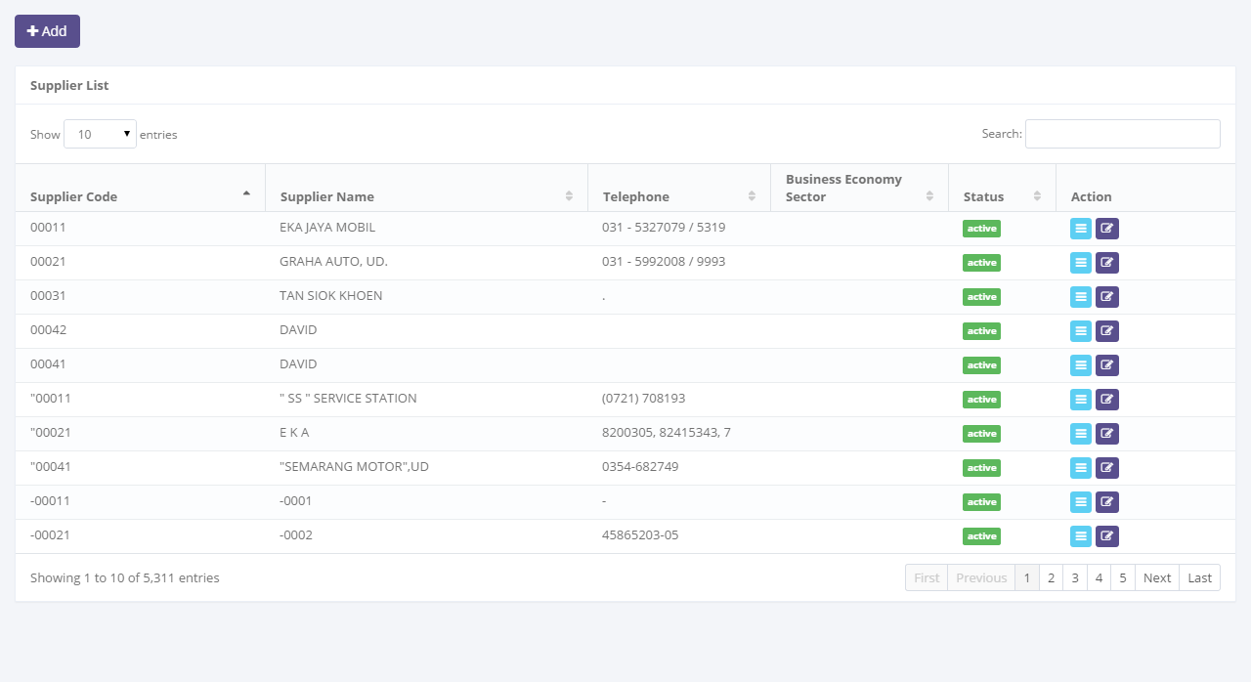

Click here to add new records.

Enter here to filter the specific records.

Pick the number of records, to filter number of records in the list.

Click here to do some action to this record such as edit and see a data detail.

1. Main Page of Supplier List

Only authorized user have access to all supplier information in order to keep them up to date. The screen above appears after you select a record from the supplier list page by clicking the action buttons as follows:

1.  , on the rightmost column. Or,
2. , on the top-left of the supplier list screen.

Supplier Information module provides several functions:

1. View detail of supplier information and/or change status of supplier records.
2. Filter and sort function.
3. Add new supplier, within save as draft and/or submit.
4. Modify this supplier’s information; keep them up-to-date.

In the Supplier Information module, the records will have several step of status when proceed by user. At the first time, when new supplier added by user, the status will be saved as . After saved, the records can be submitted by user and the status will be set as . If records have been submitted, it can be activated by authorized user, then the status will be set as .

In special cases, if the authorized user want to inactive supplier records, he/she can do some procedure to  the records, and the status will be . And also if the authorized user want the records changes by the members, they can  the record, then automatically the status records will be changes to .

### 2.2.1 Supplier Detail

To enter in supplier information data, click sub menu ‘Supplier Information’ in Master Data Information.

When first entering the Supplier Information module, user will see a list of suppliers that already recorded in the system. The main page of employee list is shown in picture below.



Click here to view this supplier’s information data.

1. Main Page of Supplier Information

This screen appears after you select a record from the supplier list page by clicking the action button, on the rightmost column.

Once the View Detail Screen opens, there are 4 buttons that can be performed on the screen as follows:

1. , on the top-left corner of the screen.
2. , on the bottom-left corner of the screen. Only for authorized user. It will be displayed if status is **active**.
3. , on the bottom-left corner of the screen. Only for authorized user. It will be be displayed if status is **inactive**.
4. , on the bottom-left corner of the screen. Only for authorized user. It will be displayed if status is **active**.

Once the view detail screen opens, all of information related to supplier in the system will be able to be seen. See the picture below:

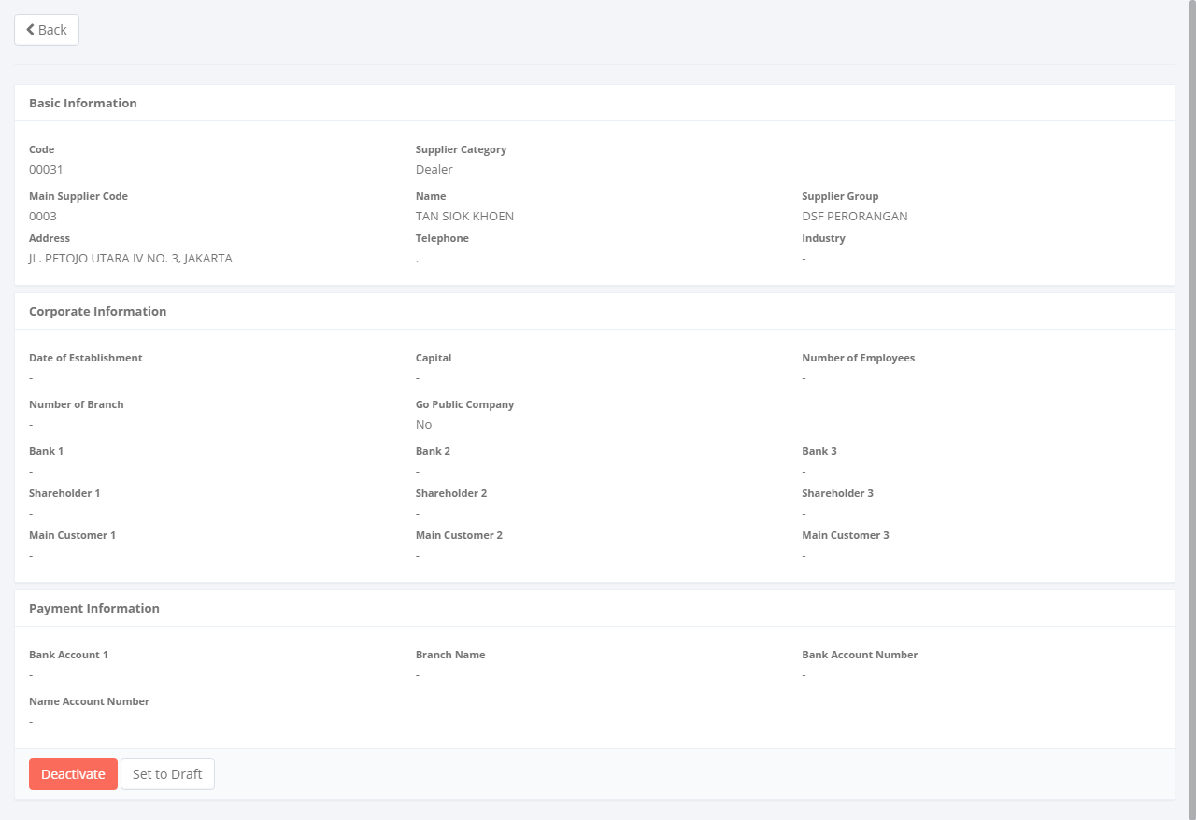

Return back to the previous page

To changes a status of supplier record

1. Supplier Detail

As mentioned above on the Supplier Information module, user will see a list of suppliers. Here you can see the detail information related with suppliers, such as; basic information, corporate information, financial information, credit information, owned product information, detail of product and so on.

If you are authorized user, you can change record status by clicking **Activate** button, and in other case you can also changes the record status to **inactive** by clicking **Deactive** button, but make sure you actually want to deactive because the records can’t be used for the transaction process in another modules.

In special case, if you are authorized user you may can ask your member to update a data within clicking **Set to Draft** button. After clicking **Set to Draft** button, that’ll give the permission for the user to update the record. You also have a **Back** button, which redirect you to the previous page, supplier information page.

### 2.2.2 Filter and Sort Supplier

To enter in supplier Information data, click sub menu ‘Supplier Information’ in Master Data Information.

When first entering the Supplier Information module, user will see a list of suppliers that already recorded in the system. The main page of employee list is shown in picture below.

Enter here to filter the specific records.



Pick the number of records, to filter number of records in the list.

Click on table header, to sort a record per columns in the list.

1. Main Page of Supplier Information

To filter the records there are two categories as follows:

* + 1. To sort the record by column, user can click  column title on the table header.
    2. Filter the number of records. User can select the number of records that want to be showed by picking this feature on the screen. If the records have been filtered based on number, the amount of records that will be shown is same as the selected number. For example if you want to display 10 supplier records, you can select 10.
    3. Filter the records with the specific information. You can do it by entering the keywords on the  field. For example, you can enter name of supplier on the **search field**, and then press **Enter** button on the keyboard. See the picture below:



1. Supplier List

### 2.2.3 Add New Supplier

To enter in supplier Information data, click sub menu ‘Supplier Information’ in Master Data Information.

When first entering the Supplier Information module, user will see a list of all suppliers that already recorded in the system. The main page of employee list is shown in picture below.



Click here to add new records.

1. Main Page of Supplier Information

This screen appears after you select a record from the supplier list page by clicking the action button, on top-left screen. To enter a data you can utilize a screen show below.

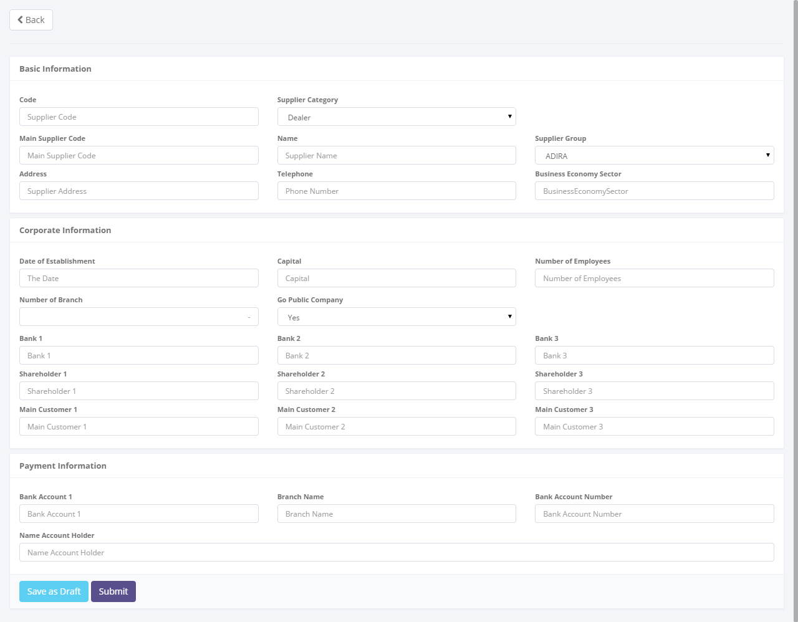

Return back to the previous page

To **Save as Draft** and **Submit** a supplier record

1. Add New Supplier

Once the Add New Supplier screen opens, there are 3 buttons that will be displayed on the screen as follows:

1. , on the top-left corner of the screen.
2.  , on the bottom-left corner of the screen.
3. , on the bottom-left corner of the screen.

If data already entered on the screen, user can save a data on the system by clicking **Save as Draft** or **Submit** button. Ensure that you actually want to **Submit** a record, because the records can’t be reserved and update after submitted by user. For authorized user, they still can be update the data after submitted. But don’t be afraid, if you don’t have an authorization, data still can be updated as long as draft.

There are 5 mandatory fields that should be inputted including; supplier code, supplier name, supplier address, supplier telephone, and so on. It can’t leave as blanks. If blanks, system will notified it after you clicking **Save as Draft** or **Submit** button. After clicking **Save as Draft** or **Submit** button, system will notified if it success or failed to save or submit a data. You also have a **Back** button, which redirect you to the previous page, supplier information page.

### 2.2.4 Edit Supplier

To enter in supplier information data, click sub menu ‘Supplier Information’ in Master Data Information.

When first entering the Supplier Information module, user will see a list of all suppliers that already recorded in the system. The main page of employee list is shown in picture below.



Click here to update a record.

1. Main Page of Supplier Information

This screen appears after you select a record from the supplier list page by clicking the action button, on top-left screen. To enter a data you can utilize a screen show below.

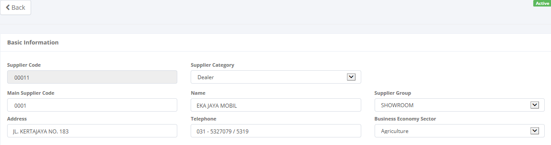

Return back to the previous page

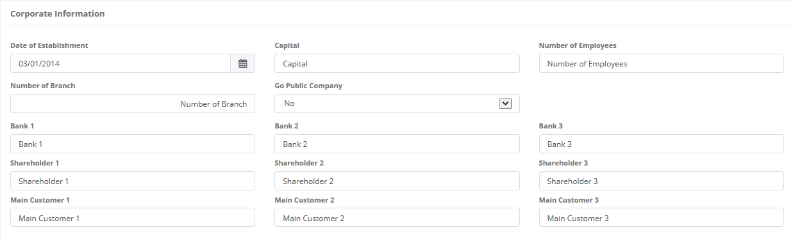

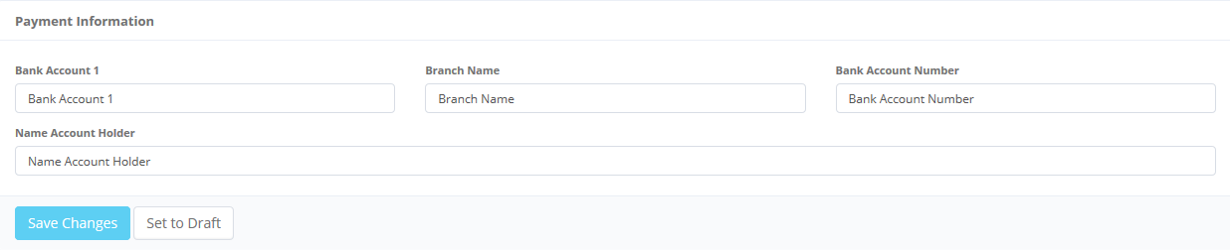

To **Save Changes** a supplier record

1. Edit Supplier

Once the Add New Supplier screen opens, there are 3 buttons that will be displayed on the screen as follows:

1. , on the top-left corner of the screen.
2.  , on the bottom-left corner of the screen.
3. , on the bottom-left corner of the screen.

If data already changes on the screen, user can save a data on the system by clicking **Save Changes** or **Submit** button. Ensure that you actually want to **Submit** a record, because the records can’t be reserved and update after submitted by user. For authorized user, they still can update the data after submitted. But don’t be afraid if you don’t have an authorization, data still can be updated as long as draft.

There are 5 mandatory fields that should be inputted including; supplier code, supplier name, supplier address, supplier telephone, and so on. It can’t leave as blanks. If blanks, system will notified it after clicking **Save Changes** or **Submit** button. After clicking **Save Changes** or **Submit** button, system will notified if it success or failed to save or submit a data. You also have a **Back** button, which redirect you to the previous page, supplier information page.

## 2.3 Product Information

The Product information feature supports the management of all data related to a product including product basic information, maintenance information, and so on.

Although each user can draft, save changes, submit, and view their respective data; activation, and deactivation of them will conducted by authorized super user only. Since the manager or supervisor will do the activation, user will have to contact them in order to activate/deactivate the records. Only authorized user, such as company manager or supervisor can changes all status (draft, submitted, active, inactive) of their information or records by using the system.

To enter in product information data, click sub menu ‘Product Information’ in Master Data Information.

When first entering the Product Information module user will see a list of all products that already recorded in the system. The main page of employee list is shown in picture below.

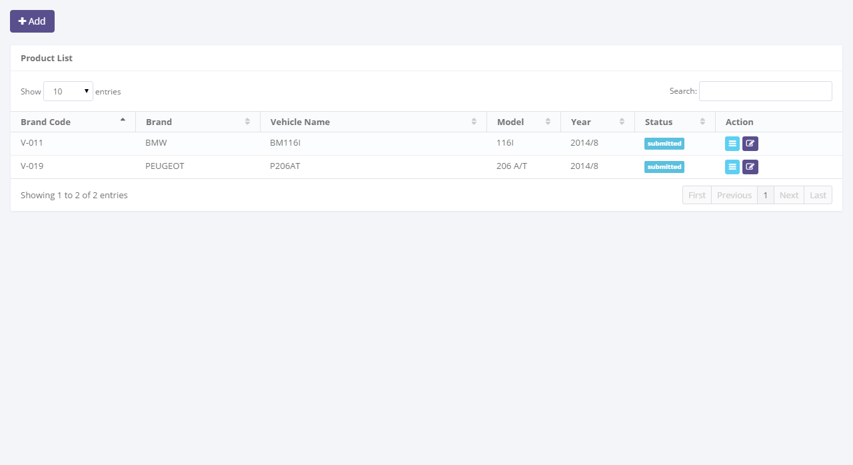

Click here to add new records.

Enter here to filter the specific records.

Click here to do some action to this record such as edit and see a data detail.

Pick the number of records, to filter number of records in the list.

1. Main Page of Product List

Only authorized users have access to all product information in order to keep them up to date. The screen above appears after you select a record from the product list page by clicking the action buttons as follows:

1.  , on the rightmost column. Or,
2. , on the top-left of the Product list screen.

In the Product Information module provides several functions:

1. View detail of Product information and/or change status of product records.
2. Filter and sort function.
3. Add new Product, within save as draft and/or submit.
4. Modify this Product’s information; keep them up-to-date.

In the Product Information module, the records will have several step of status when proceed by user. At the first time, when new product added by user, the status will be saved as . After saved, the records can be submitted by user and the status will be set as . If records have been submitted, it can be activated by authorized user, then the status will be set as .

In special cases, if the authorized user want to inactive product records, he/she can do some procedure to  the records, and the status will be . And also if the authorized user want the records changes by the members, they can  the record, then automatically the status records will be changes to .

### 2.3.1 Product Detail

To enter in product information data, click sub menu ‘Product Information’ in Master Data Information.

When first entering the Product Information module user will see a list of all products that already recorded in the system. The main page of employee list is shown in picture below.



Click here to view this supplier’s information data.

1. Main Page of Product Information

This screen appears after you select a record from the product list page by clicking the action button, on the rightmost column.

Once the View Detail Screen opens, there are 4 buttons that can be performed on the screen as follows:

1. , on the top-left corner of the screen.
2.  , on the bottom-left corner of the screen. Only for authorized user. It will be displayed if status is **active**.
3. , on the bottom-left corner of the screen. Only for authorized user. It will be be displayed if status is **inactive**.
4. , on the bottom-left corner of the screen. Only for authorized user. It will be be displayed if status is **active**.

Once the view detail screen opens, all of information related to Product in the system will be able to be seen. See the picture below:

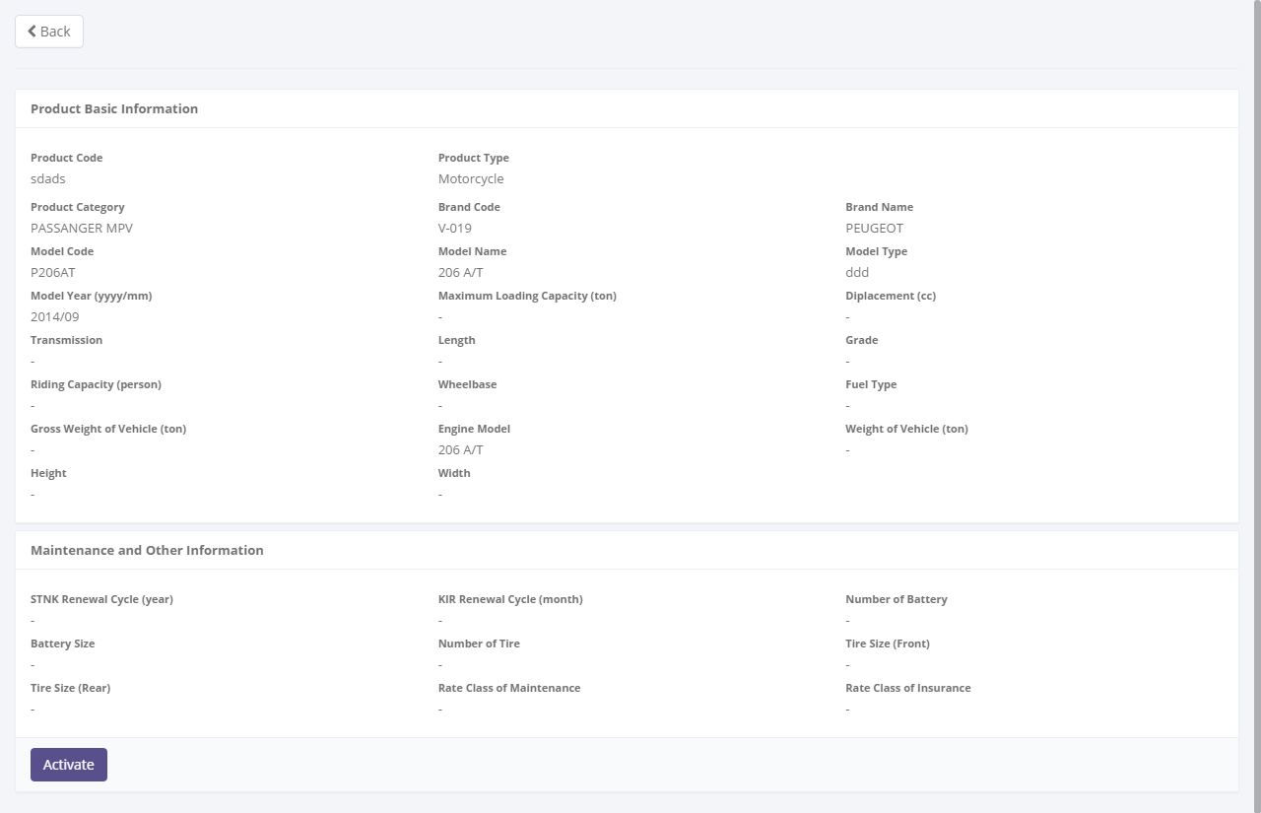

Return back to the previous page

To changes a status of supplier record

1. Product Detail

As mentioned above on the Product Information module users see a list of all products. Here you can see the detail information related with products, such as; basic information, corporate information, financial information, credit information, owned product information, detail of product and so on.

If you are authorized user, you can change record status by clicking **Activate** button, and in other case you can also changes the record status to **inactive** by clicking **Deactive** button, but make sure you actually want to deactive because the records can’t be used for the transaction process in another modules.

In special case, if you as authorized user you may can ask your member to update a data within clicking **Set to Draft** button. After clicking **Set to Draft** button, that’ll give the permission for the user to update the record. You also have a **Back** button, which redirect you to the previous page, product information page.

### 2.3.2 Filter and Sort Product’s

To enter in product information data, click sub menu ‘Product Information’ in Master Data Information.

When first entering the Product Information module user will see a list of all products that already recorded in the system. The main page of employee list is shown in picture below.



Pick the number of records, to filter number of records in the list.

Click on table header, to sort a record per columns in the list.

Enter here to filter the specific records.

Enter here to filter the specific records.

Click on table header, to sort a record per columns in the list.

1. Main Page of Product Information

To filter the records there are two categories are as follows:

1. To sort the record by column, user can click  column title on the table header.
2. Filter the number of records. User can select the number by picking this feature on the screen. If the records have been filtered based on number, the amount of records that will be shown is same as the selected. For example if you want to display 10 product record, you can select 10.
3. Filter the records with the specific information. You can do it by entering the keywords on the  field. For example, you can enter name of product on the **search field**, and then press an **Enter** button on the keyboard. See the picture below:



1. Product List

### 2.3.3 Add New Product

To enter in product information data, click sub menu ‘Product Information’ in Master Data Information.

When first entering the Product Information module user will see a list of all products that already recorded in the system. The main page of employee list is shown in picture below.



Click here to add new records.

1. Main Page of Product Information

This screen appears after you select a record from the product list page by clicking the action button, on top-left screen. To enter a data you can utilize a screen show below.

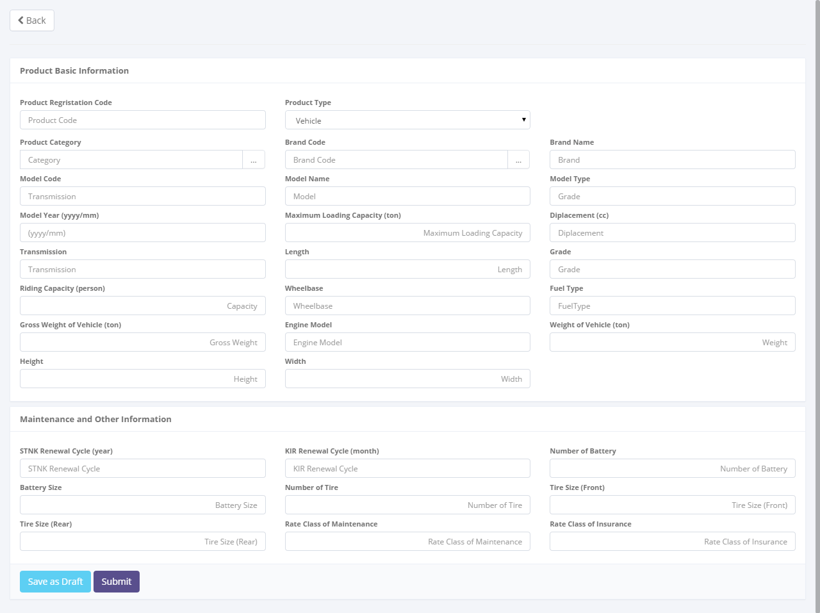

Return back to the previous page

To **Save as Draft** and **Submit** a product record

1. Add New Product

Once the Add New Product screen opens, there are 3 buttons that will be displayed on the screen as follows:

1. , on the top-left corner of the screen.
2.  , on the bottom-left corner of the screen.
3. , on the bottom-left corner of the screen.

If data already entered on the screen, user can save a data on the system by clicking **Save as Draft** or **Submit** button. Ensure that you actually want to **Submit** a record, because the records can’t be reserved and update after submitted by user. For authorized user, they still can be update the data after submitted. But don’t be afraid, if you don’t have an authorization, data still can be updated as long as draft.

There are 5 mandatory fields that should be inputted including; product code, product name, product address, product telephone, and so on. It can’t leave as blanks. If blanks, system will notified it when you clicking **Save as Draft** or **Submit** button. After clicking **Save as Draft** or **Submit** button, system will notified if it success or failed to save or submit a data. You also have a **Back** button, which redirect you to the previous page, Product information page.

To **Save as Draft** and **Submit** a customer record

### 2.3.4 Edit Product

To enter in product information data, click sub menu ‘Product Information’ in Master Data Information.

When first entering the Product Information module user will see a list of all products that already recorded in the system. The main page of employee list is shown in picture below.



Click here to update a record.

1. Main Page of Product Information

This screen appears after you select a record from the product list page by clicking the action button, on top-left screen. To enter a data you can utilize a screen show below.

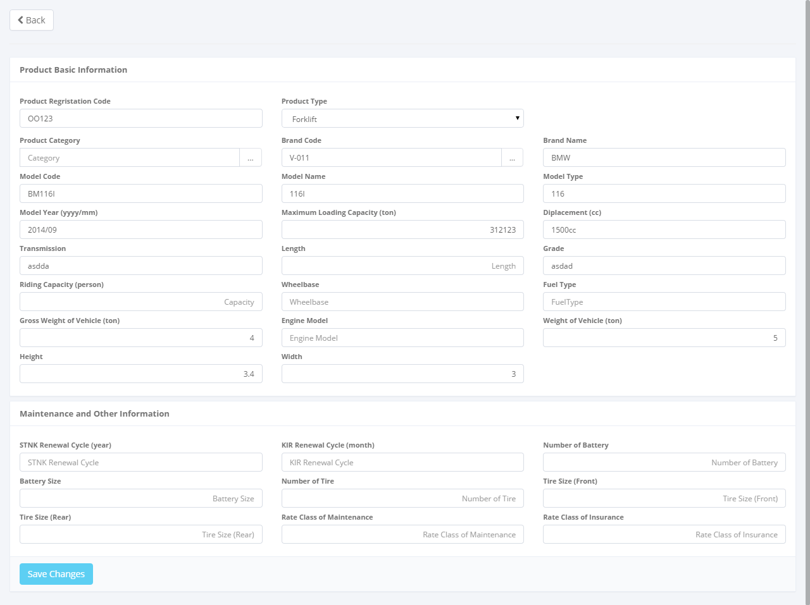

To **Save Changes** a product record

Return back to the previous page

1. Edit Product

Once the Add New Product screen opens, there are 3 buttons that will be displayed on the screen as follows:

1. , on the top-left corner of the screen.
2.  , on the bottom-left corner of the screen.
3. , on the bottom-left corner of the screen.

If data already changes on the screen, user can save a data on the system by clicking **Save Changes** or **Submit** button. Ensure that you actually want to **Submit** a record, because the records can’t be reserved and update after submitted by user. For authorized user, they still can update after submitted. But don’t be afraid if you don’t have an authorization, data still can be updated as long as draft.

There are 5 mandatory fields that should be inputted including; product code, product name, product address, product telephone, and so on. It can’t leave as blanks. If blanks, system will notified it after clicking **Save Changes** or **Submit** button. After clicking **Save Changes** or **Submit** button, system will notified if it success or failed to save or submit a data. You also have a **Back** button, which redirect you to the previous page, product information page.

# 3. Marketing Module

Operating Lease Support System includes Marketing Module features; Calculation of Refinance, Quotation of Refinance, Calculation of Operating Lease, Quotation of Operating Lease, and Agreement Information Inquiry. All features will be described in the subsequent sections. The Marketing menu of Operating Lease Support System serves as the basic access to marketing module and records of all data. With the marketing menu, you will be able to utilize features of marketing module, including information that will be adjusted through other features of Operating Lease Support System.

Additionally you can enter a record, make changes, and inspect a detail record, and also filter specific records based on columns by writing a keyword on the search field. The features and data contained in your Operating Lease Support System menu are limited by your security and data authorization settings so you may not be able to access all features.

## 3.1 Calculation of Refinance

The Calculation of refinance is designed to facilitate and maintain the calculation process for refinance that had to be done manually before. The system simplifies the calculation process by filling out the input forms. This function are consist of several information, there are; agreement information, basic product information, and calculation information and so on. Although each user can draft, save changes, submit, and view their respective data, only authorized user, such as managers or supervisor can changes the status (draft, submitted, active, inactive) their information or records by using the system.

At the beginning, user can open calculation of refinance by clicking the ‘Calculation of Refinance’ on the list of Marketing menus. Once clicked the menus, system will display the Calculation of Refinance page. This page may show a calculation list, which is done inputted including status that processed by user. When opening the Calculation of Refinance page it may look as following:

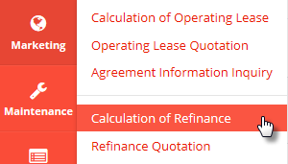

Click here to open Calculation of Refinance.

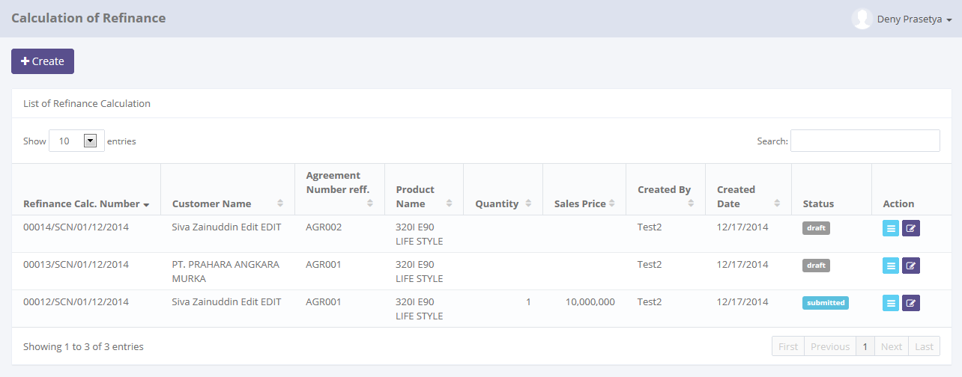

Click here to add new records.

Pick the number of records, to filter number of records in the list.

Click here to sort the records.

Click here to do some action to this record such as edit and see a data detail.

Enter here to filter the specific records.

1. Main Page of Calculation of Refinance

Only authorized user have access to all records in order to keep them up to date. This page provides following functions:

1. Create a calculation of refinance by opening ‘Create’ page. To open this page user can click , on the top-left of the list of refinance calculation.
2. Open details of calculation by click , on the rightmost column at the list.
3. Editing a calculation data using edit menu. User can click  on the rightmost column at the list.
4. Filter and sort a data that appears on the list. To do this function user can do as follows:
5. Click  to sort a record ascending or descending.
6. Filter a numbers of record by selecting .
7. Filter a records by input a keywords at .

Calculation of Refinance function will have some business rules for status when processing a data. The picture below is describing transition of status that performed by user when using this features. In this features, validation (validate and invalidate) process triggered on the refinance quotation module. If the quotation already validate, so the status of calculation will be valid too, and vice versa.

**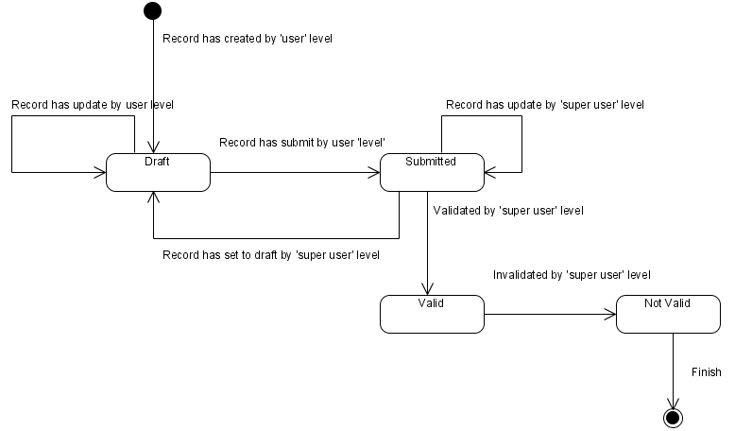**

1. Workflow of status on Calculation of Refinance

In the beginning, when new calculation created by user, the status will be saved as . After saved, the records can be submitted by user and the status will be changes to . Once it done, record can be validate by authorized user, then the status will be changes to . If the authorized user want the records changes by member, the authorized user can  the record, then the status records will be changes to  automatically.

In special cases, if the authorized user want records to be invalidate, they can do  process, and the status will be .

### 3.1.1 Details of Calculation of Refinance

To open details in Calculation of Refinance, click sub menu ‘Calculation of Refinance’ in Marketing module. Below is figure of main page of Calculation of Refinance:



Click here to Calculation of Refinance Details.

1. Main Page of Calculation of Refinance

Once user clicking , system will open details of calculation of refinance. This page displays all information related to calculations which have been inputted by user. When the details page opens it may look as follows:

Status of record

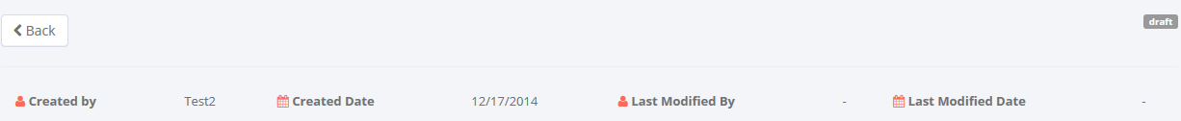

Audit rails

Return back to the previous page



Calculation of Refinance Header

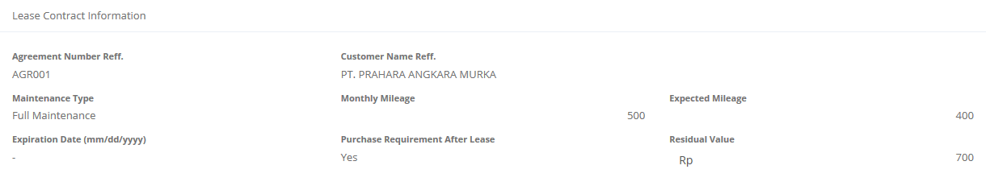

Agreement Basic Information

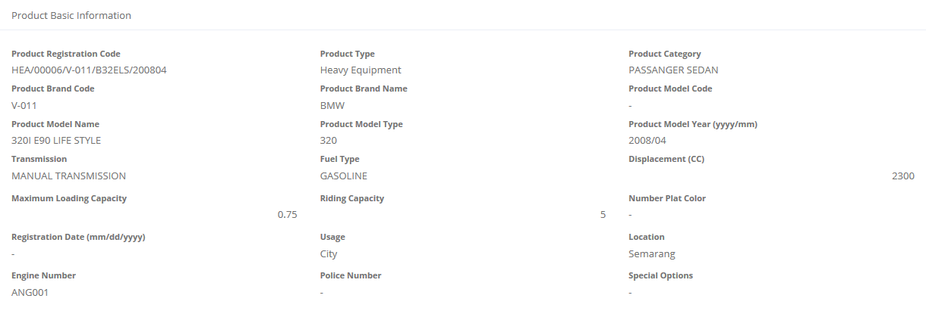

Product Basic Information

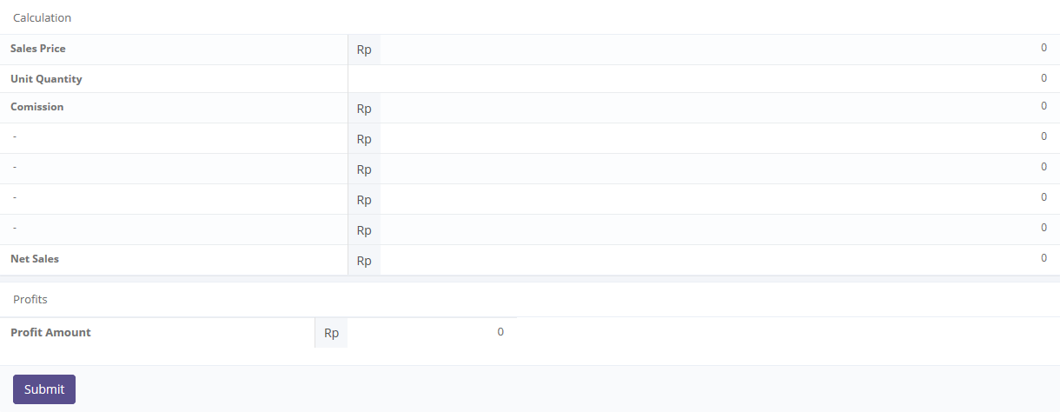

Calculation items

To update the record status

1. Details of Calculation of Refinance

Once the calculation has been created,  status is displayed on the top-right corner. If the data already confirm, user can submit the calculation by clicking . Once it done, system calculation status will be change to , then system will return back to main page of calculation of refinance (see picture 33). And also system will notify success/failure message like this:



1. Submit process notification

If user feels the calculation needs return back to draft, user can open details page of calculation (see picture 36). Once it opened,  status is displayed on the top-right corner. If submitted data already confirm, user can click  button, then system will return back to main page of Calculation of Refinance (see picture 32). And also system will notify success/failure message like this:



1. Set to draft process notification

As long as the calculation of refinance record still not validate\*), user can changes the status from draft to submitted or vice versa.

Notes:

\*) *Calculation of refinance can be validating if the record is . (see section 3.2 Refinance Quotation)*.

### 3.1.2 Filter and Sort Calculations of Refinance

To open details calculation of refinance, click sub menu ‘Customer Information’ in Marketing module. Below is figure of main page of Calculation of Refinance:



Pick the number of records, to filter number of records in the list.

Click column title, to sort a record per columns in the list.

Enter here to filter the specific records.

1. Main Page of Calculation of Refinance

To filter the records there are two categories as follows:

1. To sort the record by column, user can click  column title on the table header.
2. Filter the number of records. User can select the number by picking this feature on the screen. If the records have been filtered based on number, the amount of records that will be shown is same as the selected. For example if you want to display 10 product record, you can select 10.
3. Filter the records with the specific information. You can do it by entering the keywords on the  field. For example, you can enter name of product on the **search field**, and then press an **Enter** button on the keyboard. See the picture below:

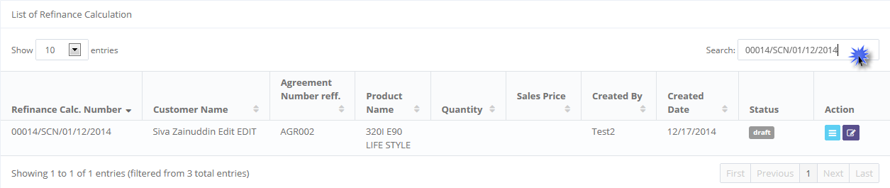

Keywords enter here

Result shows here

1. Filter and sort result on Main Page of Calculation of Refinance

### 3.1.3 Create New Calculation of Refinance

If user wants to create a new calculation, click  on the top-left corner of the main page of Calculation of Refinance (see picture 33.)

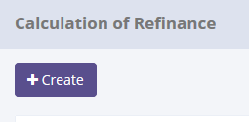

Click here to open Creates form

1. Create new button

When the Create form opens it may look as following:

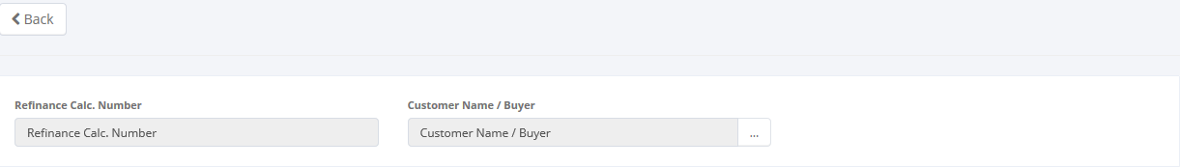

Calculation of Refinance Header

Click here to return to the main page of calculation of refinance

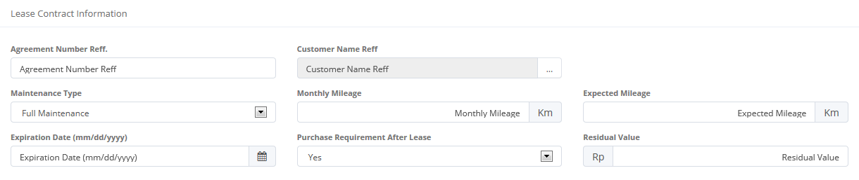

Agreement Basic Information

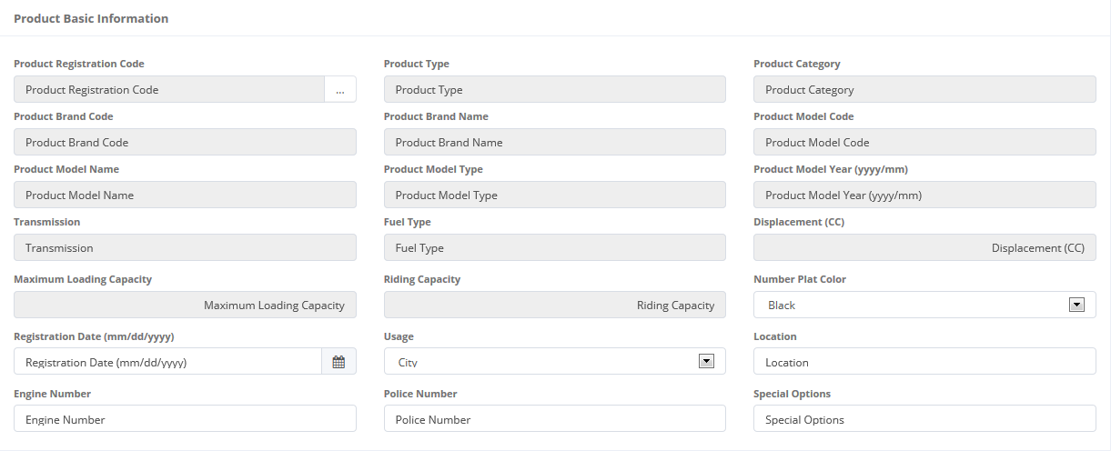

Product Basic Information

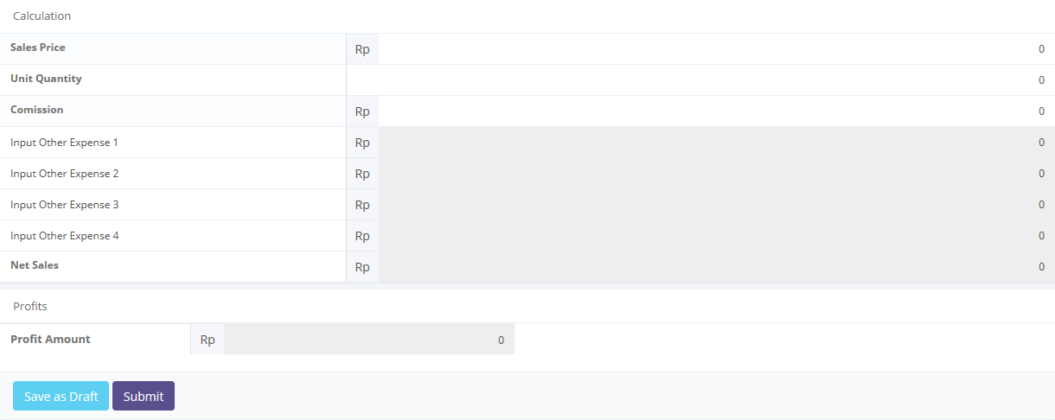

Calculation items

To save a data to Database status

1. Create new a Calculation of Refinance

Once the Add New Product screen opens, there are 3 buttons that will be displayed on the screen, are as follows:

1. , on the top-left corner of the screen.
2.  , on the bottom-left corner of the screen.
3. , on the bottom-left corner of the screen.

When creating a new calculation:

1. As default, Refinance Calculation number will be generated automatically.
2. The first field to be input is the Customer Name/Buyer. To enter its field, user can looking up a customer data then select the Customer Name (only one customer data can be selected). Once it done, Customer Name/Buyer field will be filled out automatically.

Click here to look up customer data status

Click here to look up a customer data status



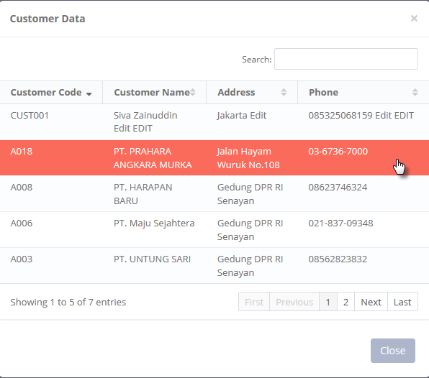

1. Customer data selection
2. After customer data selection, user can input a several data on Agreement Basic Information panel (see picture 39.) Please complete the fields on Agreement Basic Information. In this panel, there is Customer Name Ref. that should be input. To input Customer Name Ref., this is same scenario with the step point 2.

Click here to look up a customer data status





1. Customer data selection
2. On the Product Basic Information panel, user can input a several data (see picture 39.) Please complete the fields on Product Basic Information. In this panel, there Product Registration Code that should be input. To input Product Registration Code, users can look up a product data then select the Product Registration Code (only one product can be selected). Once it done, Product Registration Code field will be filled out automatically

Click here to look up customer data status



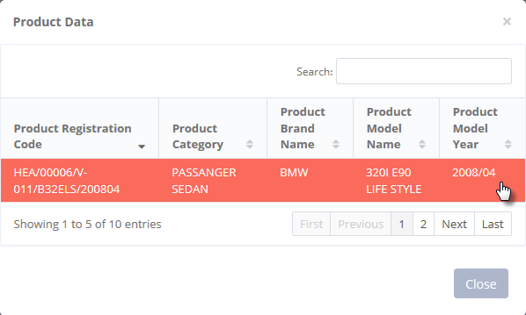

1. Product data selection
2. All the remaining fields in Product Basic Information panel and Calculation panel can be input manually.
3. If data already entered on the form, Net Sales field and Profits Amount will be calculated automatically.
4. User can save a data on the system by clicking **Save as Draft**, or **Submit** button. Ensure that you actually want to **Submit** a record, because the records cannot be reserved and update after submitted by user. For authorized user, they still can be updating after submitted. But don’t be afraid, if you don’t have an authorization, data still can be updated as long as draft. It can’t leave as blanks. If blanks, system will notified it after clicking **Save as Draft** button. After clicking **Save as Draft** button, or **Submit** button system will notified if success or failed to save or submit a data. You also have a **Back** button, to return back to main page screen.

To **Save as Draft** and **Submit** a customer record

### 3.1.4 Edit Calculation of Refinance Record

If user wants to edit a calculation of refinance record, click  on the left column of the records at the list of calculation (see picture 39.).

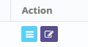

Click here to open Edits form

1. Create new button

When the Edit form opened, it may look as following:

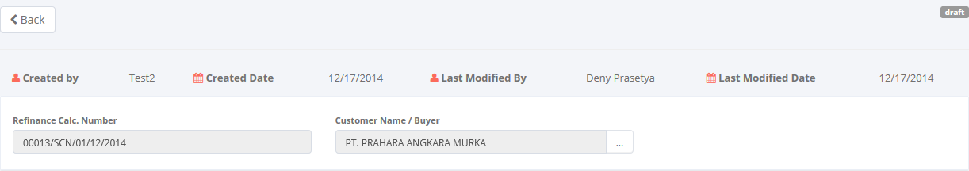

Audit rails

Calculation of Refinance Header

Click here to return to the main page of calculation of refinance.

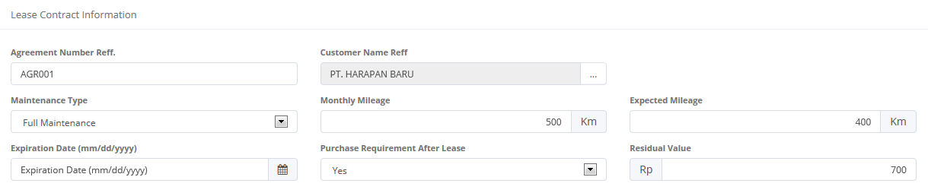

Agreement Basic Information

Product Basic Information

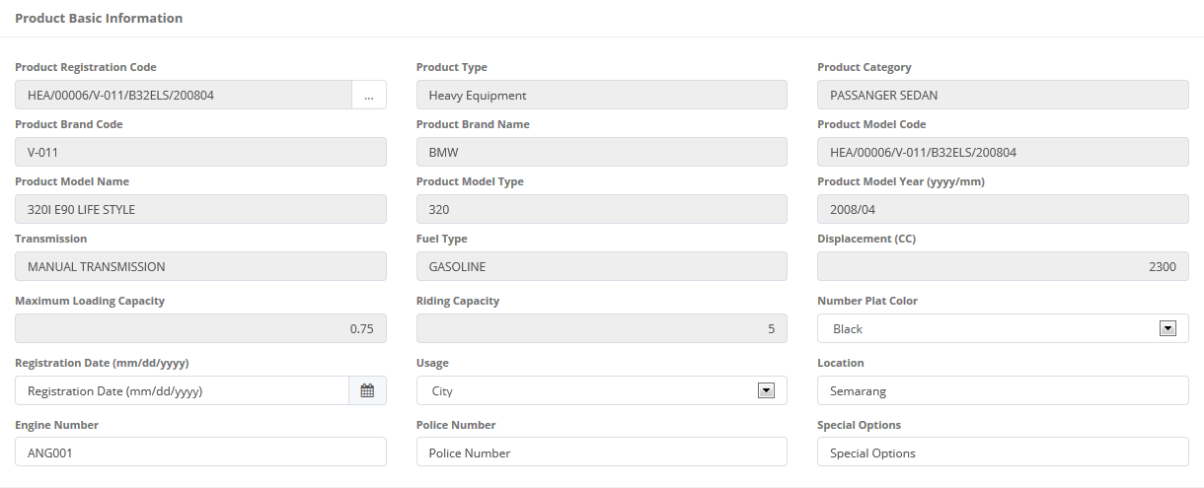

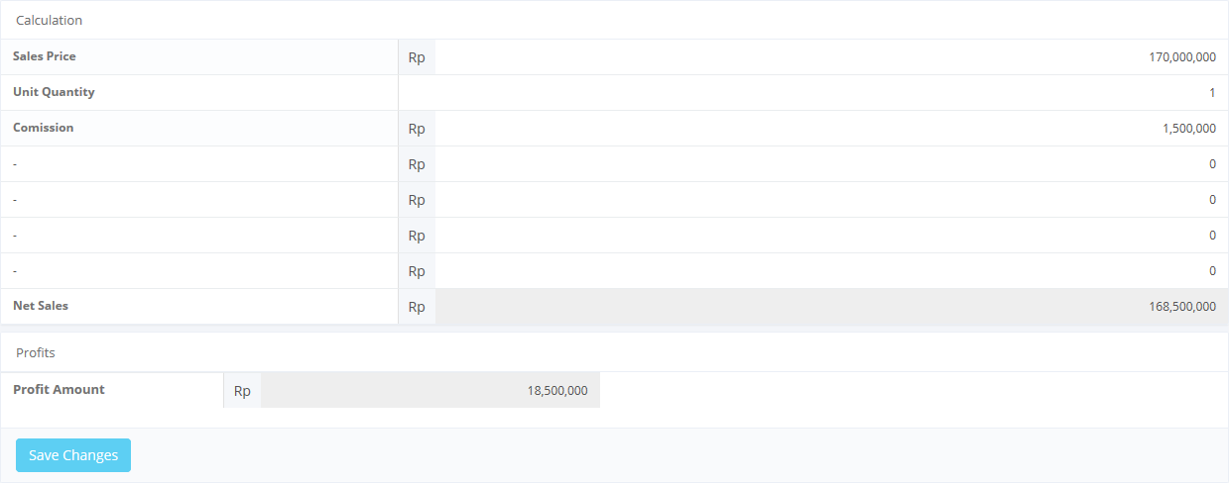

To save a data to Database status

Calculation items

1. Edits a Calculation of Refinance

Once the Edit screen opened, there are 2 buttons that will be displayed on the screen as follows:

1. , on the top-left corner of the screen.
2.  , on the bottom-left corner of the screen.

When editing a calculation:

1. As default, Refinance Calculation number already generated automatically when creating a new calculation record.
2. The first field can be edit is the Customer Name/Buyer. To edit, user can look up a customer data then select the Customer Name (only one customer data can be selected). Once it done, Customer Name/Buyer field will be filled out automatically.

Click here to look up customer data status





Click here to edit a customer data status

1. Customer data selection
2. After customer data selection, user can edit several data on Agreement Basic Information panel (see picture 47.) Please complete the fields on Agreement Basic Information. In this panel, there is Customer Name Ref. that should be input. To input Customer Name Ref., follow step 2.

Click to look up customer name reff.





1. Customer data selection
2. On the Product Basic Information panel, user can edit several data (see picture 47.) In this panel, there is Product Registration Code that can be edit. To input Product Registration Code, users can look up a product data then select the Product Registration Code (only one product can be selected). Once it done, Product Registration Code field will be filled out automatically

Click here to look up product registration code





Click here to look up customer data status

1. Product data selection
2. All the remaining fields in Product Basic Information panel and Calculation panel can be edit by input manually.
3. If data already edited on the form, Net Sales field and Profits Amount will be calculated automatically.
4. User can save a data on the system by clicking **Save Changes** or **Submit** button. Ensure that you actually want to **submit** a record, because the records cannot be reserved and update after submitted by user. For authorized user, they still can update after submitted. But don’t be afraid, if you don’t have an authorization, data still can be updated as long as draft. It can’t leave as blanks. If blanks, system will notified it after clicking **Save as Changes** or **Submit** button. After clicking **Save Changes** or **Submit** button system will notified if success or failed to save or submit a data. You also have a **Back** button, which redirect you to the previous page, Product information page.

## 3.2 Quotation of Refinance

The Quotation of refinance is designed to facilitate and maintain the quotation process for refinance that had to be done manually before. Also on this feature user can print the quotation by system. This function are consist of several information, there are; basic product information, Quotation information and so on. Although each user can draft, save changes, submit, and view their respective data only authorized user, such as managers or supervisor can changes the status (draft, submitted, active, inactive) their information or records by using the system.

At the beginning, user can open quotation of refinance by clicking the ‘Quotation of Refinance’ on the list of Marketing menus. Once clicked the menus, system will display the Quotation of Refinance page. This page may show a quotation list, which is done inputted including status that processed by user. When opening the Quotation of Refinance page it may look as following:

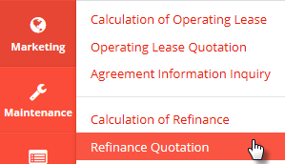

Click here to open Refinance Quotation.

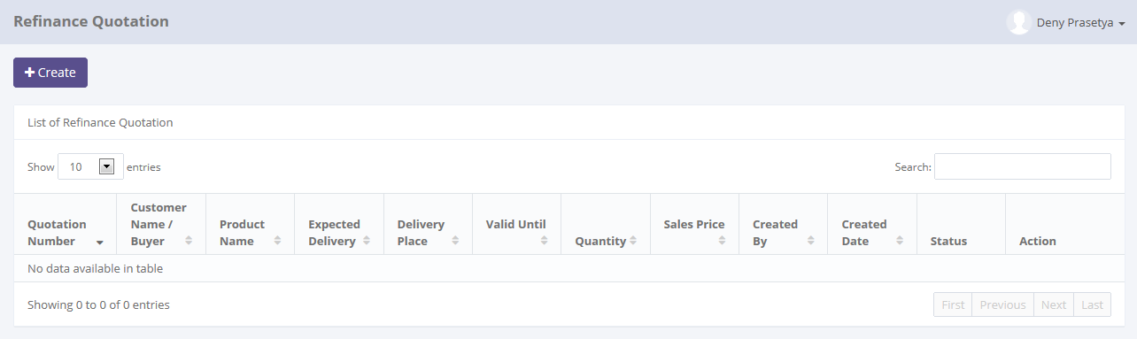

Click here to add new records.

Click here to sort the records.

Pick the number of records, to filter number of records in the list.

Enter here to filter the specific records.

Click here to do some action to this record such as edit and see a data detail.

1. Main Page of Quotation of Refinance

Only authorized user have access to all records in order to keep them up to date. This page provides following functions:

1. Create a quotation of refinance by opening ‘Create’ page. To open this page user can click, on the top-left of the list of Quotation of Refinance.
2. Open details of Quotation by click , on the rightmost column at the list.
3. Editing a Quotation data using edit menu. User can click  on the rightmost column at the list.
4. Filter and sort a data that appears on the list. To do this function user can do as follows:
5. Click  to sort a record ascending or descending.
6. Filter a numbers of record by selecting.
7. Filter a records by input a keywords at .

Quotation of Refinance function will have some business rules for status when processing a data. The picture below is describing transition of status that performed by user when using this features. In this features, validation (validate and invalidate) process triggered on the operating lease quotation module. If the quotation already validate, so the status of Quotation will be valid too, and vice versa.

****

1. Workflow of status on Quotation of Refinance

In the beginning, when new Quotation created by user, the status will be saved as. After saved, the records submitted by user, the status will be changes to . Once it done, record can be validate by authorized user , then the status will be changes to . If the quotation already validate, so the status of Quotation will be valid too, and vice versa. If the authorized user want the records changes by member, the authorized user can  the record, then the status records will be changes to automatically.

In special cases, if the authorized user want records to be invalidate, they can do  process, and the status will be.

### 3.2.1 Details of Quotation of Refinance

To open details in Quotation of Refinance, click sub menu ‘Customer Information’ in Marketing module. Below is figure of main page of Quotation of Refinance:

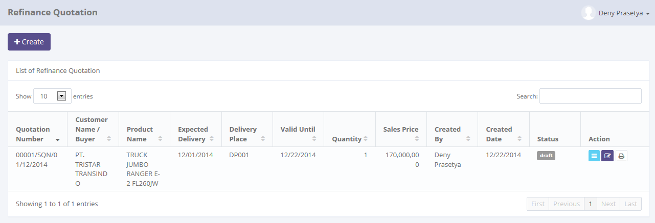

Click here to Calculation of Refinance Details.

1. Main Page of Quotation of Refinance

Once user clicking , system will open details of Quotation of Refinance. This page displays all information related to quotations which have been inputted by user. When the details page opens it may look as follows:

Status of record

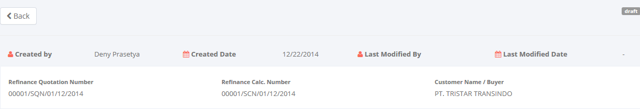

Audit rails

Return back to the previous page

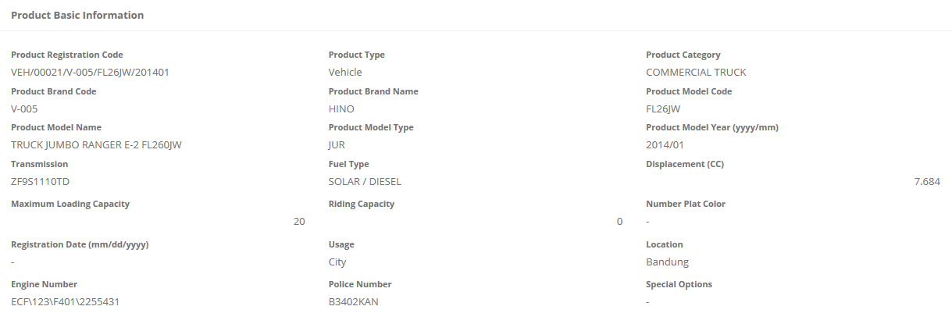

Product Basic Information

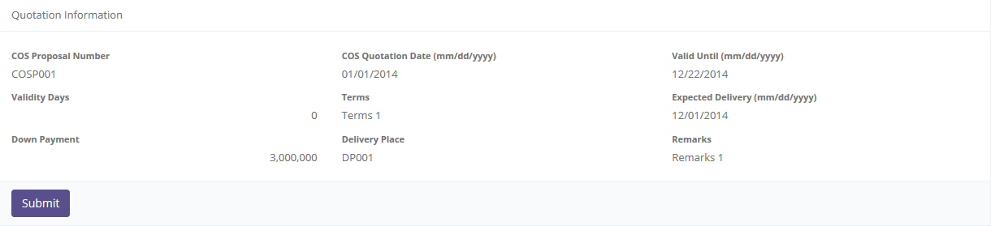

Quotation Information Information

To update the record status

1. Details of Quotation of Refinance

Once the Quotation has been created,  status is displayed on the top-right corner. If the data already confirm, user can submit the Quotation by clicking . Once it done, system quotation status will be change to, then system will return back to main page of Quotation of Refinance (see picture 53). And also system will notify success/ failure message like this:



1. Submit process notification

If user feels the Quotation needs return back to draft, user can open details page of quotation (see picture 54). Once it opened,  status is displayed on the top-right corner. If submitted data already confirm, user can click  button, then system will return back to main page of Quotation of Refinance (see picture 53). And also system will notify success/failure message like this:



1. Set to draft process notification

As long as the Quotation of Refinance record still not validate, user can changes the status from draft to submitted or vice versa.

### 3.2.2 Filter and Sort Quotation of Refinance

To open details quotation of refinance, click sub menu ‘Customer Information’ in Marketing module. Below is figure of main page of Quotation of Refinance:



Enter here to filter the specific records.

Pick the number of records, to filter number of records in the list.

Click column title, to sort a record per columns in the list.

1. Main Page of Quotation of Refinance

To filter the records there are two categories are as follows:

1. To sort the record by column, user can click  column title on the table header.
2. Filter the number of records. User can select the number by picking this feature on the screen. If the records have been filtered based on number, the amount of records that will be shown is same as the selected. For example if you want to display 10 product record, you can select 10.
3. Filter the records with the specific information. You can do it by entering the keywords on the  field. For example, you can enter name of product on the **search field**, and then press an **Enter** button on the keyboard. See the picture below:

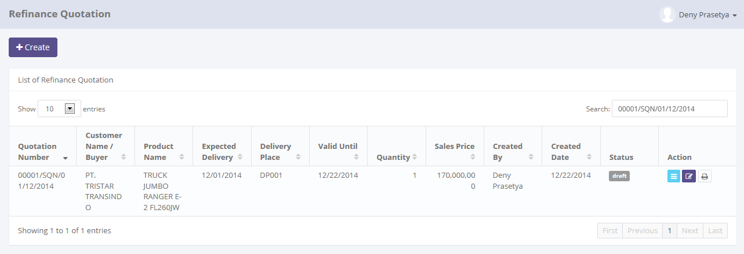

Result shows here

Keywords enter here

1. Filter and sort result on Main Page of Quotation of Refinance

### 3.2.3 Create New Quotation of Refinance

If user wants to create a new Quotation, click  on the top-left corner of the main page of Quotation of Refinance (see picture 53.)

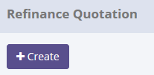

Click here to open Creates form

1. Create new button

When the Create form opened, it may look as following:

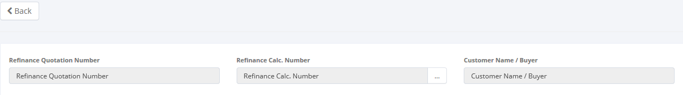

Refinance Quotation Header

Click here to return to the main page of Refinance Quotation

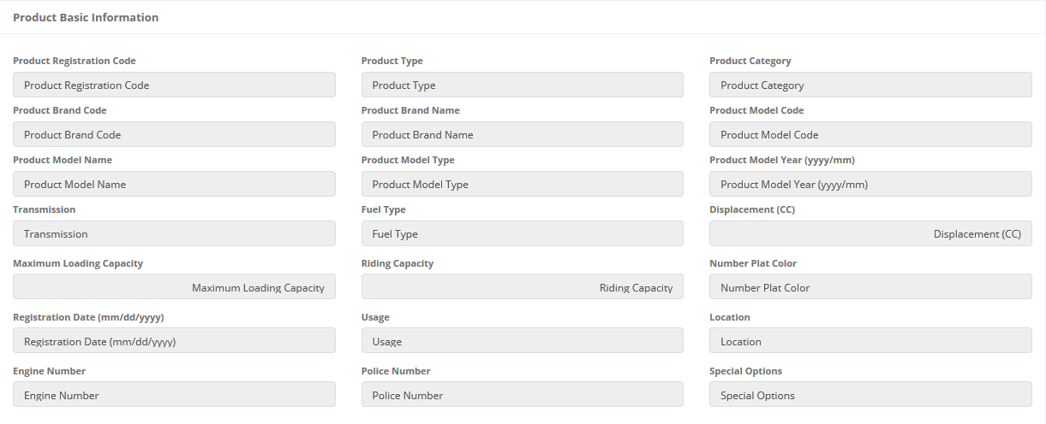

Product Basic Information

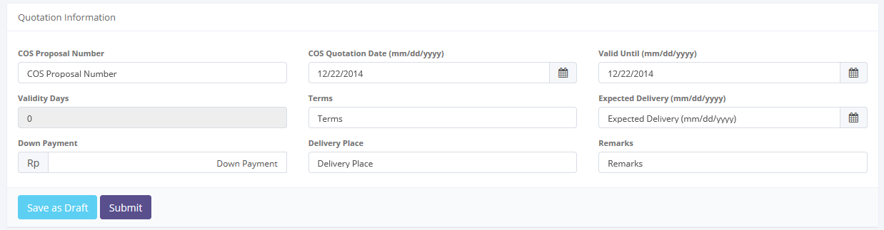

Calculation items

To save a data to Database status

1. Create new a Quotation of Refinance

Once the Create screen opened, there are 3 buttons that will be displayed on the screen, as follows:

1. , on the top-left corner of the screen.
2.  , on the bottom-left corner of the screen.
3. , on the bottom-left corner of the screen.

When creating a new Quotation:

1. As default, Quotation of Refinance number will be generated automatically.
2. The first field to be input is the Refinance Calculation Number. To enter its field, user can looking up a data then select the Refinance Calculation Number on the look up form (only one record can be selected).



Click here to look up calculation of refinance data status

Click here to look up a quotation data status

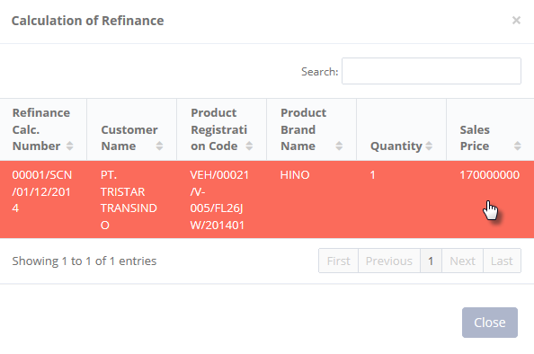

1. Calculation of Refinance data selection
2. Once it done, the field will be filled out automatically and all the remaining fields in the Refinance Quotation Header and Product Basic will be filled automatically. For the remaining field on the quotation information, it can be input manually.
3. If data already entered on the form, Net Sales field and Profits Amount will be calculated automatically.
4. User can save a data on the system by clicking **Save as Draft** or **Submit** button. Ensure that you actually want to **Submit** a record, because the records cannot be reserved and update after submitted by user. For authorized user, they still can update after submitted. But don’t be afraid, if you don’t have an authorization, data still can be updated as long as draft. It can’t leave as blanks. If blanks, system will notified it after clicking **Save as Draft** or **Submit** button. After clicking **Save as Draft** or **Submit** button system will notified if success or failed to save or submit a data. You also have a **Back** button, to return back to main page screen. (see picture 53).

### 3.2.4 Edit Quotation of Refinance record

If user wants to edit a quotation of refinance record, click  on the left column of the records at the list of quotation (see picture 48.).



Click here to open Edits form

1. Create new button

When the Create form opened, it may look as following:

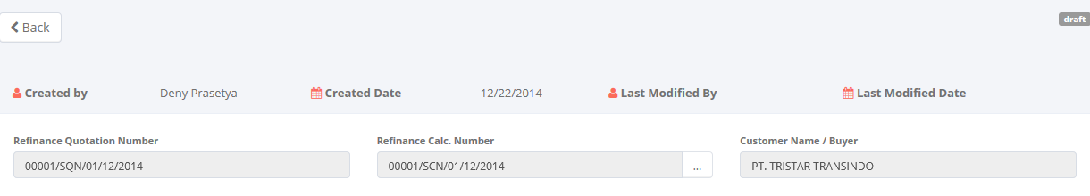

Audit rails

Calculation of Refinance Header

Click here to return to the main page of calculation of refinance.

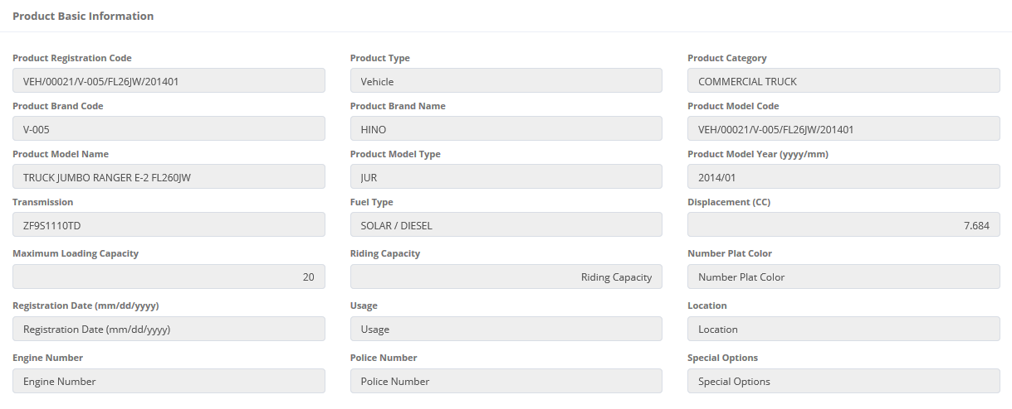

Product Basic Information

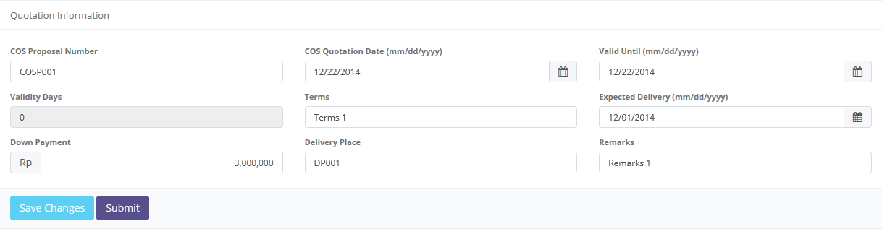

Quotation Information

To save a data to Database status

1. Edits a Quotation of Refinance

Once the Edit screen opened, there are 3 buttons that will be displayed on the screen, are as follows:

1. , on the top-left corner of the screen.
2.  , on the bottom-left corner of the screen.
3. , on the bottom-left corner of the screen.

When editing a Quotation:

1. As default, Quotation of Refinance number will be generated automatically.
2. The first field to input is the Refinance Calculation Number. To edit, user can looking up a data then select the Refinance Calculation Number on the look up form (only one record can be selected).

Click here to look up calculation of refinance data status





1. Calculation of Refinance data selection
2. Once it done, the field will be filled out automatically and all the remaining fields in the Refinance Quotation Header and Product Basic too. For the remaining field on the quotation information can be input manually.

Click here to look up a quotation data status

1. If data already entered on the form, Net Sales field and Profits Amount will be calculated automatically.
2. User can save a data on the system by clicking **Save Changes** or **Submit** button. Ensure that you actually want to **Submit** a record, because the records cannot be reserved and update after submitted by user. For authorized user, they still can update after submitted. But don’t be afraid, if you don’t have an authorization, data still can be updated as long as draft. It can’t leave as blanks. If blanks, system will notified it after clicking **Save Changes** or **Submit** button. After clicking **Save Changes** or **Submit** button system will notified if it success or failed to save or submit a data. You also have a **Back** button, to return back to main page screen. (see picture 53).

## 3.3 Calculation of Operating Lease

The Calculation of refinance is designed to facilitate and maintain the calculation process for operating lease that had to be done manually before. The system simplifies the calculation process by filling out the input forms. This function are consist of several information, there are basic product information, basic lease information, and calculation information and so on. Although each user can draft, save changes, submit, and view their respective data. Only authorized user, such as managers or supervisor can changes the status (draft, submitted, active, inactive) their information or records by using the system.

At the beginning, user can open calculation of operating lease by clicking the ‘Calculation of Operating Lease’ on the list of Marketing menus. Once clicked the menus, system will display the Calculation of Operating Lease page. This page may show a calculation list, which is done inputted including status that processed by user. When opening the Calculation of Refinance page it may look as following:

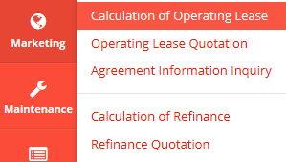

Click here to open Calculation of Refinance.

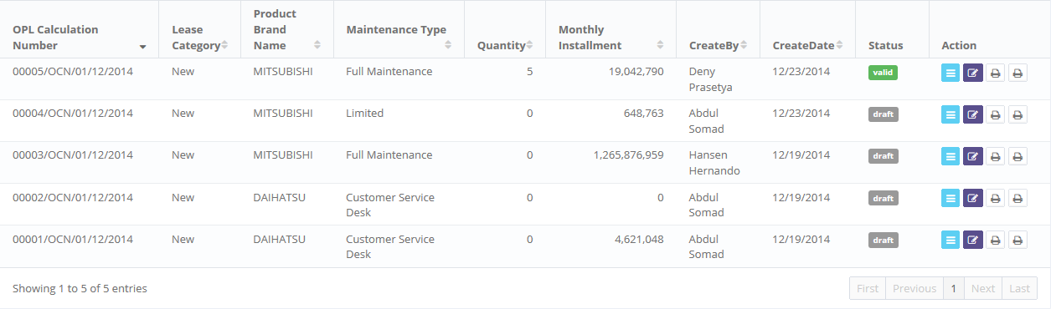

Enter here to filter the specific records.

Click here to sort the records.

Click here to do some action to this record such as edit and see a data detail.

Pick the number of records, to filter number of records in the list.

1. Main Page of Calculation of Operating Lease

Only authorized user have access to all records in order to keep them up to date. This page provides following functions:

1. Create a calculation of operating lease by opening ‘Create’ page. To open this page user can click , on the top-left of the list of refinance calculation.
2. Open details of calculation by click , on the rightmost column at the list.
3. Editing a calculation data using edit menu by click  on the right after detail icon at the list.
4. Print Proposal Report and OPL Calculation Report by click D:\IDP\OJT\DSF OLSS\Gambar\Print.PNG on the rightmost column of the list.
5. Filter and sort a data that appears on the list. To do this function user can do as follows:
6. Click  to sort a record ascending or descending.
7. Filter a numbers of record by selecting .
8. Filter a records by input a keywords at .

Calculation of operating lease function will have some business rules for status when processing a data. The picture below is describing transition of status that performed by user when using this features. In this features, validation (validate and invalidate) process triggered on the operating lease quotation module. If the quotation already validate, so the status of calculation will be valid too, and vice versa.

****

1. Workflow of status on Calculation of Operating Lease

In the beginning, when new calculation created by user, the status will be saved as . After saved and fill all the 6 step in calcaulation of operating lease, the records can be submitted by user and the status will be changes to . Once it done, record can be validate by authorized user, then the status will be changes to . If the authorized user want the records changes by member, the authorized user can  the record, then the status records will be changes to  automatically.

In special cases, if the authorized user want records to be invalidate, they can do  process, and the status will be .

### 3.3.1 Details of Calculation of Operating Lease

To open details in Calculation of Operating Lease, click sub menu ‘Calculation of Operating Lease’ in Marketing module. Below is figure of main page of Calculation of Operating Lease:





Click here to Calculation of Operating Lease Details.

1. Main Page of Calculation of Operating Lease

Once user clicking , system will open details of calculation of refinance. This page displays all information related to calculations which have been inputted by user. It will open the details page that contain 6 steps of the calculation look as follows:

* Step 1:

Return back to the previous page

Status of record

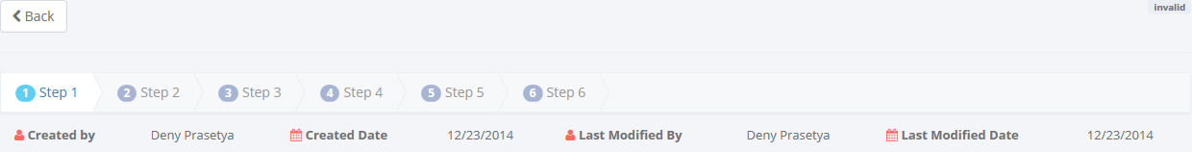

Audit rails

Step rails



Calculation of Operating Lease Header

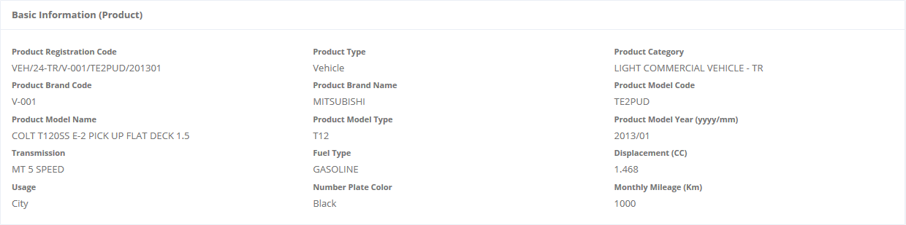

Basic Information (Product)

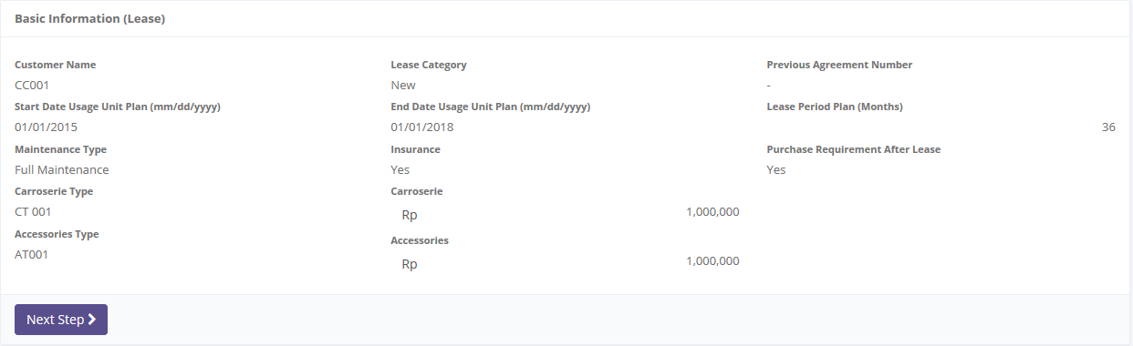

Basic Information (Lease)

To go to the next step

Status of record

1. Details of Calculation of Operating Lease – Step 1

* Step 2:

Return back to the previous page

Audit rails

Status of record

Step rails

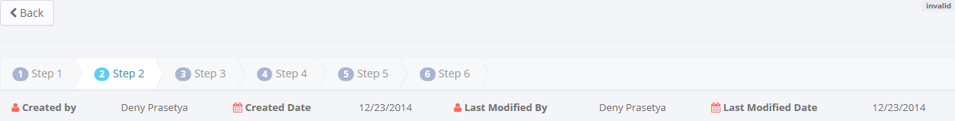

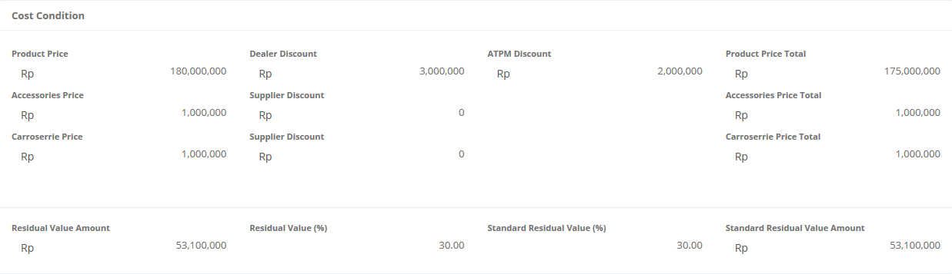

Cost Condition Details

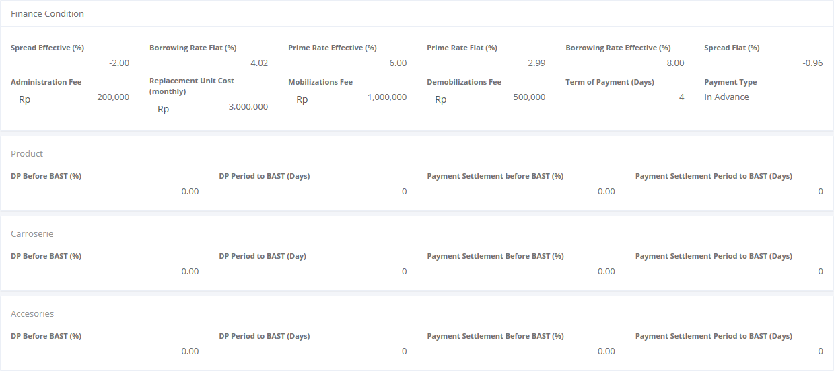

Finance Condition Details

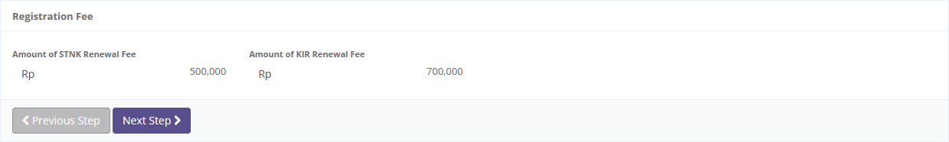

Registration Fee Details

To go to the previous/next page

1. Details of Calculation of Operating Lease – Step 2

* Step 3:

Step rails

Audit rails

Status of record

Return back to the previous page

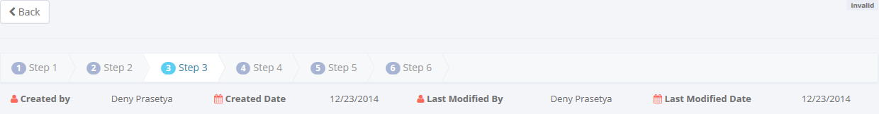

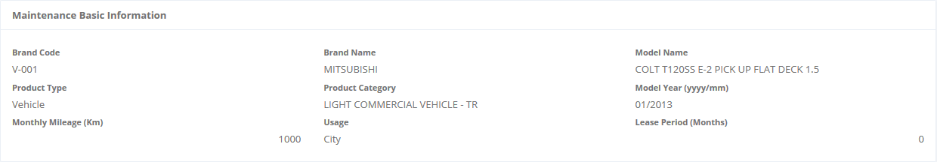

Maintenance Basic Information

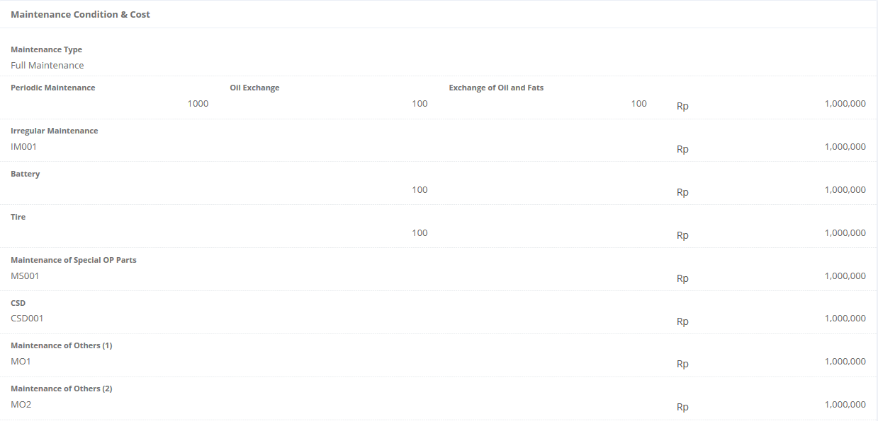

Maintenance Condition & Cost

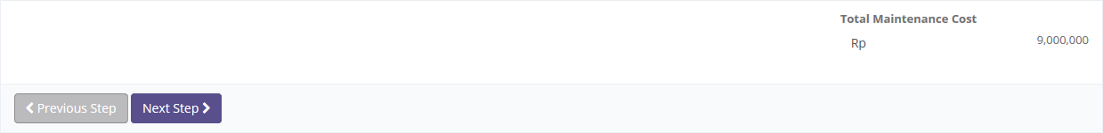

To go to the previous/next page

1. Details of Calculation of Operating Lease – Step 3

* Step 4:

Step rails

Audit rails

Status of record

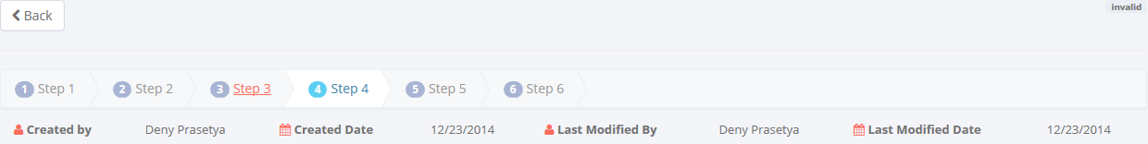

Return back to the previous page

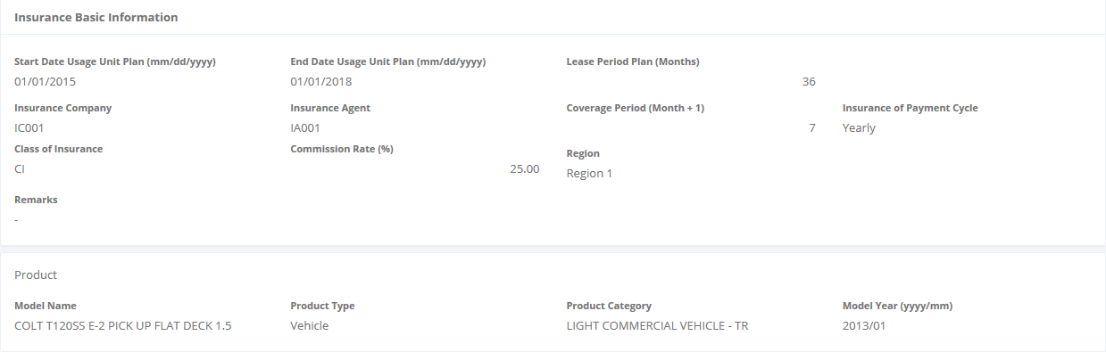

Insurance Basic Information

Product Name

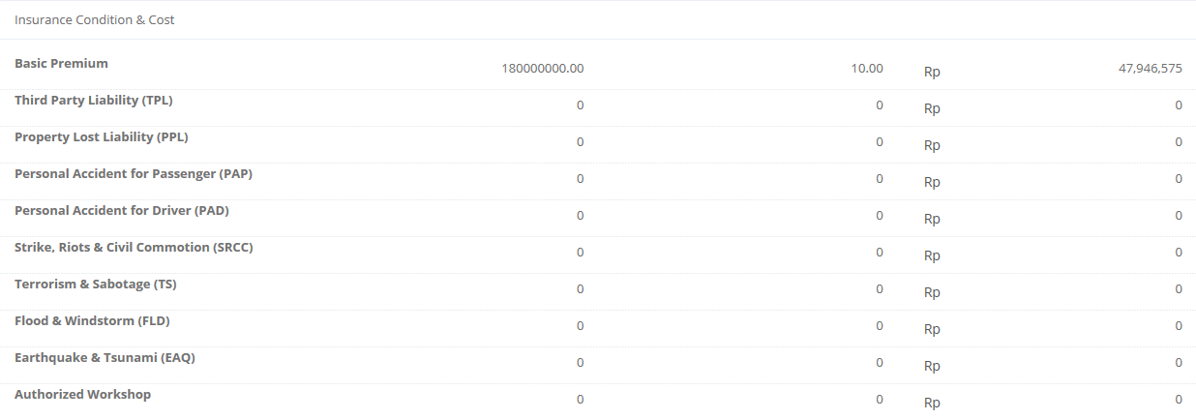

Insurance Condition & Cost

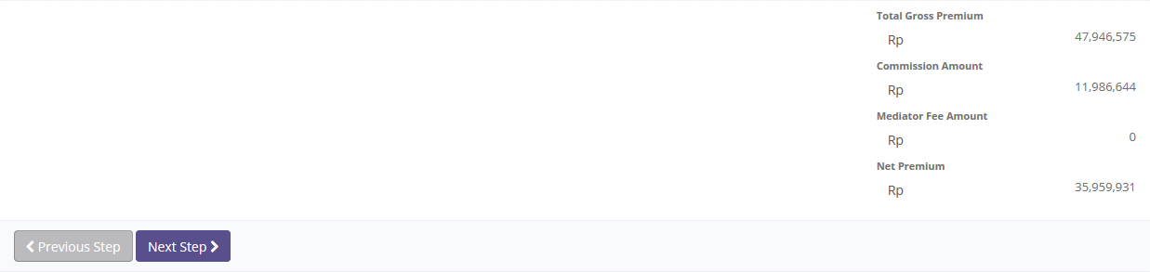

To go to the previous/next page

1. Details of Calculation of Operating Lease – Step 4

* Step 5:

Step rails

Audit rails

Status of record

Return back to the previous page

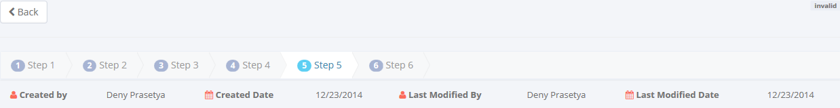

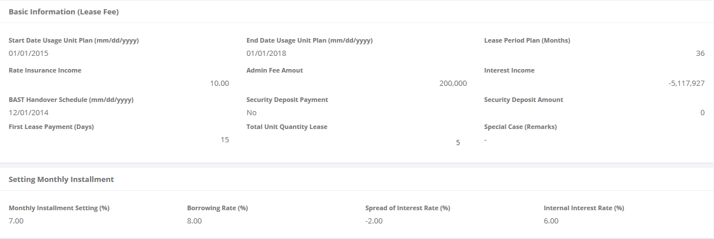

Basic Informatioan of Lease Fee

Setting Monthly Installment

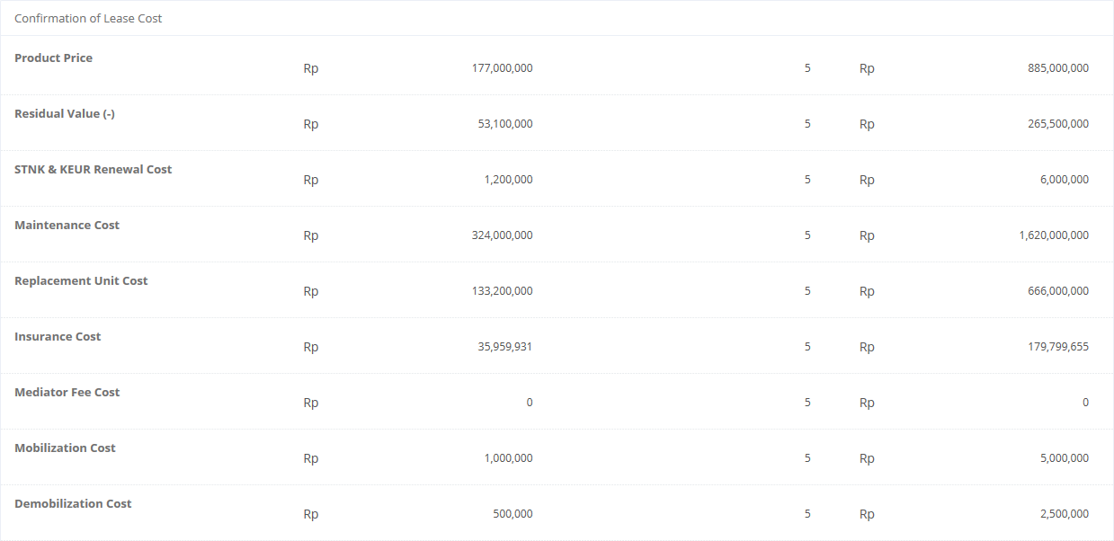

Confirmation of Lease Cost

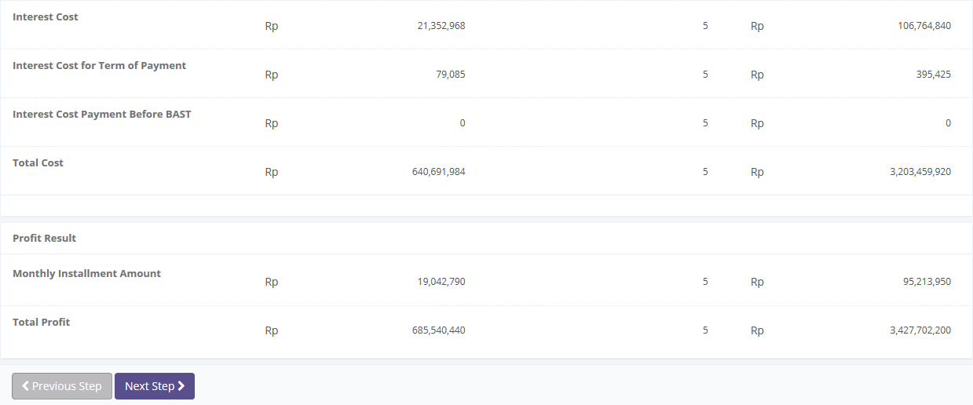

To go to the previous/next page

1. Details of Calculation of Operating Lease – Step 5

* Step 6:

Step rails

Audit rails

Status of record

Return back to the previous page

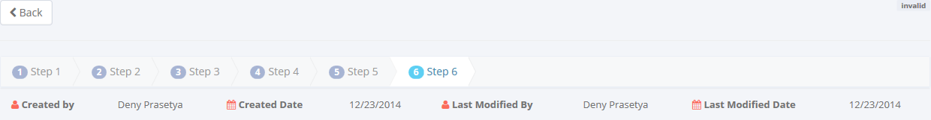

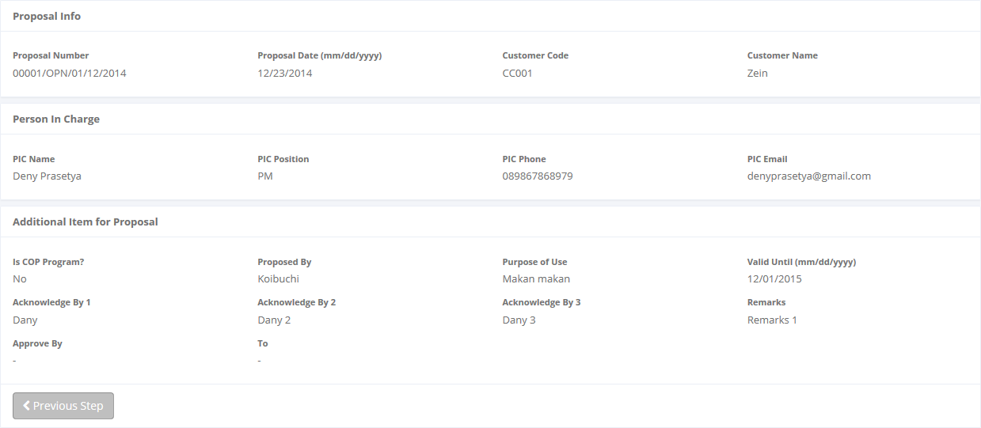

To go to the previous page

Proposal Information

Person in Charge Information

Additional item for Proposal

1. Details of Calculation of Operating Lease – Step 6

Once the calculation has been created,  status is displayed on the top-right corner. If the 6 step in Calculation of Operating Lease has not been done until the end, we will stopped in the last step that user has been successfully inputted. And when we click **Next,** the system will notify like this:

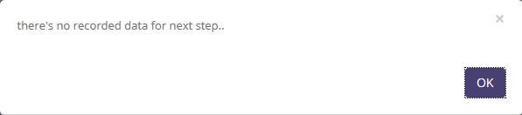

1. No Record Notification

### 3.3.2 Filter and Sort Calculations of Operating Lease

To open details calculation of operating lease, click sub menu ‘Calculation of Operating Lease in Marketing module. Below is figure of main page of Calculation of Operating Lease:



Enter here to filter the specific records.

Pick the number of records, to filter number of records in the list.



Click here to sort the records.

1. Main Page of Calculation of Operating Lease

To filter the records there are two categories as follows:

1. To sort the record by column, user can click  column title on the table header.
2. Filter the number of records. User can select the number by picking this feature on the screen. If the records have been filtered based on number, the amount of records that will be shown is same as the selected. For example if you want to display 10 product record, you can select 10.
3. Filter the records with the specific information. You can do it by entering the keywords on the  field. For example, you can enter name of product on the **search field**, and then press an **Enter** button on the keyboard. See the picture below:

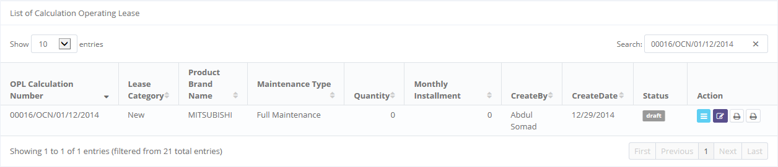

Result shows here

Keywords enter here

1. Filter and sort result on Main Page of Calculation of Refinance

### 3.3.3 Create New Calculation of Operating Lease

If user wants to create a new calculation, click  on the top-left corner of the main page of Calculation of Operating Lease (see picture 65.)

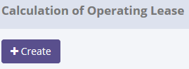

Click here to open Creates form

1. Create new button

When the Create form opens it will open 6 step that you must fill, and it may look as follows:

#### 3.3.3.1 Step 1:

D:\IDP\OJT\DSF OLSS\Gambar\Calc_Operating_List_S1_1.PNG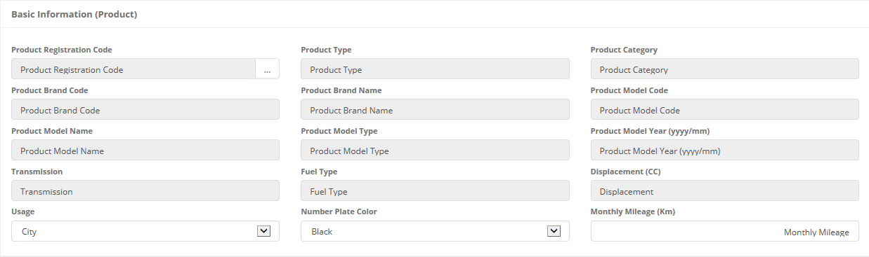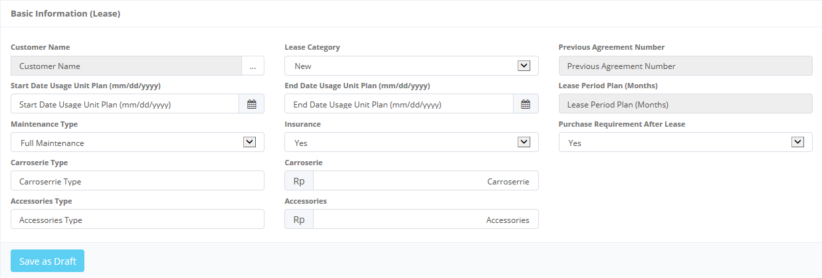

Return back to the previous page

Calculation of Operating Lease Header

Basic Information (Product)

To save a data to Database status

Basic Information (Lease)

1. Create new a Calculation of Operating Lease – Step 1

Once the Step 1 page opened, there are 2 buttons that will be displayed on the screen, are as follows:

* + 1. , on the top-left corner of the screen.
    2.  , on the bottom-left corner of the screen.

When filling step 1 form:

1. As default, OPL Calculation number will be generated automatically.
2. The first field to be input is the Basic Information (Product). To enter its field, user can look up a product registration code then select the product name and model (only one product can be selected). Once it done, Product type, category and so on, will be filled out automatically.

D:\IDP\OJT\DSF OLSS\Gambar\Calc_Operating_List_S1_BC1.PNG

Click here to look up a customer data status

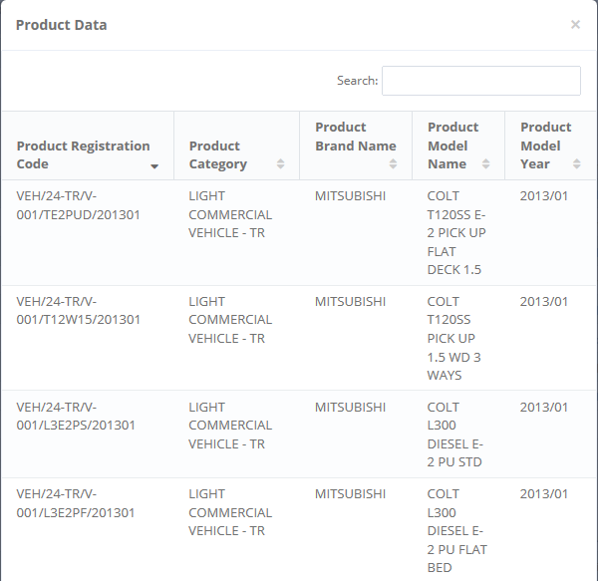

1. Product Data Selection
2. After product data selection, user can input a several data on Basic Information (Lease) panel (see picture 78.) Please complete the fields on Basic Information (Lease). In this panel, there is Customer Name Ref. that should be input. To input Customer Name Ref., this is same scenario with the step point 2.

D:\IDP\OJT\DSF OLSS\Gambar\Calc_Operating_List_S1_BC2.PNG

Click here to look up a customer data status

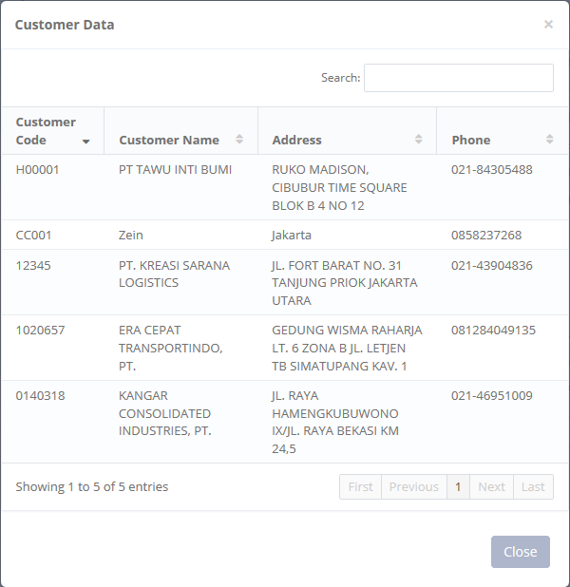

1. Customer Data Selection
2. All the remaining fields in Product Basic Information panel and Calculation panel can be input manually.
3. User can save a data on the system by clicking **Save Changes** button. There are several mandatory fields that should be inputted such as Product Registration Code, Customer Name, Start Date Usage Unit Plan, and so on. If blanks, system will notified it after clicking **Save Changes** button. After clicking **Save Changes** button system will notified if success or failed to save or submit a data. You also have a **Back** button, to return back to main page screen.
4. After success to input data, you can go to the next step by click icon as follows:

D:\IDP\OJT\DSF OLSS\Gambar\Calc_Operating_List_S1_5.PNG

1. Next Step Icon

#### 3.3.3.2 Step 2:

D:\IDP\OJT\DSF OLSS\Gambar\Calc_Operating_List_S2_1.PNG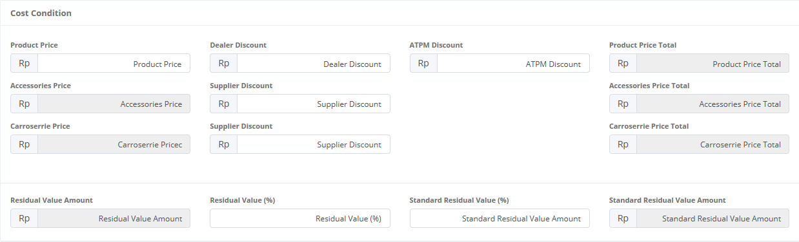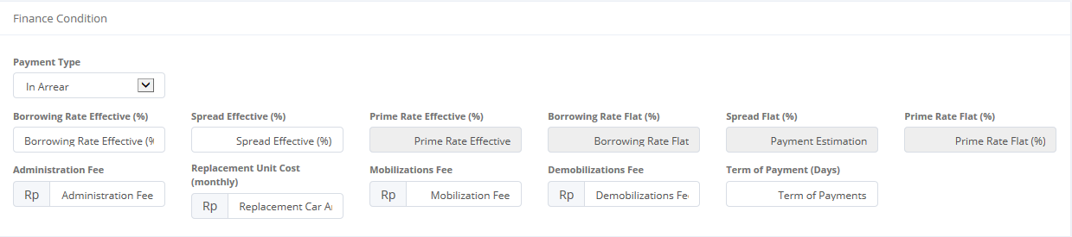

Return back to the previous page

Cost Condition Details

Finance Condition Details

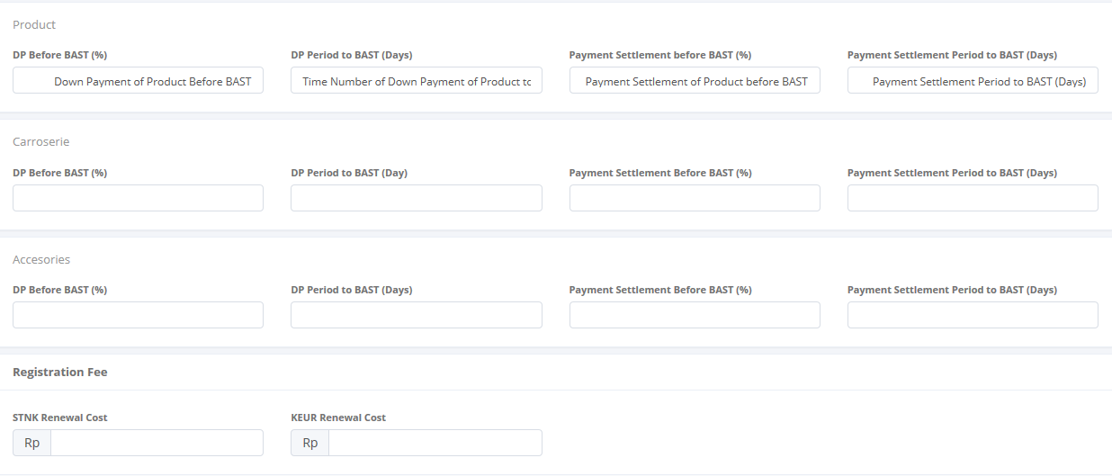D:\IDP\OJT\DSF OLSS\Gambar\Calc_Operating_List_S2_5.PNG

Registration Fee Details

Go to previous page or saving to Database

1. Create new a Calculation of Operating Lease – Step 2

Once the Step 2 page opened, there are 3 buttons that will be displayed on the screen, are as follows:

* + 1. , on the top-left corner of the screen.
    2. C:\Users\Test1\Downloads\DSF OLSS\Gambar\Previous Step.PNG , on the bottom-left corner of the screen.
    3.  , on the right after C:\Users\Test1\Downloads\DSF OLSS\Gambar\Previous Step.PNG button

When filling step 2 form:

1. All remaining fields in Product can be inputted manually.
2. User can save a data on the system by clicking **Save Changes** button. After clicking **Save Changes** button system will notified if success or failed to save or submit a data. You also have a **Back** button, to return back to main page screen.
3. After success to input data, you can go to the next step by click icon as follows:

D:\IDP\OJT\DSF OLSS\Gambar\Calc_Operating_List_S2_6.PNG

1. Next Step Icon

#### 3.3.3.3 Step 3:

D:\IDP\OJT\DSF OLSS\Gambar\Calc_Operating_List_S3_1.PNG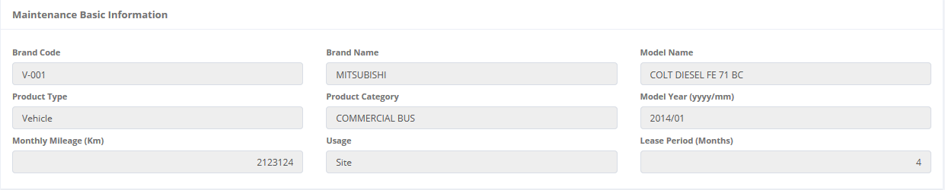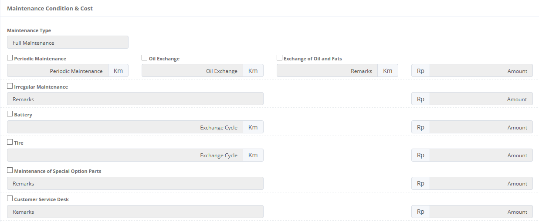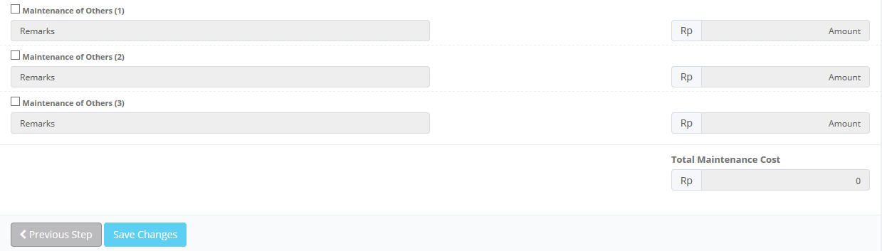

Return back to the previous page

Maintenance Basic Information

Maintenance Condition & Cost

1. Create new a Calculation of Operating Lease – Step 3

Once the Step 3 page opened, there are 3 buttons that will be displayed on the screen, are as follows:

1. , on the top-left corner of the screen.
2. C:\Users\Test1\Downloads\DSF OLSS\Gambar\Previous Step.PNG , on the bottom-left corner of the screen.
3.  , on the right after C:\Users\Test1\Downloads\DSF OLSS\Gambar\Previous Step.PNG button

When filling step 3 form:

1. All the remaining fields in can be inputted manually.
2. User can save a data on the system by clicking **Save Changes** button. After clicking **Save Changes** button system will notified if success or failed to save or submit a data. You also have a **Back** button, to return back to main page screen.
3. After success to input data, you can go to the next step by click icon as follows:

D:\IDP\OJT\DSF OLSS\Gambar\Calc_Operating_List_S2_6.PNG

Insurance Basic Information

Insurance Condition & Cost

1. Next Step Icon

#### 3.3.3.4 Step 4:



Return back to the previous page

D:\IDP\OJT\DSF OLSS\Gambar\Calc_Operating_List_S4_1.PNG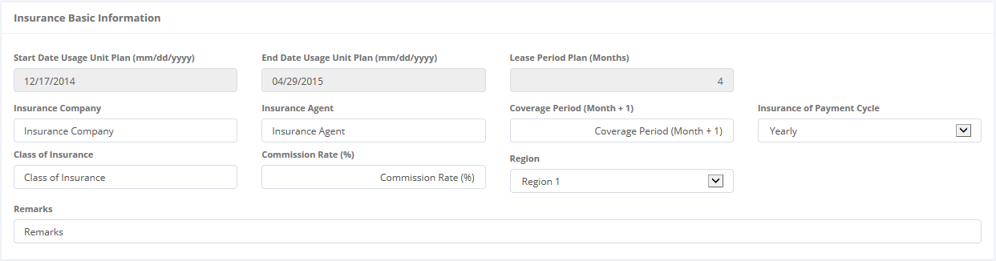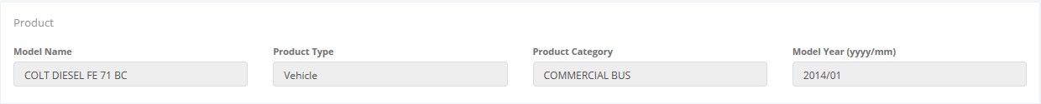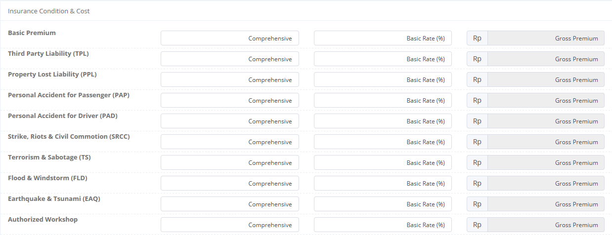

Product Name

Insurance Condition & Cost

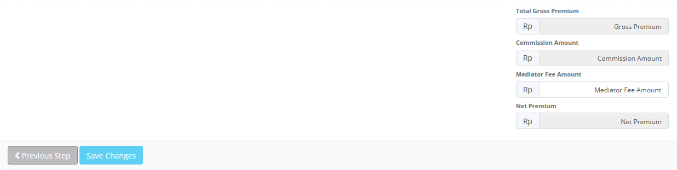

Go to previous page or saving to Database

1. Create new a Calculation of Operating Lease – Step 4

Once the Step 4 page opened, there are 3 buttons that will be displayed on the screen, are as follows:

Basic Informatioan of Lease Fee

1. , on the top-left corner of the screen.
2. C:\Users\Test1\Downloads\DSF OLSS\Gambar\Previous Step.PNG , on the bottom-left corner of the screen.
3.  , on the right after C:\Users\Test1\Downloads\DSF OLSS\Gambar\Previous Step.PNG button

When filling step 3 form:

1. All the remaining fields in can be inputted manually.
2. User can save a data on the system by clicking **Save Changes** button. After clicking **Save Changes** button system will notified if success or failed to save or submit a data. You also have a **Back** button, to return back to main page screen.
3. After success to input data, you can go to the next step by click icon as follows:

D:\IDP\OJT\DSF OLSS\Gambar\Calc_Operating_List_S2_6.PNG

1. Next Step Icon

#### 3.3.3.5 Step 5:



Return back to the previous page

D:\IDP\OJT\DSF OLSS\Gambar\Calc_Operating_List_S5_1.PNG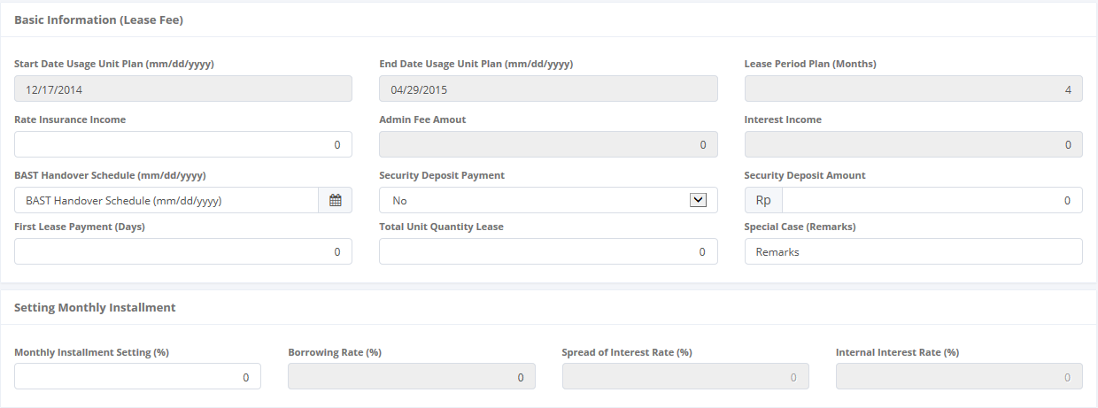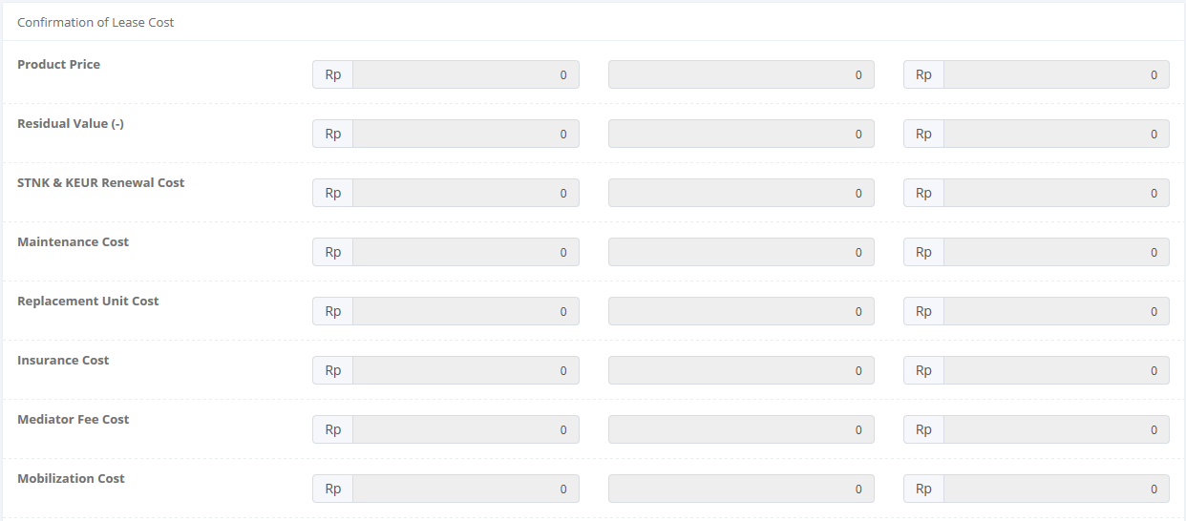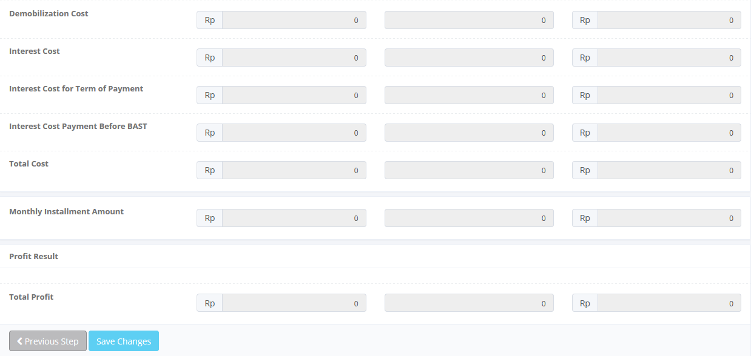

Setting Monthly Installment

Confirmation of Lease Cost

1. Create new a Calculation of Operating Lease – Step 4

Go to previous page or saving to Database

Once the Step 5 page opened, there are 3 buttons that will be displayed on the screen, are as follows:

1. , on the top-left corner of the screen.
2. C:\Users\Test1\Downloads\DSF OLSS\Gambar\Previous Step.PNG , on the bottom-left corner of the screen.
3.  , on the right after C:\Users\Test1\Downloads\DSF OLSS\Gambar\Previous Step.PNG button

When filling step 3 form:

1. All the remaining fields in can be inputted manually.
2. User can save a data on the system by clicking **Save Changes** button. After clicking **Save Changes** button system will notified if success or failed to save or submit a data. You also have a **Back** button, to return back to main page screen.
3. After success to input data, you can go to the next step by click icon as follows:

D:\IDP\OJT\DSF OLSS\Gambar\Calc_Operating_List_S2_6.PNG

1. Next Step Icon

#### 3.3.3.6 Step 6:



Return back to the previous page

D:\IDP\OJT\DSF OLSS\Gambar\Calc_Operating_List_S6_1.PNG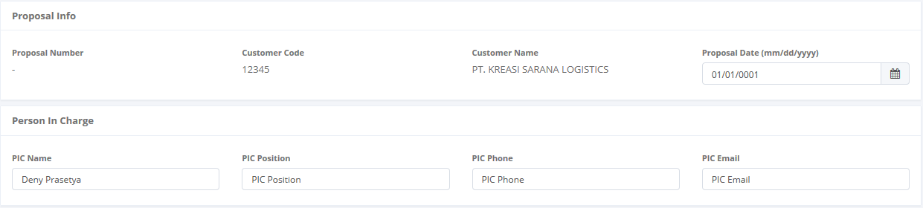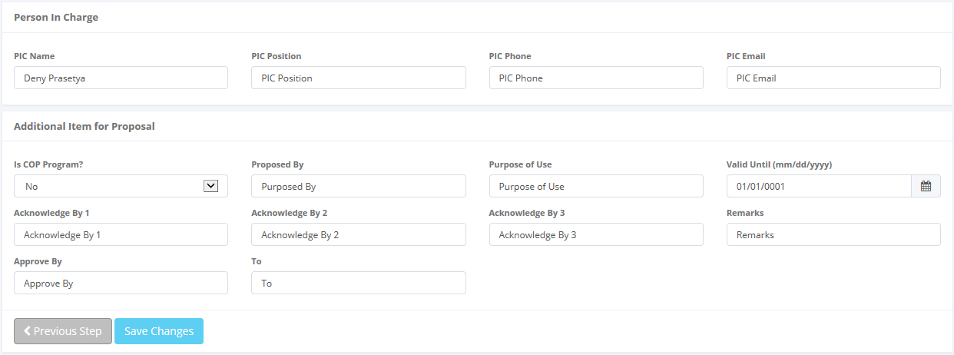

Proposal Information

Person in Charge Information

Additional item for Proposal

Go to previous page or saving to Database

1. Create new a Calculation of Operating Lease – Step 4

Once the Step 6 page opened, there are 3 buttons that will be displayed on the screen, are as follows:

1. , on the top-left corner of the screen.
2. C:\Users\Test1\Downloads\DSF OLSS\Gambar\Previous Step.PNG , on the bottom-left corner of the screen.
3.  , on the right after C:\Users\Test1\Downloads\DSF OLSS\Gambar\Previous Step.PNG button

When filling step 3 form:

1. All the remaining fields in can be inputted manually.
2. After success to input data, you can go to the next step by click icon as follows:



1. Next Step Icon
2. User can save a data on the system by clicking **Save Changes** or **Submit** button. Ensure that you actually want to **Submit** a record, because the records cannot be reserved and update after submitted by user. For authorized user, they still can be updating after submitted. But don’t be afraid, if you don’t have an authorization, data still can be updated as long as draft. You also have a **Back** button, to return back to main page screen..

### 3.3.4 Edit Calculation of Operating Lease Record

If user wants to edit a calculation of operating lease, click  on the left column of the records at the list of calculation.

Click here to open Edits form

C:\Users\Test1\Downloads\DSF OLSS\Gambar\Calc_Operating_List_B1.PNG

1. Edit Calculation

When the Edit form opened, it will open a form like in 3.4.1 and you can do editing things like in 3.4.3.

## 3.4 Quotation of Operating Lease

The Quotation of operating lease is designed to facilitate and maintain the quotation process for operating lease that had to be done manually before. Also on this feature user can print the quotation by system. This function are consist of several information, there are; basic product information, Quotation information and so on. Although each user can draft, save changes, submit, and view their respective data only authorized user, such as managers or supervisor can changes the status (draft, submitted, active, inactive) their information or records by using the system.

At the beginning, user can open quotation of operating lease by clicking the ‘Quotation of Operating Lease’ on the list of Marketing menus. Once clicked the menus, system will display the Quotation of Operating Lease page. This page may show a quotation list, which is done inputted including status that processed by user. When opening the Quotation of Operating Lease page it may look as follows:

Click to open Operating Lease Quotation

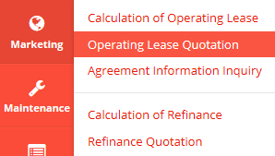

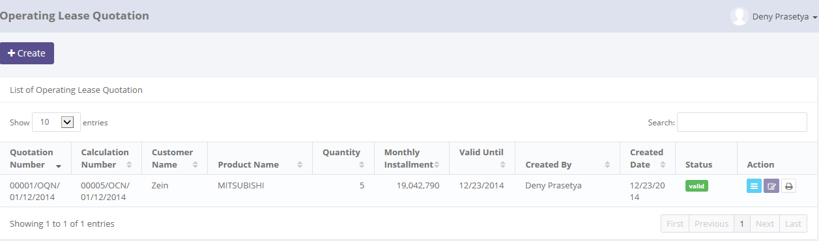

Click here to add new records.

Enter here to filter the specific records.

Click here to do some action to this record such as edit and see a data detail.

Click here to sort the records.

Pick the number of records, to filter number of records in the list.

1. Main Page of Operating Lease Quotation

Only authorized user have access to all records in order to keep them up to date. This page provides following functions:

1. Create a quotation of operating lease by opening ‘Create’ page. To open this page user can click , on the top-left of the list of Quotation of Operating Lease.
2. Open details of Quotation by click , on the rightmost column at the list.
3. Editing a Quotation data using edit menu. User can click  on the rightmost column at the list.
4. Print Operating Lease Quotation by click on the rightmost column of the list.
5. Filter and sort a data that appears on the list. To do this function user can do as follows:
6. Click  to sort a record ascending or descending.
7. Filter a numbers of record by selecting.
8. Filter a records by input a keywords at .

Quotation of Operating Lease function will have some business rules for status when processing a data. The picture below is describing transition of status that performed by user when using this features. In this features (validate and invalidate), process triggered on the operating lease quotation module. If the quotation already validate, so the status of Quotation will be valid too, and vice versa.

****

1. Workflow of status on Quotation of Refinance

In the beginning, when new Quotation created by user, the status will be saved as . After saved, the records submitted by user, the status will be changes to . Once it done, record can be validate by authorized user, then the status will be changes to . If the quotation already validate, so the status of Quotation will be valid too, and vice versa. If the authorized user want the records changes by member, the authorized user can  the record, then the status records will be changes to automatically.

In special cases, if the authorized user want records to be invalidate, they can do  process, and the status will be.

### 3.4.1 Details of Quotation of Operating Lease

To open details in Quotation of Operating Lease, click sub menu ‘Operating Lease Quotation’ in Marketing module. Below is figure of main page of Quotation of Refinance:



Click here to Calculation of Operating Lease Details.

1. Main Page of Quotation of Refinance

Once user clicking , system will open details of Quotation of Refinance. This page displays all information related to quotations which have been inputted by user. When the details page opens it may look as follows:

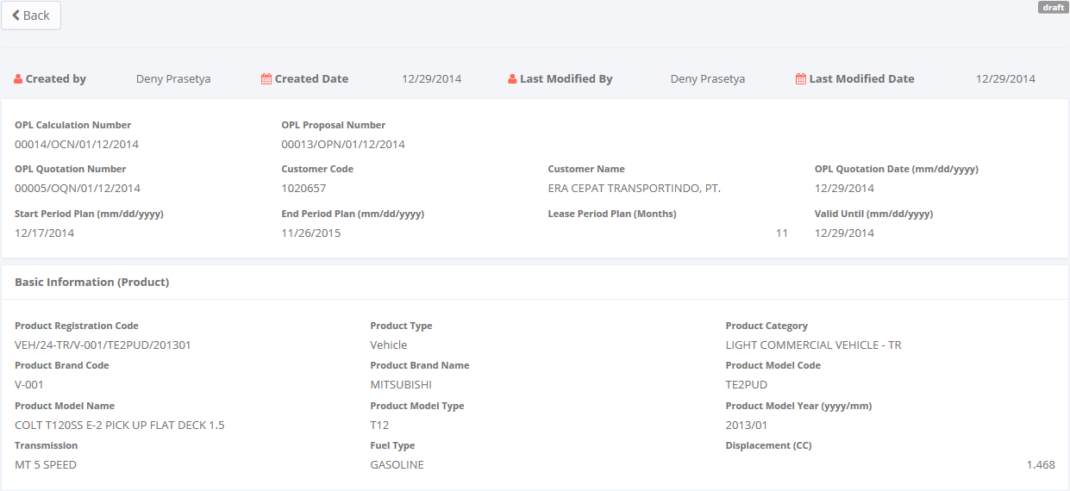

Audit rails

Return back to the previous page

Basic Information (Product)

Status of record

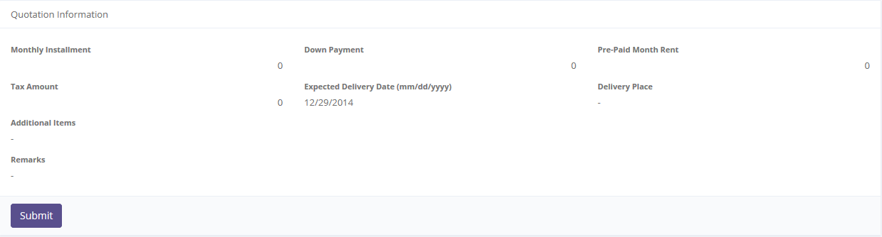

Quotation Information Information

To update the record status

1. Details of Quotation of Operating Lease

Once the Quotation has been created,  status is displayed on the top-right corner. If the data already confirm, user can submit the Quotation by clicking . Once it done, system quotation status will be change to, then system will return back to main page of Quotation of Operating Lease (see picture 96). And also system will notify success/ failure message like this:



1. Submit process notification

If user feels the Quotation needs return back to draft, user can open details page of quotation (see picture 96). Once it opened,  status is displayed on the top-right corner. If submitted data already confirm, user can click  button, then system will return back to main page of Quotation of Refinance (see picture 96). And also system will notify success/failure message like this:



1. Set to draft process notification

As long as the Quotation of Operating Lease record still not validate, user can changes the status from draft to submitted or vice versa.

### 3.4.2 Filter and Sort Quotation of Operating Lease

To open details quotation of operating lease, click sub menu ‘Operating Lease Quotation’ in Marketing module. Below is figure of main page of Quotation of Operating Lease:



Enter here to filter the specific records.

Pick the number of records, to filter number of records in the list.

Click column title, to sort a record per columns in the list.

1. Main Page of Quotation of Refinance

To filter the records there are two categories as follows:

1. To sort the record by column, user can click  column title on the table header.
2. Filter the number of records. User can select the number by picking this feature on the screen. If the records have been filtered based on number, the amount of records that will be shown is same as the selected. For example if you want to display 10 product record, you can select 10.
3. Filter the records with the specific information. You can do it by entering the keywords on the  field. For example, you can enter name of product on the **search field**, and then press an **Enter** button on the keyboard. See the picture below:

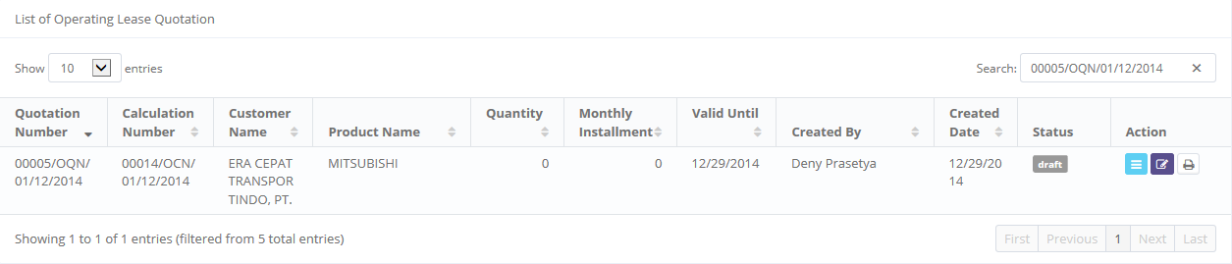

Result shows here

Keywords enter here

1. Filter and sort result on Main Page of Quotation of Refinance

### 3.4.3 Create New Quotation of Refinance

If user wants to create a new Quotation, click  on the top-left corner of the main page of Quotation of Refinance.

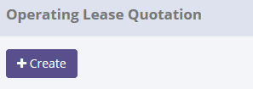

Click here to Creates form

1. Create new button

When the Create form opened, it may look as following:

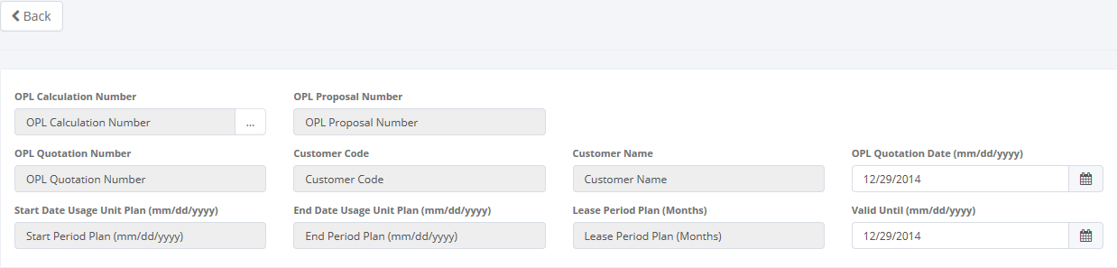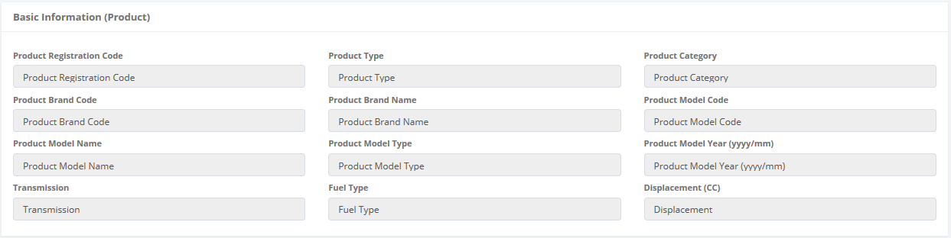

Click here to return to the main page of Refinance Quotation

OPL Calculation Number

Product Basic Information

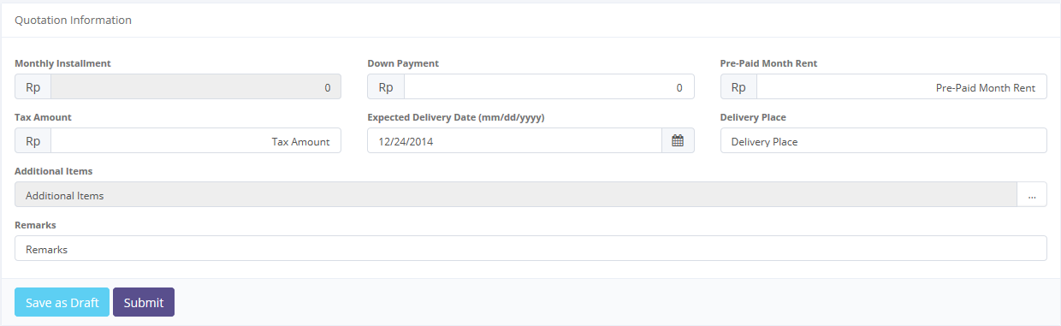

Quotation Information

To save a data to Database

1. Create new a Quotation of Operating Lease

Once the Create screen opened, there are 3 buttons that will be displayed on the screen, as follows:

1. , on the top-left corner of the screen.
2.  , on the bottom-left corner of the screen.
3. , on the bottom-left corner of the screen.

When creating a new Quotation:

1. As default, Quotation of Operating Lease number will be generated automatically.
2. The first field to be input is the OPL Calculation Number. To enter its field, user can looking up a data then select the OPL Calculation Number on the look up form (only one record can be selected).

Click here to look up a quotation data status



Click here to look up calculation of refinance data status

* 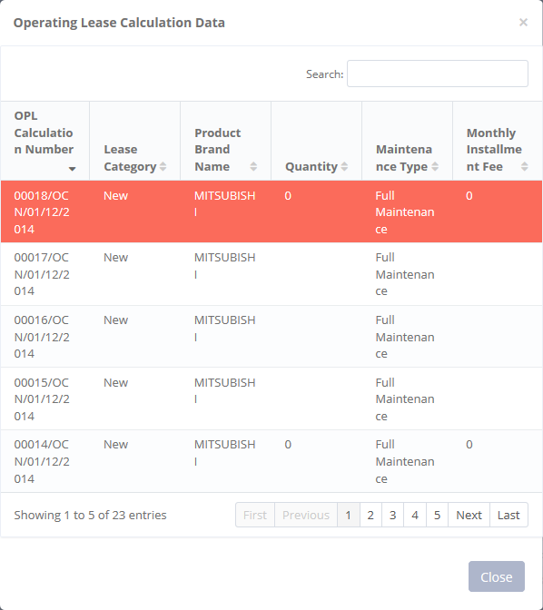

1. Calculation of Operating Lease data selection
2. Once it done, the field will be filled out automatically and all the remaining fields in the OPL Quotation Header and Product Basic will be filled automatically. For the remaining field on the quotation information, it can be input manually.
3. User can save a data on the system by clicking **Save as Draft** or **Submit** button. Ensure that you actually want to **Submit** a record, because the records cannot be reserved and update after submitted by user. For authorized user, they still can update after submitted. But don’t be afraid, if you don’t have an authorization, data still can be updated as long as draft. After clicking **Save as Draft** or **Submit** button system will notified if success or failed to save or submit a data. You also have a **Back** button, to return back to main page screen. (see picture 99).

### 3.2.4 Edit Quotation of Operating Lease record

If user wants to edit a quotation of operating lease record, click  on the left column of the records at the list of quotation.

Click here to open Edits form

C:\Users\Test1\Downloads\DSF OLSS\Gambar\Ref_Quot_B1.PNG

1. Create new button

When the Edit form opened, it may look as following:

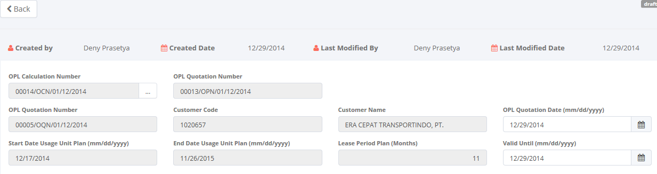

Audit rails

Click here to return to the main page of calculation of refinance.

Calculation of Operating Lease Header

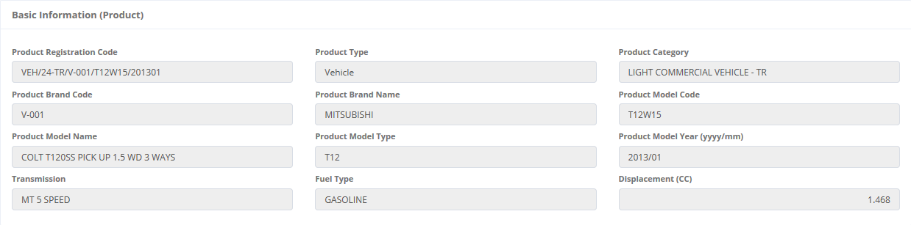

Product Basic Information

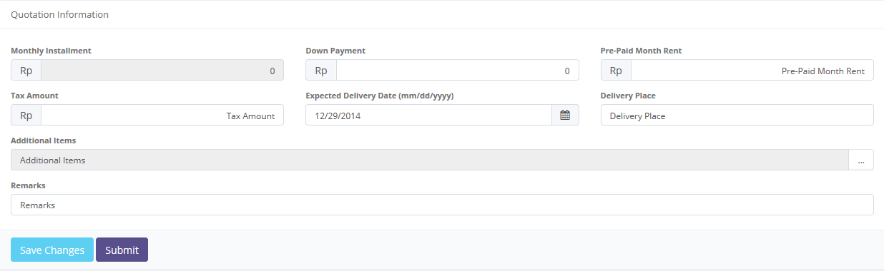

Quotation Information

To save a data to Database status

1. Edits a Quotation of Refinance

Once the Edit screen opened, there are 3 buttons that will be displayed on the screen, are as follows:

1. , on the top-left corner of the screen.
2.  , on the bottom-left corner of the screen.
3. , on the bottom-left corner of the screen.

When editing a Quotation:

1. As default, Quotation of Operating Lease number will be generated automatically.
2. The first field to input is the Refinance Calculation Number. To edit, user can looking up a data then select the Refinance Calculation Number on the look up form (only one record can be selected).

Click here to look up calculation of refinance data status





1. Editing Quotation of Operating List
2. Once it done, the field will be filled out automatically and all the remaining fields in the Refinance Quotation Header and Product Basic too. For the remaining field on the quotation information can be input manually.
3. If data already entered on the form, Net Sales field and Profits Amount will be calculated automatically.
4. User can save a data on the system by clicking **Save Changes** or **Submit** button. Ensure that you actually want to **Submit** a record, because the records cannot be reserved and update after submitted by user. For authorized user, they still can update after submitted. But don’t be afraid, if you don’t have an authorization, data still can be updated as long as draft. After clicking **Save Changes** or **Submit** button system will notified if it success or failed to save or submit a data. You also have a **Back** button, to return back to main page screen.

## 3.5 Agreement Information Inquiry

The Agreement Infromation Inquiry is designed to facilitate and maintain the process for make an agreement that had to be done manually before. The system simplifies the calculation process by filling out the input forms. This function are consist of several information, there are; quotation number, BAST date, agreement date and so on. Although each user can draft, save changes, submit, and view their respective data. Only authorized user, such as managers or supervisor can changes the status e.g. draft, submit, validate, invalidate, terminate, and generate periodic service and billing payment schedule by using the system.

At the beginning, user can open agreement information inquiry by clicking the ‘Agreement Information Inquiry’ on the list of Marketing menus. Once clicked the menus, system will display the Agreement Information Inquiry page. When opening the page it may look as following:

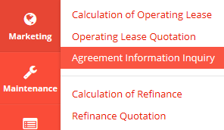

Click here to open Calculation of Refinance.

Enter here to filter the specific records.

Click here to add new records.

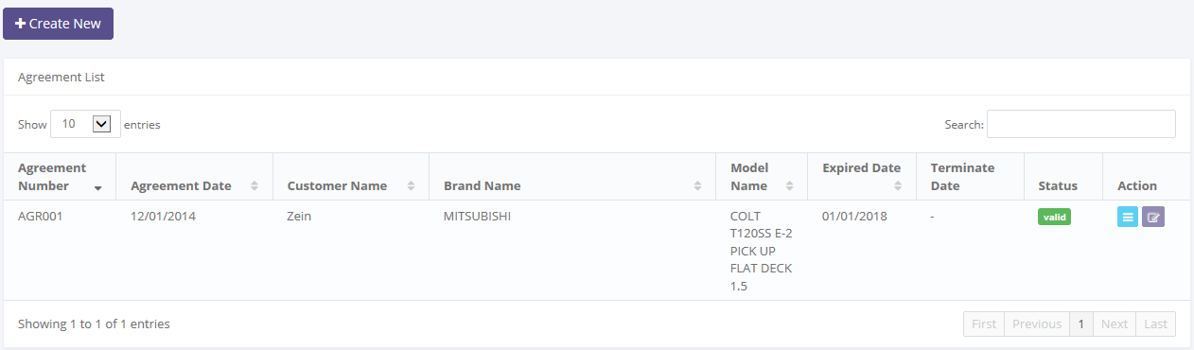

Pick the number of records, to filter number of records in the list.

Click here to sort the records.

Click here to do some action to this record such as edit and see a data detail.

1. Main Page of Agreement Information Inquiry

Only authorized user have access to all records in order to keep them up to date. This page provides following functions:

1. Create a calculation of refinance by opening ‘Create’ page. To open this page user can click , on the top-left of the list of refinance calculation.
2. Open details of calculation by click , on the rightmost column at the list.
3. Editing a calculation data using edit menu. User can click  on the rightmost column at the list.
4. Filter and sort a data that appears on the list. To do this function user can do as follows:
5. Click  to sort a record ascending or descending.
6. Filter a numbers of record by selecting .
7. Filter a records by input a keywords at .

Agreement Information Inquiry function will have some business rules for status when processing a data. The picture below is describing transition of status that performed by user when using this features.

****

1. Workflow of Agreement Information Inquiry

In the beginning, when new agreement information created by user, the status will be saved as . After saved, the records can be submitted by user and the status will be changes to . Once it done, record can be validate by authorized user, then the status will be changes to . If the authorized user want the records changes by member, the authorized user can  the record, then the status records will be changes to  automatically.

In special cases, if the authorized user want records to be invalidate, they can do  process, and the status will be .

### 3.5.1 Details of Agreement Information Inquiry

To open details in agreement information inquiry, click sub menu ‘Agreement Information Inquiry’ in Marketing module. Below is figure of main page of Agreement Information Inquiry:



Click here to Agreement Information Details.

1. Details of Agreement Information Inquiry

Once user clicking , system will open details of agreement information. This page displays all information related to calculations which have been inputted by user. When the details page opens it may look as follows:

Audit rails

Status of record

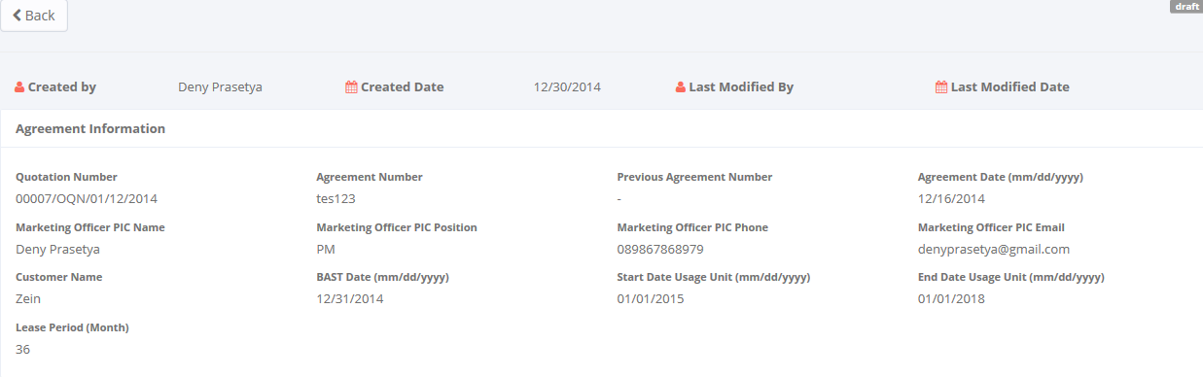

Return back to the previous page

Agreement Information Header

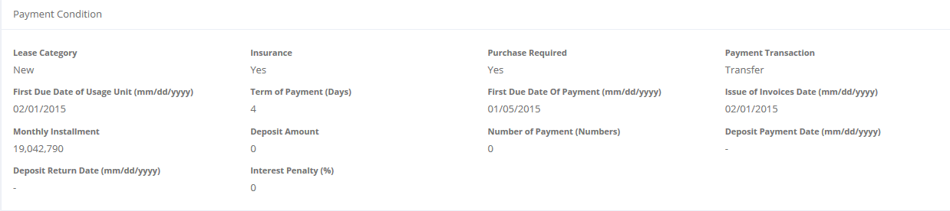

Payment Condition

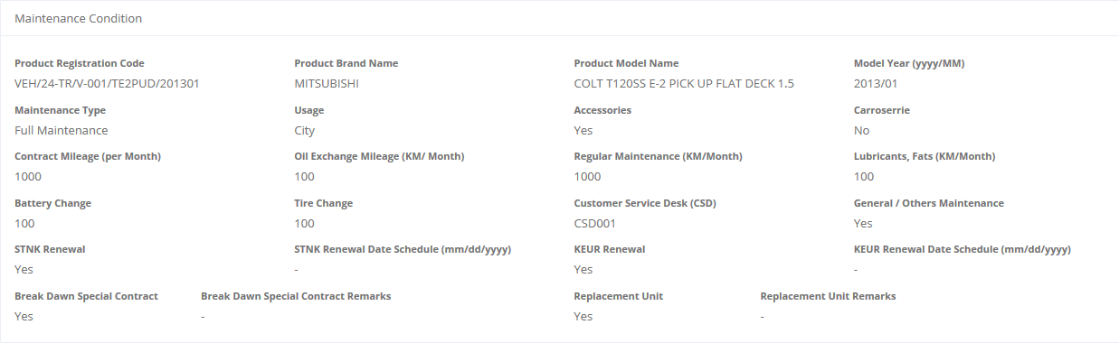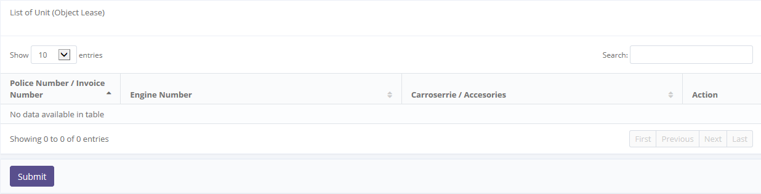

Maintenance Condition

List of Unit (Object Lease)

To update the record status

1. Details Page of Agreement Information Inquiry

Once the calculation has been created,  status is displayed on the top-right corner. If the data already confirm, user can submit agreement information by clicking . Once it done, system agreement information will be change to , then system will return back to main page of agreement information (see picture 107). And also system will notify success/failure message like this:



1. Submit process notification

If user feels the agreement information needs return back to draft, user can open details page of agreement information (see picture 110). Once it opened,  status is displayed on the top-right corner. If submitted data already confirm, user can click  button, then system will return back to main page of Agreement Information (see picture 107). And also system will notify success/failure message like this:



1. Set to Draft process notification

As long as the agreement information record still not validate\*), user can changes the status from draft to submitted or vice versa.

Notes:

\*) *Agreement Information can be validating if the record is . (see section 3.5 Agreement Information Inquiry)*.

### 3.5.2 Filter and Sort Agreement Information Inquiry

To open details Agreement Information Inquiry, click sub menu ‘Agreement Information Inquiry’ in Marketing module. Below is figure of main page of Agreement Information Inquiry:



Click here to Agreement Information Details.

1. Details of Agreement Information Inquiry

To filter the records there are two categories as follows:

1. To sort the record by column, user can click  column title on the table header.
2. Filter the number of records. User can select the number by picking this feature on the screen. If the records have been filtered based on number, the amount of records that will be shown is same as the selected. For example if you want to display 10 product record, you can select 10.
3. Filter the records with the specific information. You can do it by entering the keywords on the  field. For example, you can enter name of product on the **search field**, and then press an **Enter** button on the keyboard. See the picture below:

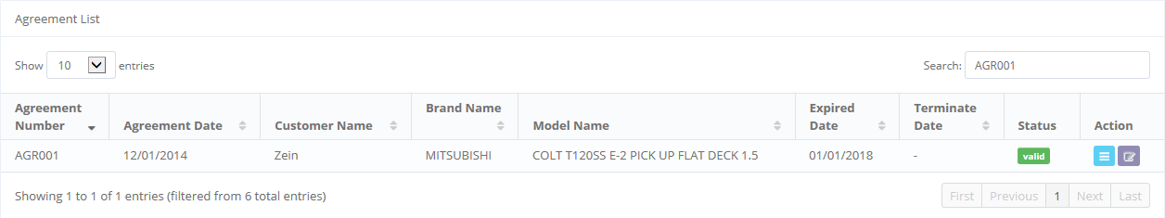

Result shows here

Keywords enter here

1. Filter and Sort Result on Main Page of Agreement Information Inquiry

### 3.5.3 Create New Agreement Information Inquiry

If user wants to create a new agreement, click  on the top-left corner of the main page of Agreement Information Inquiry (see picture 33.)

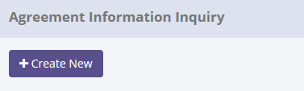

Click here to open Creates form

1. Create new Button

When the Create form opens it may look as following:

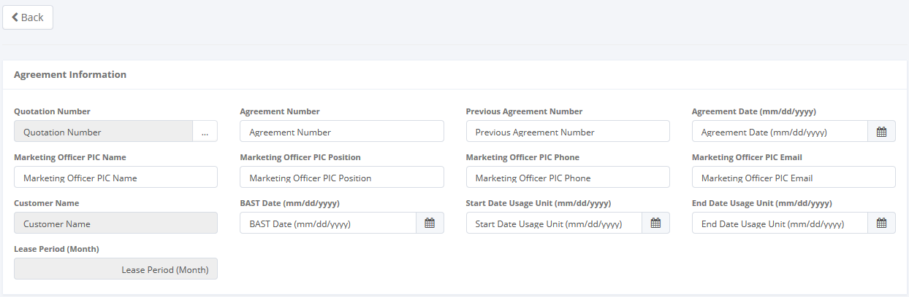

Click here to return to the main page of calculation of refinance

Agreement Information Header

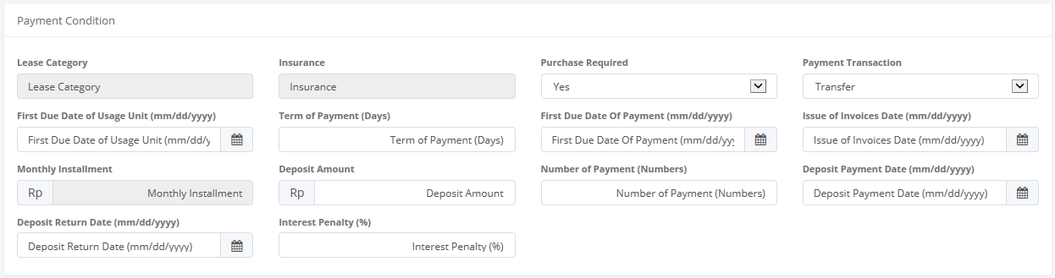

Payment Condition

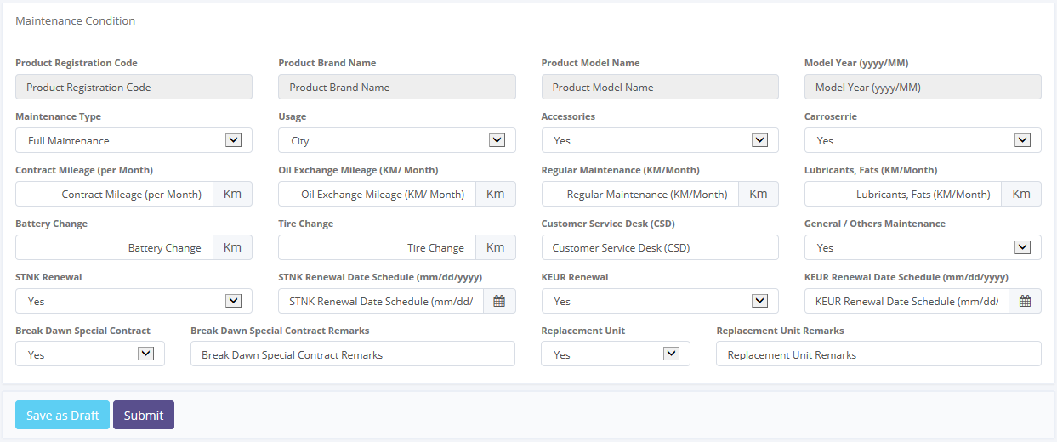

Maintenance Condition

Saving or Submit to database

1. Create new Agreement Information

Once the Add New Product screen opens, there are 3 buttons that will be displayed on the screen, are as follows:

1. , on the top-left corner of the screen.
2.  , on the bottom-left corner of the screen.
3. , on the bottom-left corner of the screen.

When creating a new Agreement Information:

1. The first field to be input is the Quotation Number. To enter its field, user can looking up a quotation data then select the QuotationNumber (only one quotation data can be selected). Once it done, Quotation Number field will be filled out automatically.

Click here to look up customer data status



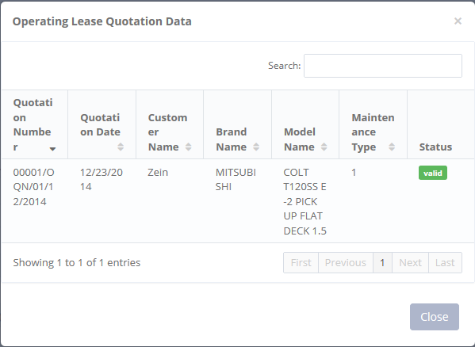

1. Quotation Data Selection
2. All the remaining fields in Agreement Information, Paymet, and Maintenance panel can be input manually.

Agreement Information Header

1. User can save a data on the system by clicking **Save as Draft**, or **Submit** button. Ensure that you actually want to **Submit** a record, because the records cannot be reserved and update after submitted by user. For authorized user, they still can be updating after submitted. But don’t be afraid, if you don’t have an authorization, data still can be updated as long as draft. It can’t leave as blanks. If blanks, system will notified it after clicking **Save as Draft** or **Submit** button. After clicking **Save as Draft** or **Submit** button system will notified if success or failed to save or submit a data. You also have a **Back** button, to return back to main page screen.

### 3.5.4 Edit Agreement Information Inquiry Record

If user wants to edit an agreement record, click  on the left column of the records at the list of agreement.



1. Edit Button

When the Edit form opened, it may look as following:

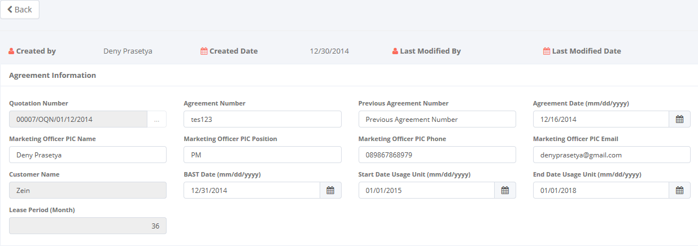

Audit rails

Click here to return to the main page of calculation of refinance.

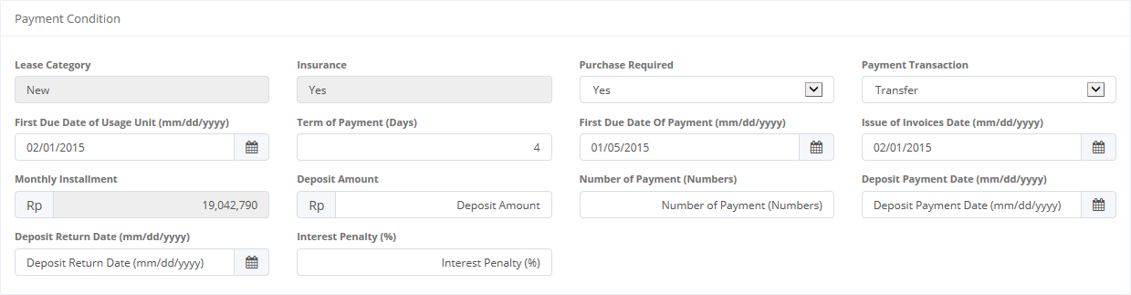 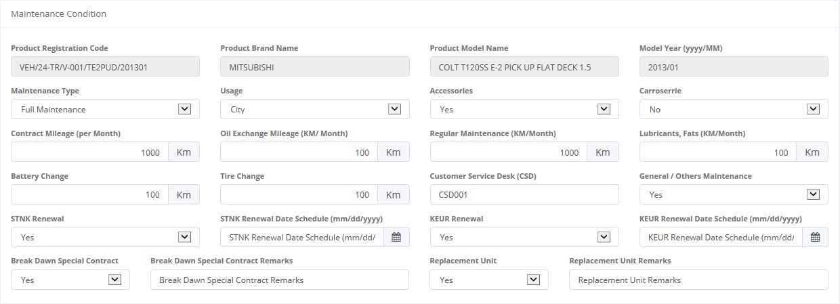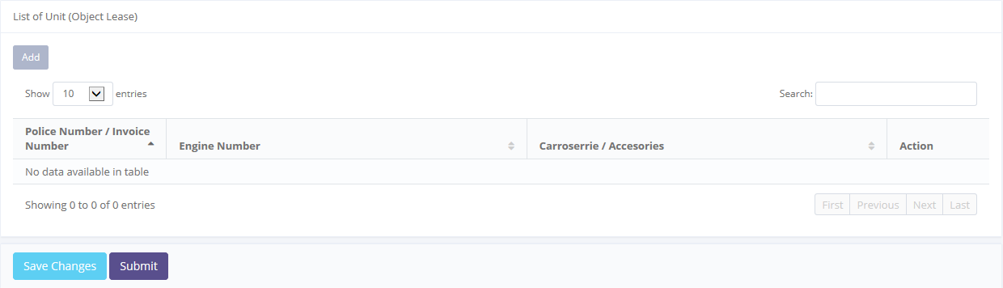

Payment Condition

Maintenance Condition

Saving or Submit to database

1. Edit Agreement Information

Once the Edit screen opened, there are 2 buttons that will be displayed on the screen as follows:

1. , on the top-left corner of the screen.
2.  , on the bottom-left corner of the screen.
3. , on the bottom-left corner of the screen.

When creating a new Agreement Information:

1. The first field to be input is the Quotation Number. To enter its field, user can looking up a quotation data then select the QuotationNumber (only one quotation data can be selected). Once it done, Quotation Number field will be filled out automatically.

Click here to look up customer data status





1. Quotation Data Selection
2. All the remaining fields in Agreement Information, Paymet, and Maintenance panel can be input manually.
3. User can save a data on the system by clicking **Save as Draft**, or **Submit** button. Ensure that you actually want to **Submit** a record, because the records cannot be reserved and update after submitted by user. For authorized user, they still can be updating after submitted. But don’t be afraid, if you don’t have an authorization, data still can be updated as long as draft. It can’t leave as blanks. If blanks, system will notified it after clicking **Save as Draft** or **Submit** button. After clicking **Save as Draft** or **Submit** button system will notified if success or failed to save or submit a data. You also have a **Back** button, to return back to main page screen.

# Maintenance Module

Operating Lease Support System includes Maintenance Module features; Service History Inquiry. The features will be described in the subsequent sections. The Maintenance menu of Operating Lease Support System serves as the basic access to maintenance module and records all data. With the maintenance menu, you will be able to utilize features of maintenance module, including information that will be adjusted through other features of Operating Lease Support System.

Additionally you can enter a record, make changes, and inspect a detail record. The features and data contained in your Operating Lease Support System menu are limited by your security and data authorization settings so you may not be able to access all features.

## 4.1 Service History Inquiry

At the beginning, user can open service history inquiry by clicking the ‘Service History Inquiry’ on the list of Maintenance menus. Once clicked the menus, system will display the Service History Inquiry page. When opening the page it may look as following:

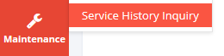

Click here to add new records.

Click here to open Service History Inquiry

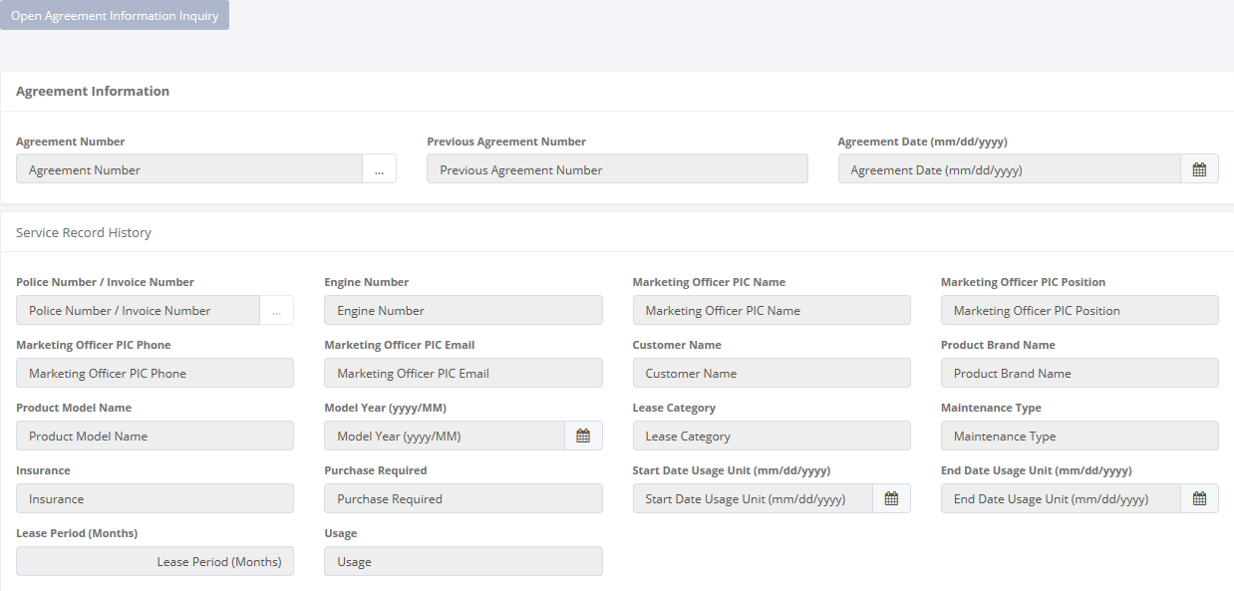

Pick the agreement number

1. Service History Inquiry

This page provides following functions:

1. Open Agreement Information Inquiry. Go to Agreemenet Information by click , on the top-left of the list of Service History Inquiry.
2. Open details service history by choose Agreement Number  and Police Number/Invoice Number .

Service History Inquiry function will have some business rules for status when processing a data. The picture below is describing transition of status that performed by user when using this features.

****

1. Workflow of Service History Inquiry

### 4.1.1 Open Service History Inquiry

To open details in service history inquiry, click sub menu ‘Service History Inquiry’ in Maintenance module. Below is figure of main page of Service History Inquiry:



Click here to open Agreement Number

Click here to open Police/Invoice Number

1. Main Page Service History Inquiry

When opening Service History Information:

* + 1. The first field to be input is the Agreement Number. To enter its field, user can looking up a agreement data then select the Agreement Number (only one agreement data can be selected).



Click here to look up agreement

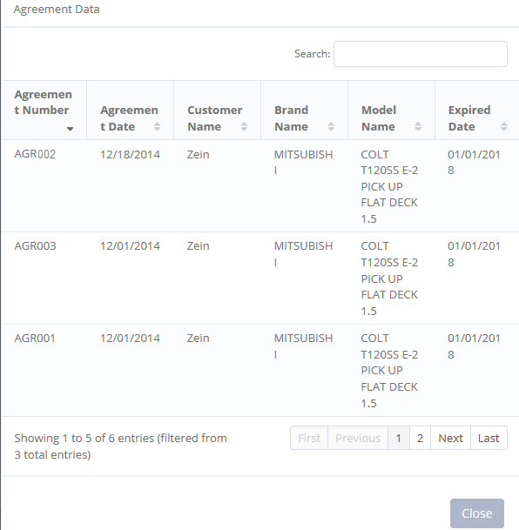

1. Agreement Number
2. After that you can select Police/Invoice Number that the servicerecord history you want to see. User can looking up a Police/Invoice Number in its field.



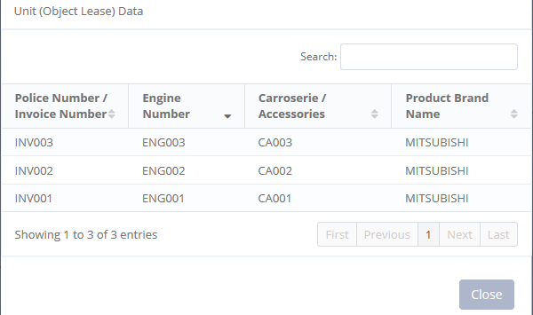

Click here to look up police/invoice number

1. Police/Invoice Number

Once the two field above has been inputted, the page will display service history in the bottom of the page as follows:

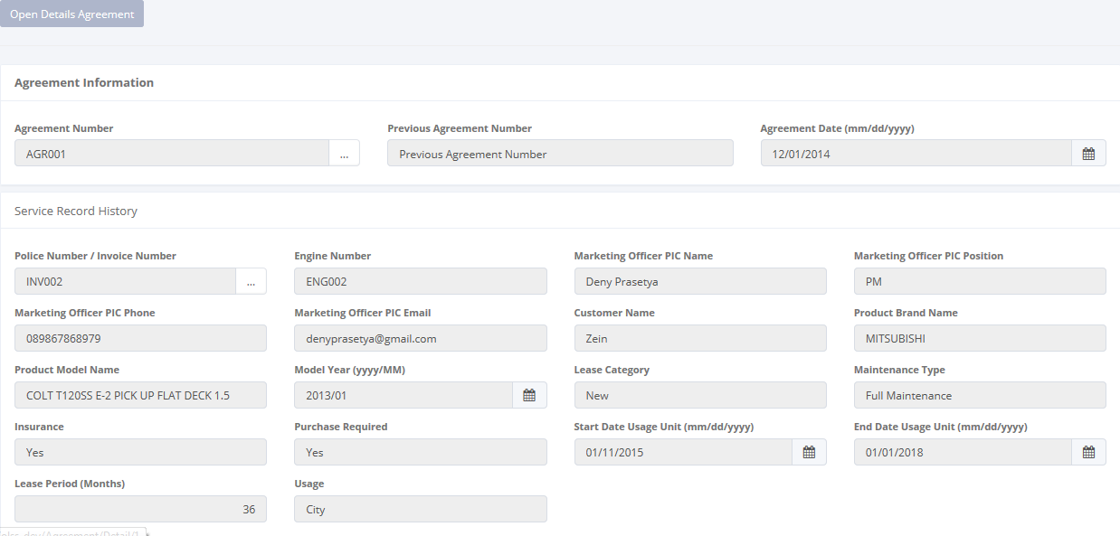

Agreement Information

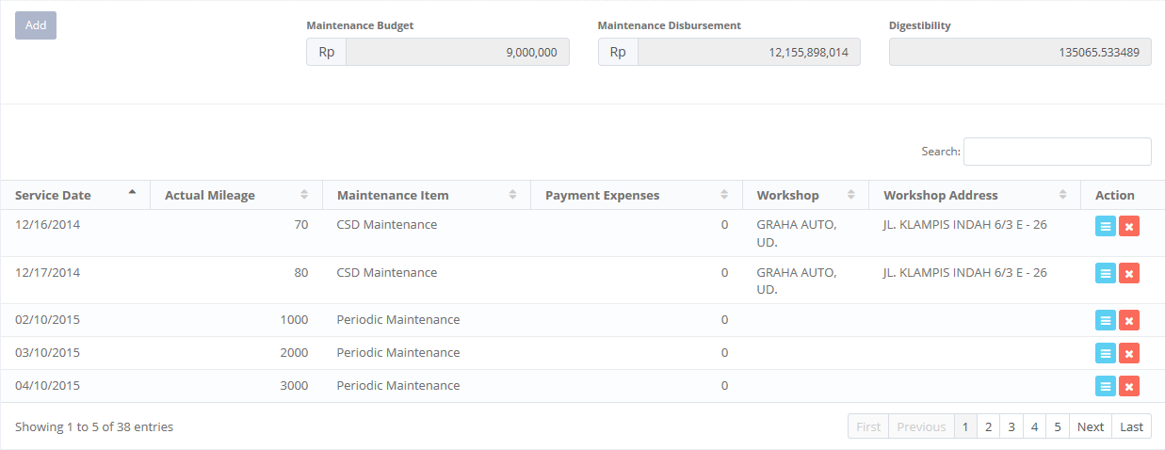

Add Service History

1. Service History Inquiry

This page provides following functions:

1. Open Agreement Information Inquiry. Go to Agreemenet Information by click , on the top-left of the list of Service History Inquiry.
2. Open details service history by choose Agreement Number  and Police Number/Invoice Number .
3. Add Service History Inquiry by click Add



Click to Add Service History Inquiry

1. Add Service History Inquiry

### 4.1.2 Add Service History Inquiry

To open details service history, click sub menu ‘Service History Inquiry’ in Maintenance module. Below is figure of main page of Service History Inquiry:



Pick the agreement number

Click here to open Police/Invoice Number

1. Main Page Service History Inquiry

After you open Service History Inquiry like in step 4.1.1, you can add service history inquiry by click Add (see picture 127) and you will go to page as follows:

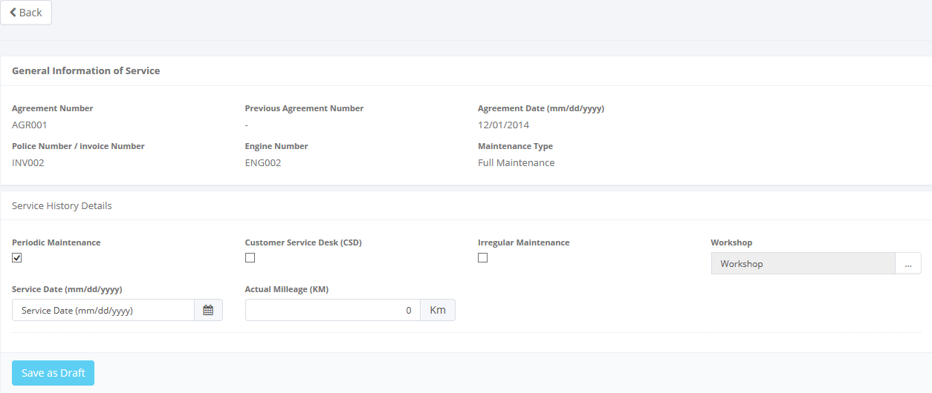

1. Add Service History Inquiry

This page provides following functions:

1. Choices of Maintenance e.g. Periodic, CSD, and Irregular Maintenance.
2. Choices of Workshop. User can choose the workshop by click in its field.



Click here to look up workshop

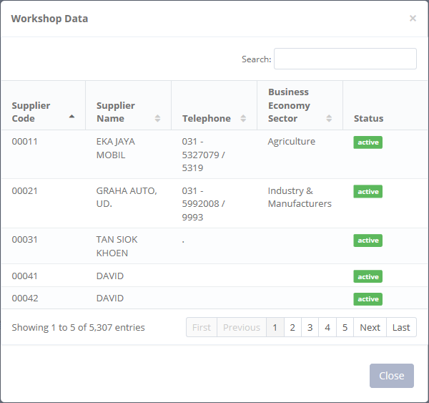

1. Workshop Data
2.  , on the bottom-left corner of the screen.

### 4.1.3 Details of Service History

To open details service history, click sub menu ‘Service History Inquiry’ in Maintenance module. Below is figure of main page of Service History Inquiry:



Pick the agreement number

Click here to open Police/Invoice Number

1. Main Page Service History Inquiry

After you open Service History Inquiry like in step 4.1.1, you can see details of service history by click as follows:



Click to see details

1. Go to Service History Inquiry Details

And you will go to page below:

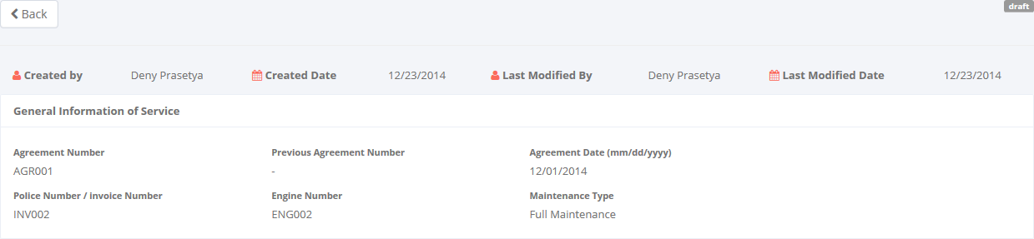

General Information of Service

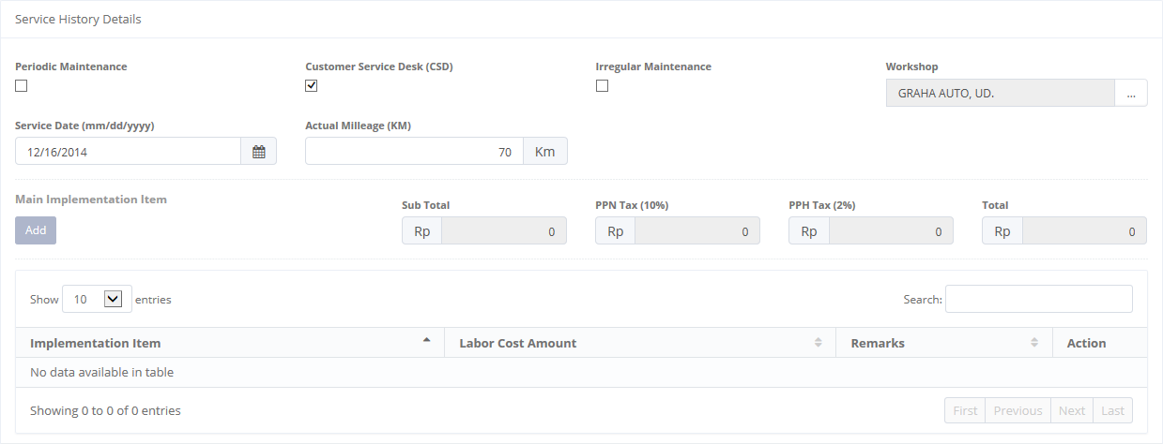

Service History Details

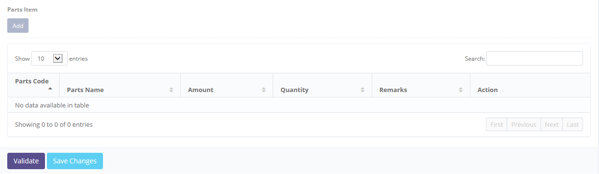

1. Service History Details

Once the Service History Details opened, there are 5 buttons that will be displayed on the screen, are as follows:

1. , on the top-left corner of the screen.
2. , for adding Main Implementation Item.
3. , for adding Parts Item.
4. , on the bottom-left corner of the screen.
5. , beside Validate button.

When look at details of Service History Inquiry:

1. The first you can add is main implementation item. To add its field, user click the following icon:

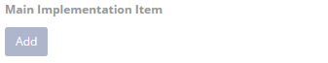

Click here to add item

And there will a pop-up a page as follows:

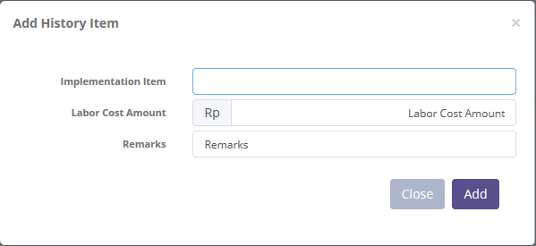

1. Add History for Main Implemenetation Item
2. The second you can add is parts item. To add its field, user can click the following icon:



Click here to add item

And there will a pop-up a page as follows:

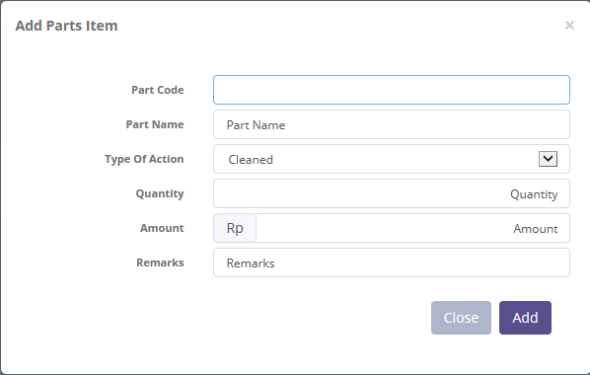

1. Add History for Parts Item
2. User can save a data on the system by clicking **Save Changes** or **Validate** button. Ensure that you actually want to **Validate** a record, because the records cannot be reserved and update after validated by user. For authorized user, they still can be updating after submitted. After clicking **Save Changes or Validate** button system will notified if success or failed to save or submit a data. You also have a **Back** button, to return back to main page screen.

# 5. Collection Module

Operating Lease Support System includes Collection Module features; Billing Payment History. The features will be described in the subsequent sections. The Collection menu of Operating Lease Support System serves as the basic access to collection module and records all data. With the collection menu, you will be able to utilize features of collection module, including information that will be adjusted through other features of Operating Lease Support System.

Additionally you can make changes status and inspect a detail of record. The features and data contained in your Operating Lease Support System menu are limited by your security and data authorization settings so you may not be able to access all features.

## 5.1 Billing Payment History

At the beginning, user can open billing payment history by clicking the ‘Billing Payment History’ on the list of Collection menus. Once clicked the menus, system will display the Billing Payment History page. When opening the page it may look as following:

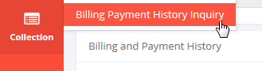

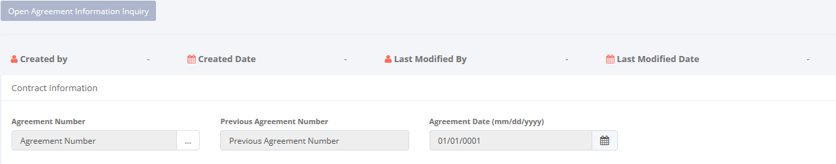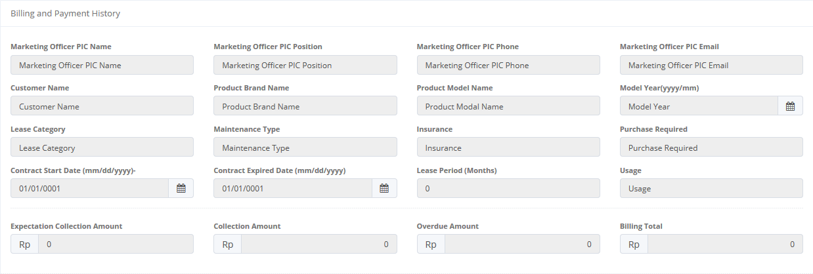

Pick the agreement number

Click here to open Service History Inquiry

1. Billing Payment History

This page provides following functions:

1. Open Agreement Information Inquiry. Go to Agreemenet Information by click , on the top-left of the list of Service History Inquiry.
2. Open details billing payment history by choose Agreement Number  .

Pick the agreement number

Billing Payment History function will have some business rules for status when processing a data. The picture below is describing transition of status that performed by user when using this features.

****

1. Workflow of Billing Payment History

### 5.1.1 Open Billing Payment History

To open details in billing payment history, click sub menu ‘Billing Payment History’ in Collection module. Below is figure of main page of Billing Payment History:



Pick the agreement number

Click here to open Service History Inquiry

1. Main Page of Billing Payment History

When opening Billing Payment History:

* + 1. The first field to be input is the Agreement Number. To enter its field, user can looking up a agreement data then select the Agreement Number (only one agreement data can be selected).



Click here to look up agreement

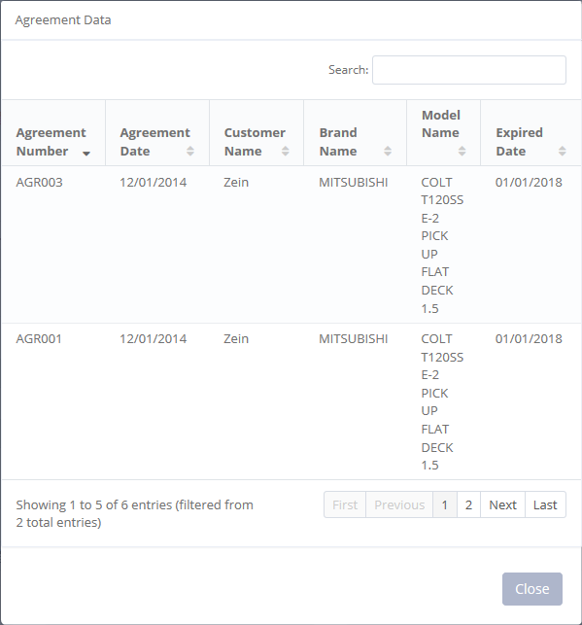

1. Agreement Number

Once the field above has been inputted, the page will display billing payment history in the bottom of the page as follows:

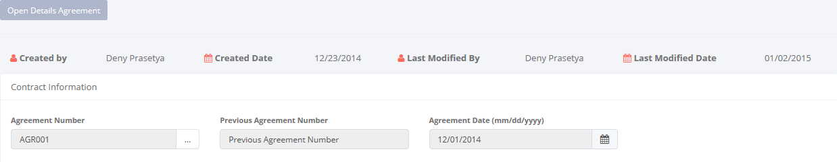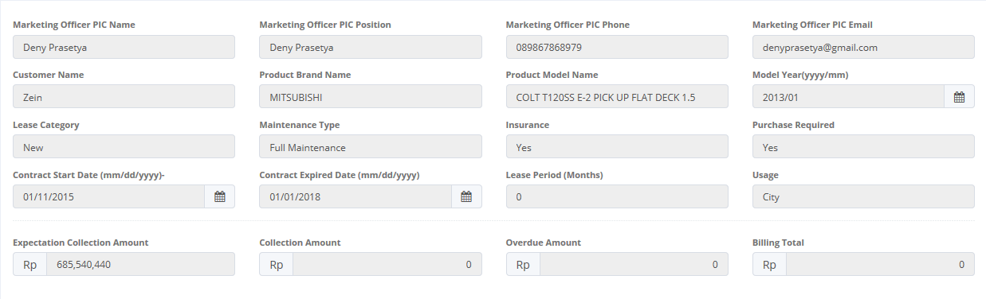

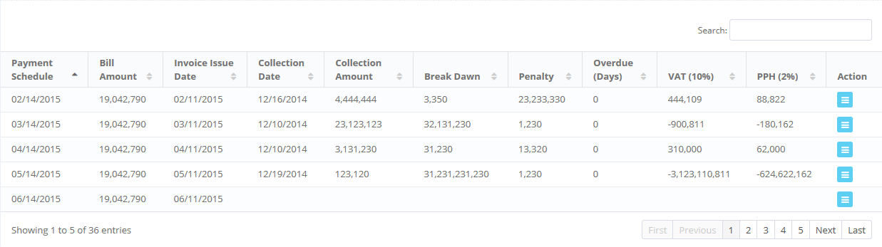

1. Billing Payment History Opened

This page provides following functions:

1. Open Details Agreement. Go to Details of Agreemenet page by click , on the top-left of the list of Billing Payment History.
2. Open details billing payment history by click action button beside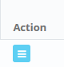 .

### 5.1.2 Details of Billing Payment History

To open details billing payment history, click sub menu ‘Billing Payment History’ in Collection module. Below is figure of main page of Billing Payment History:



Pick the agreement number

Click here to open Service History Inquiry

1. Main Page of Billing Payment History

After you open Billing Payment History like in step 5.1.1, you can see details of billing payment history by click as follows:



Click to see details

1. Go to Billing History Payment Details

And you will go to page below:

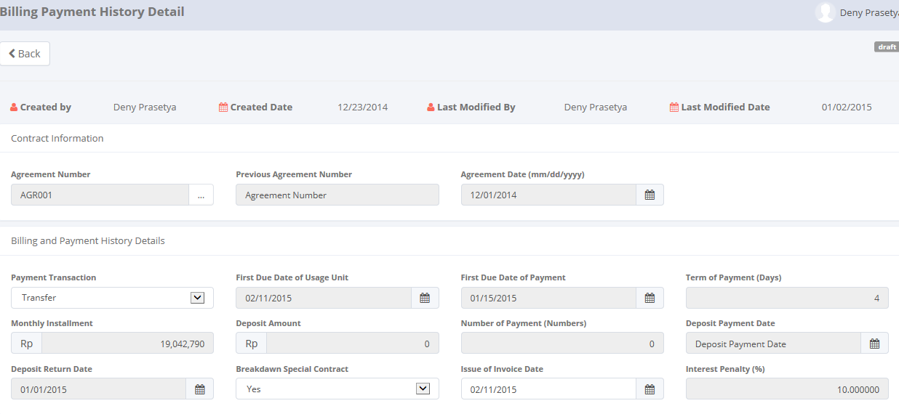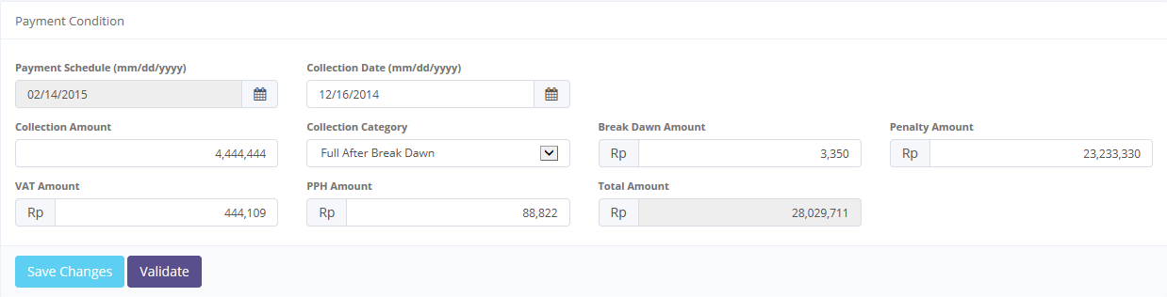

1. Billing Payment History Details

Once the Service History Details opened, there are 5 buttons that will be displayed on the screen, are as follows:

1. , on the top-left corner of the screen.
2. , on the bottom-left corner of the screen.
3. , beside Save Changes button.
4. Or if the data has been validated, then there will be , on the bottom-left corner of the screen.

When look at details of Service History Inquiry, user can save a data on the system by clicking **Save Changes** or **Validate** button. After clicking **Save Changes or Validate** button system will notified if success or failed to save or submit a data. You also have a **Back** button, to return back to main page screen.